

**School-Wide Behavior Expectations Handbook**

***A Step-by-Step Guide for School Leaders***

***Vision***

## ****The Richmond County School System will provide an equitable education for all students****

## ****to prepare them for life beyond the classroom.****

***Mission***

**Building a globally competitive school system that educates the whole child**

**through teaching, learning, collaboration, and innovation.**



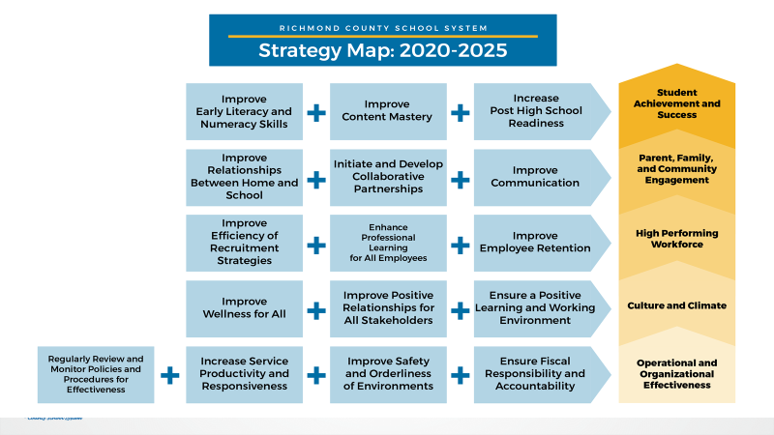

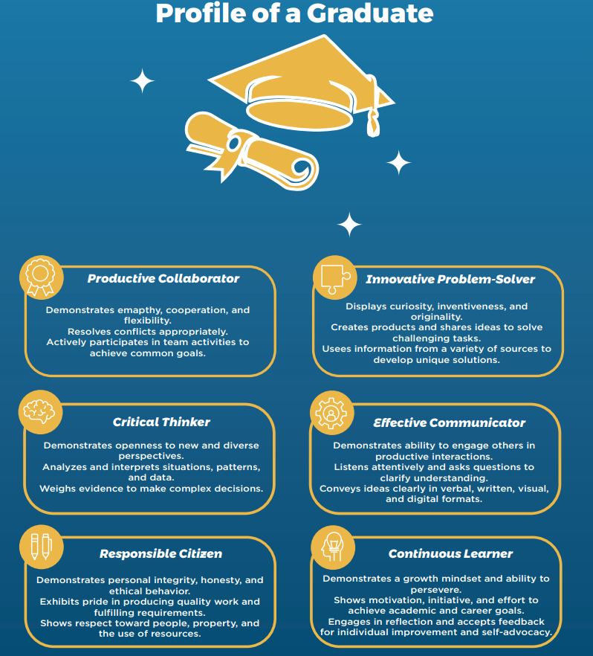

**Table of Contents**

Planning for the Implementation of a Schoolwide Behavior Plan 6

* Administrative Leadership
* Team Composition
* Team Operating Procedures

Step One – Define 3-5 Behavior Expectations 7

* Links to Examples from ES, MS, and HS
* Link to Sample Template and Online Resource

Step Two – Develop Lesson Plans to Teach Schoolwide Expectations 8

* Links to Examples from ES, MS, and HS
* Link to Sample Template
* Teacher Resources

Step Three – Plan for Acknowledgement of Staff/Students 9

Step Four – Define Problem Behaviors and “Who Handles What” 10-12

* Discipline Flow Chart
* Examples and Reminders

Step Five – Use Data to Monitor, Target, and Adjust 13

* Problem Solving Protocols
* Five Key Questions

Preparing for the First Days of School 14

Schoolwide Behavior Planning –Timeline and Quick Reference Guide 15

Additional Resources 16

**Planning for the Implementation of a Schoolwide Behavior Plan**

Prior to developing a Schoolwide Behavior Plan, school leaders should consider the following:

**Administrative Leadership**

Any successful schoolwide effort requires the endorsement and active participation of all administrators in the building, especially the principal. As Todd Whitaker says in *What Great Leaders Do Differently,* “when the principal sneezes, the whole school catches a cold.” When principals scoff at plans or delegate them away, school staff sense it, and the plan’s importance is diminished.

*How will you embrace and support the Schoolwide Behavior Plan? How will all members of your administrative team share responsibility for implementing, monitoring, and supporting the plan?*

**Team Composition**

Success of teams is dependent upon the collective contributions of talented players. As you recruit members of your Behavioral Support Team, consider a cross section of members from all departments and grade levels. Look for positive people who are willing to ask tough questions to help make the school climate even better. Consider those members who have a particular talent with classroom management, academic coaching, and historical knowledge of your school’s culture and norms.

*How will your teacher-leaders contribute to the success of the plan? How will you maximize their strengths?*

**Team Operating Procedures**

High-performing teams meet regularly to analyze data and participate in the decision-making process. As such, regular meeting attendance should be planned and expected.

*How will you develop a schedule for your Behavior Team meetings to meet at least monthly? How will you work to define norms, roles, and expectations for members of the team?*

**Step One: Define 3-5 Clear Behavioral Expectations**

Schoolwide Behavior Teams should work together to define 3-5 expectations based on the mission and vision of the school. Then, teams should come to consensus on what these expectations will look like in all areas of the school: Cafeteria, Bus Circle,

Hallways, Gym/P.E., Media Center, Office, Playground, etc.

Once these are established, then ALL classroom teachers should base their own expectations on the schoolwide plan. These rules and expectations should be clearly posted in all classrooms. The goal with this step of the planning process is to create a common language across the school, with all expectations stated positively and aligned with the schoolwide standards.

Below are links to sample Schoolwide Behavior Expectations, along with a template that can be utilized for any school.

[Behavior Matrix - Elementary School](https://rcboe-my.sharepoint.com/:w:/g/personal/wrighki_richmond_k12_ga_us/EbMG-CGSWtVHiIgb6NbsV9QB4wjrsQRWkjdpE4qgjvmM5A?e=PSWqcB)

[Behavior Matrix - Middle School](https://rcboe-my.sharepoint.com/:w:/g/personal/wrighki_richmond_k12_ga_us/EX3GKoDj_jVDoiBOz8vPXOABT6g5X1ykeEdxfZC1XLaCrw?e=91sMe3)

[Behavior Matrix - High School 1](https://rcboe-my.sharepoint.com/:w:/g/personal/wrighki_richmond_k12_ga_us/EaKNQl8xsV5GoF0rhLm9ZMkBjIH_uH5JhwaFqEmZqri8AA?e=tU9M3G)

[Behavior Matrix - High School 2](https://rcboe-my.sharepoint.com/:w:/g/personal/wrighki_richmond_k12_ga_us/ETptC5SrxOhBkw8Wla1nBwMBabqZBgch57Ob_tOCeKCO7Q?e=yMT7jt)

[Sample Classroom Matrix](https://rcboe-my.sharepoint.com/:w:/g/personal/wrighki_richmond_k12_ga_us/EXiwUWdNqxVFiuHAaGQFoSIBHx129Cm3kbeIeGi0k9rZQA?e=ler4cP)

[Template - School Wide Behavior Matrix.docx](https://rcboe-my.sharepoint.com/:w:/g/personal/wrighki_richmond_k12_ga_us/EU5UBtmeEVBEqSztxsZmljwBkiRfCZOOjS89iUtQkZw3ig?e=s5nVGV)

[PBIS](https://mascotjunction.com/pbis-matrix-templates-editable-downloads/) Matrix Templates - Editable Downloads

**Step Two: Develop Lesson Plans to Teach Schoolwide Expectations**

When students come to school with deficiencies in reading and writing skills, we teach them how to read and write. **When students come to school with deficits in behavior, we should provide similar instruction.** At the start of the school year, plans should be developed for teachers to directly instruct students in Schoolwide Behavior Expectations in all areas of the school.

Once these plans are in place, ALL teachers should be made aware of these plans prior to the start of school and should be expected to teach these expectations to their students during the first week of school. Administrators can reinforce these expectations through morning announcements and visibility in common areas and classrooms.

Below are links to sample lesson plans and templates that teachers/teams can utilize for teaching schoolwide expectations.

[Behavior Lesson Plan - Examples.docx](https://rcboe-my.sharepoint.com/:w:/g/personal/wrighki_richmond_k12_ga_us/ETIzujE17idNtpHtyh6JmjgBOcv0g24vpYafYXmLyphLog?e=aYLCJl)

[Teaching Behaviors - Sample Schedule](https://rcboe.sharepoint.com/:w:/s/hornsbyelempbis/EURHR6xmkDdNu9JF0Jl_GwEBLoGlDAkc7DEE_FGaEr7h7Q?e=oDoE0f)

[Behavior Lesson Plan - Template.doc](https://rcboe-my.sharepoint.com/:w:/g/personal/wrighki_richmond_k12_ga_us/Eco6GCxSv9VHmMBun2DwfBQBq2w0VHTq1gy-L29TR3YukA?e=JLGcEL)

[Sample Lesson Planning Activity for Teams](https://rcboe-my.sharepoint.com/:w:/g/personal/wrighki_richmond_k12_ga_us/EWbrQjaVQgtDotULUwdB0f0B8k7fvNfiXGgxNNAMukSICA?e=EUinxf)

[Additional Lesson Planning Resources](https://sites.google.com/a/plaea.org/pbis/sw-pbis-training-materials/universal/tier-1-session-1/lesson-plans-for-teaching-school-wide-expectations)

Remind teachers to refer to Modules 6.5 and 6.6 of ***Richmond Ready*** and the resources below.

* [**Creating Classroom Routines & Procedures**](https://teacher.scholastic.com/classroom_management_pictures/index.html)
* [**Rules and Routines in the Classroom**](https://www.edutopia.org/blog/rules-routines-school-year-start-classroom-management)
* [**Classroom Routines and Procedures: Why Are They Important**](https://classroommanagementexpert.com/blog/classroom-routines-and-procedures-why-are-they-important/)

**Step Three: Plan for Acknowledgement of Students/Staff**

As with any new plan, students and staff need to know “what’s in it for them” to start strong and build momentum. As such, after defining expected behaviors, the team needs to determine how stakeholders will be acknowledged for meeting Schoolwide Behavioral Expectations. **The best way to ensure a strong school climate is to acknowledge often what you believe in as a school and how everyone is working hard toward that vision. Make success visible, tangible, and meaningful.**

[Team Activities for Designing an Acknowledgement System](https://rcboe-my.sharepoint.com/:w:/g/personal/wrighki_richmond_k12_ga_us/EVeFxTS06gdFjh7TVMRmAOQB-RGWFyvt_WTKedqpDWp5yw?e=7E40Vf)

Here are some sample acknowledgement plans and activities from within the district:

[Elementary Acknowledgement Plan](https://rcboe-my.sharepoint.com/:w:/g/personal/wrighki_richmond_k12_ga_us/ESg7vdz2mhxIqyY2mCH3TeEBDUW74CK8JAs8y9CqE8pPHA?e=jeECT5)

[Middle School Acknowledgement Plan](https://rcboe-my.sharepoint.com/:w:/g/personal/wrighki_richmond_k12_ga_us/EfCbNR4wkJBDvV2so79fJC0BaVTmEgSN3TVgacE12pqiug?e=ru5Q8l)

[High School Acknowledgement Plan](https://rcboe-my.sharepoint.com/:w:/g/personal/wrighki_richmond_k12_ga_us/ESSo2VRM585Akw880rcQq1QBXFi_YoUjlSXGADXIVhBecQ?e=nDSCeg)

Here are additional resources for developing effective acknowledgement systems:

[Tips for Schoolwide Acknowledgement Systems](https://rcboe-my.sharepoint.com/:b:/g/personal/wrighki_richmond_k12_ga_us/ERJJis7AzcJOumR1Hq4TezQBWjyaf8ieDExo_81nakANcQ?e=ISe0Jc)

[High School Acknowledgement Systems](https://rcboe-my.sharepoint.com/:b:/g/personal/wrighki_richmond_k12_ga_us/EcQQtq7NLSlGtpfAqBUhoBgBoSfGsAh7XpPIIDDutG1J0A?e=eM8VuQ)

[Planning Effective Student and Staff Acknowledgement Systems](https://rcboe-my.sharepoint.com/:b:/g/personal/wrighki_richmond_k12_ga_us/EXfWeTVmLI5Go31fXg5redMBn_7Z2Jg_d6QME0k0mB6k-Q?e=1VxUqO)

**Step Four: Define Problem Behaviors and “Who Handles What”**

Work with school teams to define those behaviors that are minor/teacher-managed versus major/office managed. While this is not an inclusive list of behaviors, these are guidelines that can apply to the entire district and drive the conversations of your teams. When addressing any student behavior, consideration should be given to the grade level and age of students involved.

Teams can utilize this template to define problem behaviors within their individual schools: [Team Activity - Defining Problem Behaviors](https://rcboe-my.sharepoint.com/:w:/g/personal/wrighki_richmond_k12_ga_us/EfJLVRxfh31PnCjHH0O_geQBsw6plTtWZ_lnK0HjGh7bAQ?e=hRpyFE)

|  |  |
| --- | --- |
| **Minor/Teacher-Managed**   * Class Disruption * Disrespectful Behavior * Unkind Words/Name Calling * Non-compliance/Refusal to Work * Off-task Behavior/Talking in Class * Tussling/Horseplay/Play Fighting * Minor Aggression * Inappropriate Language/Gestures * Material/Property Misuse * Dress Code Violation * Inappropriate Use of Technology * Leaving Assigned Area without Permission * Verbal Altercation * Verbal Aggression toward Classmates * Lying * Sleeping in Class * Stealing from Others * Food/Drink in Classroom | **Major/Office-Managed**   * Weapons * Fighting * Assault * Threats * Harassment * Alcohol Use/Possession * Drug Use/Possession * Smoking * Bullying/Cyberbullying * Extreme Property Damage/Vandalism * Skipping Class/Chronic Truancy * Sexual Misconduct * Leaving Campus without Permission * Physical Aggression toward School Staff * Bomb Threat/False Alarm * Excessive Tardiness |

**Discipline Flow Chart Example**

Observe Problem Behavior

**NO**

**YES**

*Complete Office Discipline Referral Form*

Is immediate removal necessary to ensure safety?

Remind and Restate the Expectation/Rule

**NO**

Is behavior office managed?

**YES**

|  |  |
| --- | --- |
| Classroom Managed | Office Managed |
| *Issue warning of next steps and re-teach expected behavior.* | *Administrator provides teacher feedback.*  *Administrator determines consequence*  *Contact office for assistance.* |

**For students with chronic minor behaviors:**

* Track incidents, looking at the ABC’s, to determine function of behavior.
* Examine academic performance.
* Use prompts & pre-correction frequently until issue is resolved.
* Re-teach and practice with individual student.
* Conference with family to determine if other issues may be contributing to behavior.

*Conference with student for transition back to school/class.*

**Discipline Examples from the District**

[Discipline Flow Chart - Elementary](https://rcboe-my.sharepoint.com/:w:/g/personal/wrighki_richmond_k12_ga_us/ESr7hYlRUwdBuswVRhsqFVYBxZny-_D8-awjCxJAhQb8qw?e=N7zgrB)

[Discipline Flow Chart - High School](https://rcboe-my.sharepoint.com/:w:/g/personal/wrighki_richmond_k12_ga_us/EZJuN62YMSxKuFvbQRkuZ98BUJO_xe9kRS3zdrVqD_M1Mg?e=4W5ddz)

[Majors vs Minors - Elementary School](https://rcboe-my.sharepoint.com/:w:/g/personal/wrighki_richmond_k12_ga_us/EVwLvf149AJGglb2oEYZcBABP8_oLh7K7QLtcV2UPzFxbw?e=QDG3pS)

[Majors vs Minors - Middle School.docx](https://rcboe-my.sharepoint.com/:w:/g/personal/wrighki_richmond_k12_ga_us/Ebro3n0OV89Fqz1GxePUjb4BnlFqA5bYo0zDEW_i1K1Jvw?e=rGVA97)

***Remember…***

* Teachers have the right to refer students to the office, but administrators have the same right to expect consistency and proactive practice from teachers. Getting on the same page with minor versus major behaviors provides a solid foundation for these mutual expectations to be upheld.
* Schoolwide Behavior Teams should consider professional learning for teachers on the use of low-profile, respectful, and restorative practices in dealing with student behavior. Here is a link to a list of teacher strategies and responses for dealing with minor behavior problems: [Teacher Strategies and Responses](https://rcboe-my.sharepoint.com/:w:/g/personal/wrighki_richmond_k12_ga_us/ETJ7vV38m2pJv8YZQufsR_gBUxyuVErqkmBhOSO1MPmtmA?e=s61pom)
* We as educators will often be the most positive adults in an individual student’s life. We must remember that in each interaction with a student, we are either building a relationship or tearing it down.
* Be sure that all teachers are expected to utilize Spotlight in Infinite Campus as the vehicle for recording minor behaviors starting this school year. This data will be crucial in making informed decisions for students.

**Step Five: Using Data to Monitor, Target, and Adjust**

In the same way that leaders and teachers utilize academic data to make informed instructional decisions, schoolwide behavior data assists school teams to monitor and adjust behavior plans. Both USHA and Spotlight allow school teams to analyze data in multiple ways, drilling down to frequency of behaviors in particular locations of the building at various times of the school day. Below are two templates that assist Behavior Support Teams with analyzing data and monitoring the schoolwide plan.

[Problem Solving Protocol Form 1](https://rcboe-my.sharepoint.com/:w:/g/personal/wrighki_richmond_k12_ga_us/EfOf4A2plBdEjdPv20QWVe0BuliCMSbi5lnwSlYEcyJucw?e=vUWNxU)

Form 1 is for schools that may be new to the process of digging deeper into schoolwide behavior data.

[Problem Solving Protocol Form 2](https://rcboe-my.sharepoint.com/:w:/g/personal/wrighki_richmond_k12_ga_us/Ed-xUnXliHVLgDKA6DON91IBkhIaIt3YWm7iDQPK7OEpzw?e=pQQFSl)

Form 2 is a more concise version for schools that are more advanced in the problem-solving process.

**Five Questions Every Team Should Ask About School-wide Behavior** (from PBISApps)

1. ***Are the results of our data analysis accurate?***

Do not explain it away. Accept the truth, even if it is bad news.

1. ***What is the current problem?***

Do not stop at the first number you see. Drill down so that you can pinpoint the area/s in your building that require the most attention and identify the precise problem.

1. ***What is contributing to our precise problem?***

Consider all the variables that may factor into the problem areas in your schoolwide behavior. Drill down even further for the who, what, where, and when.

1. ***What is the smallest amount of change for the biggest impact on student outcomes?***

Develop a plan to improve your precise problem area/s, without impacting those that are already effective.

1. ***Did we implement our plan and is it working?***

At the next team meeting, analyze new data to assess the effectiveness of the plan.

|  |  |
| --- | --- |
| Procedure: | |
| 1.  2.  3. | 4.  5.  6. |
| Teaching Procedure: (Include how it will be taught, where it will be posted or published, when it will be reviewed. | |
| How students will be re-taught or coached to follow the procedure: | |
| Rewards / Acknowledgement: | |
| Consequences: | |

**Preparing for First Days of School**

Efficiency in the classroom is the hallmark of an effective learning environment. Established procedures consistently applied and taught to your students at the onset of the school year will significantly improve a teacher’s classroom management.

Linked below is a list of important classroom procedures that teachers should consider when planning for the first weeks.

[Sample List of Classroom Procedures](https://rcboe-my.sharepoint.com/:w:/g/personal/wrighki_richmond_k12_ga_us/EQhdL1yQ2phDvmkz8HInoW8BRUzFGzSERATWOdg9bsoWzA?e=EnmmKp)

This lesson plan template will assist teachers in teaching those procedures to students. Make copies for teachers as needed.

**School-Wide Behavior Planning**

Recommended Timeline for Implementation and Quick Reference Guide

|  |  |  |
| --- | --- | --- |
| **Month** | **Tasks** | **Resources** |
| **Pre-Planning** | Establish Team/Monthly Meeting Schedule  Define Expectations  Develop School Matrix  Develop Behavior Lesson Plans | [PBIS Matrix Templates - Editable Downloads](https://mascotjunction.com/pbis-matrix-templates-editable-downloads/)  [Template - School Wide Behavior Matrix.docx](https://rcboe-my.sharepoint.com/:w:/g/personal/wrighki_richmond_k12_ga_us/EU5UBtmeEVBEqSztxsZmljwBkiRfCZOOjS89iUtQkZw3ig?e=s5nVGV)  [Sample Lesson Planning Activity for Teams](https://rcboe-my.sharepoint.com/:w:/g/personal/wrighki_richmond_k12_ga_us/EWbrQjaVQgtDotULUwdB0f0B8k7fvNfiXGgxNNAMukSICA?e=EUinxf) |
| **August - September** | Teach Expectations  Monitor for Classroom Matrices  Develop Acknowledgement Plan  Define Problem Behaviors | [Sample Classroom Matrix](https://rcboe-my.sharepoint.com/:w:/g/personal/wrighki_richmond_k12_ga_us/EXiwUWdNqxVFiuHAaGQFoSIBHx129Cm3kbeIeGi0k9rZQA?e=ler4cP)  [Team Activities - Designing an Acknowledgement System](https://rcboe-my.sharepoint.com/:w:/g/personal/wrighki_richmond_k12_ga_us/EVeFxTS06gdFjh7TVMRmAOQB-RGWFyvt_WTKedqpDWp5yw?e=7E40Vf)  [Team Activity - Defining Problem Behaviors](https://rcboe-my.sharepoint.com/:w:/g/personal/wrighki_richmond_k12_ga_us/EfJLVRxfh31PnCjHH0O_geQBsw6plTtWZ_lnK0HjGh7bAQ?e=hRpyFE) |
| **Monthly**  **(Sept. – Dec.)** | Team Data Reviews  Share Data/Next Steps with Staff | [Problem Solving Protocol Form 1](https://rcboe-my.sharepoint.com/:w:/g/personal/wrighki_richmond_k12_ga_us/EfOf4A2plBdEjdPv20QWVe0BuliCMSbi5lnwSlYEcyJucw?e=vUWNxU)  [Problem Solving Protocol Form 2](https://rcboe-my.sharepoint.com/:w:/g/personal/wrighki_richmond_k12_ga_us/Ed-xUnXliHVLgDKA6DON91IBkhIaIt3YWm7iDQPK7OEpzw?e=pQQFSl) |
| **January** | Revisit Schoolwide Expectations  Plan reboot event involving students/staff |  |
| **Monthly**  **(Jan. – April)** | Team Data Reviews  Share Data/Next Steps with Staff | [Problem Solving Protocol Form 1](https://rcboe-my.sharepoint.com/:w:/g/personal/wrighki_richmond_k12_ga_us/EfOf4A2plBdEjdPv20QWVe0BuliCMSbi5lnwSlYEcyJucw?e=vUWNxU)  [Problem Solving Protocol Form 2](https://rcboe-my.sharepoint.com/:w:/g/personal/wrighki_richmond_k12_ga_us/Ed-xUnXliHVLgDKA6DON91IBkhIaIt3YWm7iDQPK7OEpzw?e=pQQFSl) |
| **May - June** | Team Data Review  Plan/Adjust for Next School Year | [Problem Solving Protocol Form 1](https://rcboe-my.sharepoint.com/:w:/g/personal/wrighki_richmond_k12_ga_us/EfOf4A2plBdEjdPv20QWVe0BuliCMSbi5lnwSlYEcyJucw?e=vUWNxU)  [Problem Solving Protocol Form 2](https://rcboe-my.sharepoint.com/:w:/g/personal/wrighki_richmond_k12_ga_us/Ed-xUnXliHVLgDKA6DON91IBkhIaIt3YWm7iDQPK7OEpzw?e=pQQFSl) |
| **Ongoing:**   * Identify PL needs based on data and reach out to School Climate team for support * Make expectations and success visible through spirit weeks, celebrations, etc. * Do not wait for meeting dates on urgent matters—convene the team to tackle problem areas. * Revisit expectations after every student holiday, before testing, and during long months of school. * Principals make the biggest difference in the overall success of schoolwide behavior plans. 😊 | | |

**Additional Resources**

Georgia PBIS Information: [Positive Behavioral Interventions and Supports (gadoe.org)](https://www.gadoe.org/Curriculum-Instruction-and-Assessment/Special-Education-Services/Pages/Positive-Behavioral-Interventions-and-Support.aspx)

GPB Classroom Climate Resources: [Classroom Climate Plans | Georgia Public Broadcasting (gpb.org)](https://www.gpb.org/education/learn/k-12-learning-plans/positiveclimate)

Get Better Faster: [Wiley: Get Better Faster Companion Site](https://www.wiley.com/WileyCDA/Section/id-832797.html)

Teach Like a Champion: [Teach Like a Champion](https://teachlikeachampion.org/)

PBIS World: [PBIS World | A Complete Tier 1 Through Tier 3 Positive Behavior Interventions & Supports System](https://www.pbisworld.com/)

Responsive Classroom: [Responsive Classroom](https://www.responsiveclassroom.org/)

What Great Principals Do Differently: [What Great Principals Do Differently | Twenty Things That Matter Most](https://www.taylorfrancis.com/books/mono/10.4324/9780429325991/great-principals-differently-todd-whitaker)

Restorative Practices: [What are Restorative Practices? — Restorative Schooling](https://www.restorativeschooling.org/what-are-restorative-practices)

***Handbook developed by***

***RCSS School Climate Department***