5Grade Level: Second Grade Dates March 21 – April 22
School Information  School: Copeland Elementary  School Code: 060043  Teachers: Brown, Echols, Huggins, Timmons, and Ginn  Buffer: April 25-27 | Transdisciplinary Theme: How We Express Ourselves  Segment of Theme: Beliefs and Values  Over Arching Concept: Culture
Section 1: Overview
- Central Idea: Experiences, values and beliefs can help us understand ourselves.
- Key Concepts: Reflection , Connection and Perspective
- Guiding Related Concepts: | - Lines of Inquiry: | - Teacher Questions (Guided Questions):
Evolution  Identity  Values | Cultures use symbols to represent celebration and traditions (Connections)  The impact of the past helps shape the future. (Reflection) | DOK Level 3 & 4 ( 4-6 Questions)  - What is culture?  - Describe your culture and how it affects your life?  - How did Creek Indians express themselves?  - How did Cherokee Indians express themselves?  - Explain some traditional things we do in our culture.  - Explain and share your individual family dynamics.  - Describe some traditions in your family.
- Prior Content Knowledge: | - Assessing the Lines of Inquiry:
Students should understand the regions of Georgia.  Students should understand the rivers of Georgia.  Students should understand trading and bartering. | How will you assess student’s understanding of the lines of inquiry?-  Students will complete Studies Weekly.  I-See- I Think – I Wonder  KWL Charts
Section 2: What Are Our Target Goals?
- Concept Based Summative Assessment: | - Targeted Approaches to Learning (highlight 3): | - Targeted Learner Profile Attributes (highlight 2):
What are the possible ways of assessing students’ understanding of the central idea? What evidence, including student-initiated actions, will we look for?  Assessment tool- Teacher Observation/Rubrics  Talent Show:  Create a traditional artifact based on the communication of the Creek/Cherokee Indians to tell a personal story.  Pictograph story  Pottery/Painting/Artistic representation  Poem  Essay  Dance/Song/Music  Special talent  Create a house or shelter. | Social Skills, Research Skills, Communication Skills. Thinking Skills, Self-Management Skills | well-balanced, caring, principled, open-minded, risk taker, knowledgeable, communicator, reflective, thinker, inquirer
Section 3: What Assessments will be provided in this unit of inquiry?
- Pre-Assessments:  What assessment will be given at the beginning of the unit to inform current understanding | - Formative Content Based Assessments:  What assessments will be given to monitor student learning of content? | - Summative Content Based Assessments:  What assessments will be given for students to show mastery of unit content?
I-Ready– Pre Tests  Discussion questions  SeeSaw - Activities on common and proper nouns, and adjectives. Activities on Punctation and Capitalization in sentences. | (KWL charts, gallery walks, quizzes)  Compare and Contrast differences between Creek and Cherokee Indians | Performance matters, benchmark,
Section 4: How will we Facilitate Learning?
- Provocation:  How will interest into this unit be sparked? | - Learning Experiences:  What activities/experiences will help facilitate the learning? | - Evidence of Differentiation:  How will the learning experiences be adjusted to different learning styles/abilities?
“Me Bag”  Students bring in artifacts that represents an important memory that will help them to develop a personal story.  Teacher will write the sentence “How We Express Ourselves " on the board and the students will share what it means to express themselves. | Tuning In:  KWL Chart Cherokee Indians  KWL Chart Creek Indians  See-Think-Wonder - Three-part organizer used to observe a stimulus, usually an image, and tell what you see in it, what it makes you think, and what you still wonder about it. Students observe the image of the Cherokee mother with her children. Students tell what they see in it, what it makes them think, and what they still wonder about it. Below Level/Developing: Teacher gives the student sentence stems. Examples: “I see the mother is holding ...” “I notice that the child looks ...” “I think the children ...” “I wonder what the mother ...”  Finding Out  Students will learn about the stories told by Native peoples through read alouds and through Myon – Fables and Folktales  Culture all around the world (Kelly) , Boys and girls around the world (Kelly), People around the world (Kelly), People and places of the Southeast (Micklos), The tortoise and the hare: an Aesop fable (Stevens), Doctor Coyote: A Native American Aesop fables ( Bierhorst), Feed me!: an Aesop fable (Hooks), The fox and the stork (McDermott), Rabit’s gift: a fable from China, The little red hen (Pinkney)  BrainPop Video: Immigration, Hip Hop and Rap, Diwaai, Ramadan  Sorting Out  Students will create a compare and contrast graphic organizer, students write similarities and differences between themselves and Cherokee and Creek Indians of long ago. Below Level/Developing: Give students a list of similarities and differences. Student cuts apart and sorts onto the graphic organizer.  Some activities/experiences will come from or be reference from the STUDIES WEEKLY magazine.  Going Further  Unit Project – Student Choice – Students will present their summative assessment. | Through our Studies Weekly students are differentiated by lesson tasks.
- Learning Experiences in Specials:  How are Specials Courses able to connect to this unit? | - Local/National/Global Connections:  How can we connect the content to local/national/global issues? | - Student Action:  What learning experiences support potential student-initiated action?
PE  . In P.E we will focus on students’ past and current physical level and students will form goals for the future physical level they would like to reach. We will focus on building endurance to reach our future physical fitness goals. Students will use the key concept of reflection and by the end of this unit students will reflect on their initial goal and then determine if building physical endurance has shaped their future physical fitness. | Studies Weekly video on how their cultures lives now and then. | - Students may want to host a cultural day at school.  - Students may want to create posters to display around the school about various cultures  - Students may want to learn about another culture  - Students may choose to check out books about native peoples or other cultures from the library to read on their own
- Student Agency and Play:  What learning experiences provide students with voice, choice and ownership? What play opportunities will be provided by Kindergarten/Pre-K? hands on/STEAM for K-5? |  | - Resources:  Which resources will you and the students use? This may include people, places, technologies, spaces and physical materials.
Students used choice boards to choose between (writings, shoes, houses, food, etc.). Students used the foods of Cherokee and Creek Indians and compared it to the lunch that they eat in school today. |  | Construction paper, markers, color pencils, laptops, etc.
Section 5: Reflection (Write the year, change font color for each year)
- Reflect on learning experiences: learning
Huggins 21-22-Students enjoyed learning about the Creek and Cherokee Indians. Students were compassionate when we discussed the “Trail of Tears” and did not understand why people would do such a horrible thing to them. Students were reflective when they found out that Sequoyah had to start over with his written language. Student expressed that Sequoyah did not give up but kept on working like Pete the cat.
2022-Ginn- My students also really enjoyed learning about how the Creek and Cherokee Indians lived and how they helped each other. They did not think it was fair that others were asked to move away. They loved learning how they were similar and different. Students shared many expressions and inquiry in creating their own shelters.
21-22 Brown: My students enjoyed and became very engaged in this unit. The students were so intrigued to learn how the Creek and Cherokee survived through difficult times without having technology. My student also was inspired to try gardening to get some of their food instead of going to a grocery store like they normally would.
Timmons 21-22: Students showed interest when learning about the Creek and Cherokee Indians. For my students, they were surprised when they found out that these people used to live in the same state as they do but things were so different. They were able to make some connections between the two different tribes while seeing some similarities from how they live.
Echols21-22 Students enjoyed learning about Creek and Cherokee Indians
- How were the tasks differentiated to meet different learning styles? |  | - How did the learning experiences and strategies we used throughout the unit help to develop and show students understanding of the central idea?
Huggins- Students were put together based on their strengths and weakness in order to complete assignments on the Creek and Cherokee Indians.  2022-Ginn- Students worked together to help one another and complete their assignments  Timmons 21-22: Students were given an assignment to compare and contrast the Creek and Cherokee. Some students were able to write a paragraph, while others did a Vinn diagram to complete the assignment.  Echols 2021-2022 Students were given a choice board of activities to do.  Brown 21-22: Students were given choice boards to complete the different learning activities. I also grouped my higher level thinkers to do more research activities and my below level thinkers did more hands on task. |  | Huggins 21-22- Students were able to understand the central idea by showcasing different way to express ourselves. Since we are global learners I related how the Creek and Cherokee expressed themselves to the way that Ghanaians expressed themselves. The students really enjoyed learning the differences and the similarities of different cultures and was able to relate it to their own culture.  2022-Ginn- Students were able to relate the central idea and the lines of inquiry. They shared the importance of values for themselves and the Creek and Cherokee.  Brown 21-22: My students were able to tie the key concepts, lines of inquiry, and central idea together very well.  Timmons 21-22: Students were able to make the connection between the central idea and activities we did with Creek and Cherokee.
- What learning experiences best supported students’ development and demonstration of the attributes of the learner profile and approaches to learning? |  | - How effective were the summative assessments in measuring student learning? What, if any, changes need to be made to the assessments?
Huggins 21-22- The best learning experience for my students was them being able to empathize with the Creek and Cherokee Indians with the “Trail of tears” and Sequoyah creating a written language for his people. Students were shocked to know that the Cherokee Phoenix still runs today long after Sequoyah. Students were able to use key words from the learner profile: reflective, caring, principled, etc.  2022-Ginn- My students loved learning how the Creek and Cherokee Indians built their homes, they also loved learning about the differences between themselves and the Creek and Cherokee.  Timmons 21-22: Students were able to demonstrate the learner profile of being a communicator while discussing Sequoyah’s alphabet and why it was so important.  Echols2021-2022 When they related their family customs to Native American traditions making graphic organizers, writing and demonstrating their own customs.  Brown 21-22: My students enjoyed learning about the culture of the Cherokee and Creek Indians and comparing their culture with the students very own culture. They were intrigued to learn how much of our culture we got from the Indians. They also enjoyed creating the mock lunches comparing the Indian culture to their culture. |  | Huggins 21-22- The summative assessments were very effective.  2022-Ginn- The summative assessments help show their creativity. The students loved creating their own shelter. They used higher-order thinking to be creative risk-takers. Timmons 21-22: Assessments were effective when observing student progression.  Echols2021-2022 Students enjoyed self-expression activity and helped evaluation themselves with scoring rubric  Brown 21-22: The summative assessment helped me to really tap in on the students that really engaged and took advantage of the learning experiences.
- What student-initiated inquiries (questions) arose from this unit of inquiry? |  | - What student action arose from this unit of inquiry?
Huggins 21-22- Students wanted to know why would people kick the Creek and Cherokee Indians off of their own land. Students asked how did the Creek and Cherokee Indians keep rain from entering their homes based on how they were designed?  2022-Ginn- Students wanted to learn about their language, and the importance of them working together.  Brown 21-22: My students wanted to know more about the reservations and how was school life on the different reservations. I let some of my students dive deeper and do their own research on the different reservations.  Timmons 21-22: Students wanted to know if the Creek and Cherokee knew each other. Students were also curious as to why the had to small houses and not one big one. |  | Huggins 21-22- Some students expressed that they would like to make their own summer and winter homes like the Creek and Cherokee Indians.  2022-Ginn- Students loved creating the meals and look forward in making the summer and winter homes.  Timmons 21-22: Student really enjoyed creating the lunches from Creek and Cherokee, and being able to compare it to their own.  Brown21-22: The student action that arose from my students was what made the soil so great for the indians crops to grow so well. My students researched “how to create good healthy soil for crops” .
- Any additional notes or changes that need to be considered next year?
Huggins- None at this time.
Echols- More student focused personal expression activities

Section 6: Picture Evidence
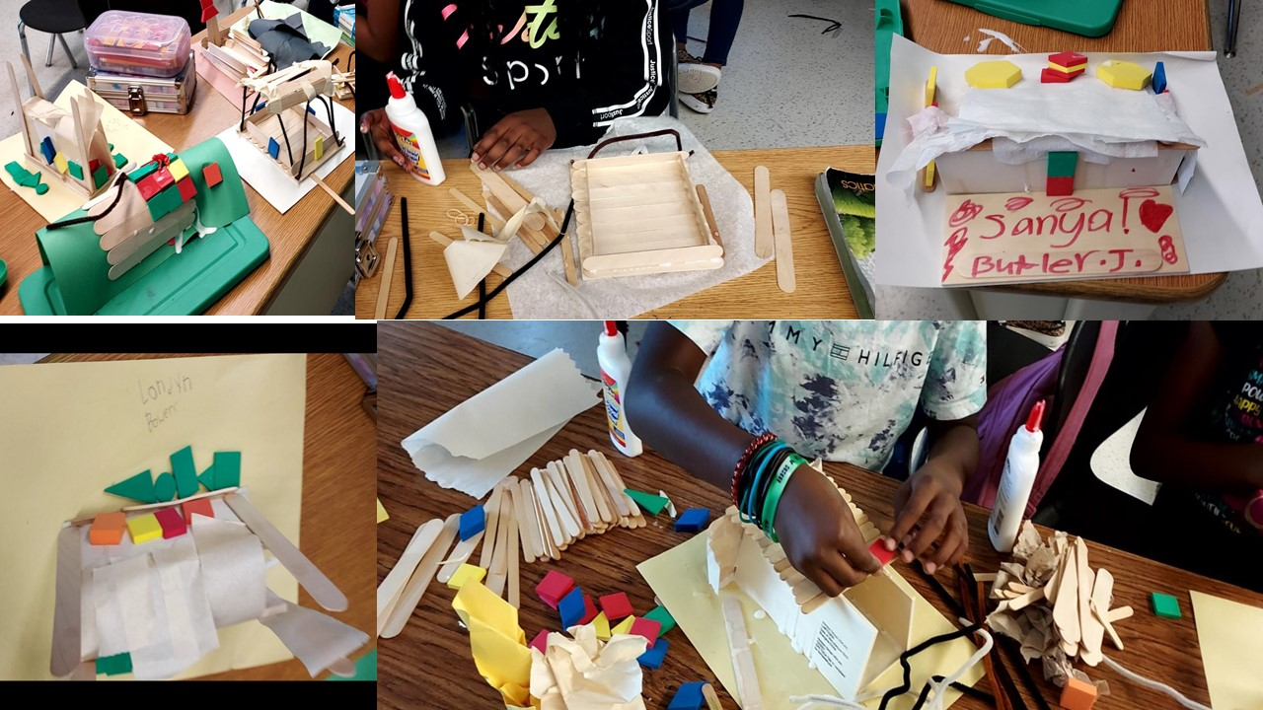
**Scroll Down for Unit Standards**

Unit Standards:

ELA:

Math:

Science:

Social Studies:

