Grade Level:4th Dates: October 13th- November 30th
School Information  School: Copeland Elementary  School Code: 060043  Teachers: David, Jennings, Nelson  Buffer: * (Thanksgiving Break: November 22nd- November 26th) | Transdisciplinary Theme: How We Organize Ourselves  Segment of Theme: Societal decision-making  Over Arching Concept: Causation
Section 1: Overview
- Central Idea: Societal decisions create structure.
- Key Concepts: Causation, Function, Change
- Guiding Related Concepts: | - Lines of Inquiry: | - Teacher Questions (Guided Questions):
Identity  Cooperation  Transformation | Societal decisions influence the way things function.  Our country is impacted by societal decisions.  In a society, responsibility leads to structure. | DOK Level 3 & 4  Can you conclude that the Constitution could have been written without compromise?  Can you provide evidence to show that compromise was essential to creating the United States Constitution?  Can you create a model to show the roles of organisms and the flow of energy within an ecosystem?
- Prior Content Knowledge: | - Assessing the Lines of Inquiry:
Students should have prior knowledge of The American Revolution and The Declaration of Independence.  Students will utilize the wonder wall in the classroom to share what they know, what they want to know and what they learned about Organisms. | How will you assess student’s understanding of the lines of inquiry?  - Graphic Organizer: Complete graphic organizer to outline the challenges faced by the framers of the Constitution.  - Informative Writing Assignment: Students will write informative journals about the framers of the Constitution, and the major issues debated at the Constitutional Convention.  - Mini day group projects: Students will develop a model to describe the roles of producers, consumers, and decomposers in a community, and simple models to illustrate the flow of energy through a food web/food chain.
- Concept Based Summative Assessment: | - Targeted Approaches to Learning (highlight 3): | - Targeted Learner Profile Attributes (highlight 2):
- Broken pieces activity: Teachers will break up the Central Idea into words/ phrases on chart paper. Students will walk around writing down in their own words what the word/ phrase means to them. After the activity, students will share what the Central Idea means to them in their journals. | Social Skills, Research Skills, Communication Skills. Thinking Skills, Self-Management Skills | well-balanced, caring, principled, open-minded, risk taker, knowledgeable, communicator, reflective, thinker, inquirer
Section 3: What Assessments will be provided in this unit of inquiry?
- Pre-Assessments:  What assessment will be given at the beginning of the unit to inform current understanding | - Formative Content Based Assessments:  What assessments will be given to monitor student learning of content? | - Summative Content Based Assessments:  What assessments will be given for students to show mastery of unit content?
-Canvas Pre-assessments  -I-ready | - Exit tickets – Students will complete a graphic organizer to show the flow of energy through a food web/food chain beginning with sunlight and including producers, consumers, and decomposers.  - 3-2-1 prompt – Students will list 3 things they learned about the Organisms, 2 things they want to learn more about, and 1 question they have.  - Brochure: Students will create a brochure to identify the major leaders of the Constitutional Convention  - Quizzes – given weekly to assess students learning of the Constitutional Convention and Organisms. | Constitutional Convention Collaborative Inquiry project: SS4H2a-b  Students will work in groups to research the challenges faced by the framers of the Constitution. The groups will then create an activity for other students to learn about the challenges. Students will create a poster to explain their challenge and present to the class.  Ecosystems Collaborative Inquiry project: S4L1  Students will work together in groups to research and create models describe the roles of organisms and the flow of energy within an ecosystem.
Section 4: How will we Facilitate Learning?
- Provocation:  How will interest into this unit be sparked? | - Learning Experiences:  What activities/experiences will help facilitate the learning? | - Evidence of Differentiation:  How will the learning experiences be adjusted to different learning styles/abilities?
- Virtual Fieldtrips: The Constitutional Virtual Tour: Teacher will display the virtual field trip for students to view. (Essential Question: What were the major events in the development of the Constitution?)  - Flipped Classroom: “Court Room” for the Great Compromise. Students will be divided into teams to research their side; students will then come to court to have a debate. (Essential Question: How was compromise essential to creating the United States Constitution?)  - Nature walk around the school: Teacher will take students outside and ask them to look for producers, consumers, and decomposers in our school community.  - Virtual Fieldtrip: Share video “Wolves of Yellowstone” for students to get understanding of the roles of organisms. After stopping at second 40, answer the question you heard the narrator ask. How do you think it is possible that reintroducing the wolves to Yellowstone National Park had such a large impact on the landscape there? (Reassure students that they are just making a prediction about what they think happened and that we will be learning about the “Why” and “How” through this unit). | Week1: Social Studies:  Standards: SS4H2 Analyze the challenges faced by the framers of the Constitution. a. Identify the major leaders of the Constitutional Convention (James Madison, George Washington, and Benjamin Franklin).  Provocations:  - Build a structure: Students will be placed into random groups. Teacher will give each group random items. The students will have to make decisions together to create a stable structure.  - Artifacts: Students will pair together, plan and create mini Classroom Constitutions on DIY stroll paper. (Essential Question: Could the Constitution be written without compromise?)  - Virtual Fieldtrips: The Constitutional Virtual Tour: Teacher will display the virtual field trip for students to view. (Essential Question: What were the major events in the development of the Constitution?)  Activities:  - International Connection: How has the US Constitution influenced other countries? Share Constitutions from around the world, then have students fill out a Venn diagram comparing a country of their choice to the United States. ( https://www.constituteproject.org/search?lang=en )  - What Do You Think? Put a T if you think the sentence is true, and an F if you think the sentence is false.  ___F___ The Constitution listed the reasons why people were upset with England and wanted to be free. The Declaration of Independence did that. The Constitution is a plan that created and guides our government. ___F__ George Washington is called the “Father of the Constitution.” George Washington is called the “Father of our Country.” James Madison is called the “Father of the Constitution.”  ___T___ The Constitution has seven parts, called articles.  ___T___ The Constitution divided the government into three branches: executive, legislative, and judicial.  ___F___ The Constitution was signed on July 4, 1776. The Declaration of Independence was signed on that date. The Constitution was signed on September 17, 1787.  ___T___ The Constitution can be changed. Changes to the Constitution are called amendments.  - Preamble Match Activity: Have students complete this activity to help them better understand the Preamble. Teacher will have mix up the words of the Preamble, students will work together to put it back together.  Week 2: Social Studies:  Standards: SS4H2 Analyze the challenges faced by the framers of the Constitution b. Evaluate the major issues debated at the Constitutional Convention: the weaknesses of the Articles of Confederation, the rights of states to govern themselves (federal system), the Great Compromise, and slavery (Three-Fifths Compromise).  Provocations:  - Documents: In groups, students will break down the Articles of Confederation into their own words. Students will then place their summaries on large DIY stroll paper. (Essential Question: In what ways did the Constitution address the problems with the Articles of Confederation?)  - Mock Election: Students will participate in a mock election, using voting tickets with the actual candidates’ names. (Essential Question: Should government reflect the will of the people?)  - Letters: Students write letters to the local government (principal) expressing a concern that they have in their city (school) and changes they want to bring to the school. (Essential Question: How does the federal system meet the needs of all citizens?)  Activities:  - Election knowledge: Students will watch videos on voting and elections. Student will then complete a discussion post on Canvas.  - Journal Writing: Students will write a list of fictional characters they think would make a good president. These characters can be from favorite books, television, comics, video games, etc. Next to each name, have students list one or more IB Learner Profile attribute of that character that would make him or her a good leader. Ask students to put a star next to the character who would be their first choice for president.  - The Aftermath of the 2020 Election: After an election, examine the results as a class, specifically those from your community. Discuss implications of new policies or elected leaders. Then look at election results throughout the country to give students a national picture.  Week 3: Social Studies:  Standards: SS4H2 Analyze the challenges faced by the framers of the Constitution b. Evaluate the major issues debated at the Constitutional Convention: the weaknesses of the Articles of Confederation, the rights of states to govern themselves (federal system), the Great Compromise, and slavery (Three-Fifths Compromise).  Provocations:  - Plays/Reenactments: Students will plan, practice and present the stage play. “Shh! We’re Writing the Constitution” (Essential Question: What is the basic structure of the Constitution?)  - Flipped Classroom: “Court Room” for the Great Compromise. Students will be divided into teams to research their side; students will then come to court to have a debate. (Essential Question: How was compromise essential to creating the United States Constitution?)  Activities:  - Weaknesses of the Articles of the Confederation Hand:  - Becoming an American https://wethepeople.scholastic.com/etc/classroom-magazines/reader.html?id=800-000001  Week 4: Science:  Standards: S4L1. Obtain, evaluate, and communicate information about the roles of organisms and the flow of energy within an ecosystem. a. Develop a model to describe the roles of producers, consumers, and decomposers in a community  Provocations:  - Nature walk around the school: Teacher will take students outside and ask them to look for producers, consumers, and decomposers in our school community.  - Virtual Fieldtrip: Share video “Wolves of Yellowstone” for students to get understanding of the roles of organisms. After stopping at second 40, answer the question you heard the narrator ask. How do you think it is possible that reintroducing the wolves to Yellowstone National Park had such a large impact on the landscape there? (Reassure students that they are just making a prediction about what they think happened and that we will be learning about the “Why” and “How” through this unit).  Activities:  - Class Discussion: After completing “What is an ecosystem” PowerPoint. Have students think individually first and fill out the “I Think” section on a graphic organizer. Give them the chance to write their initial ideas about what they already know about ecosystems. Then ask students to turn to their elbow partner and share their thinking with one another. Once they do have them work together to create a statement under the column “We think”.  Week 5: Science:  Standards: S4L1 b. Develop simple models to illustrate the flow of energy through a food web/food chain beginning with sunlight and including producers, consumers, and decomposers.  Provocations:  - What eats what online game.  Activities:  - Food web and Food chain activity: Students will complete the chain/web by selecting the missing component:  http://projects.plattebasintimelapse.com/prp_a/food_chain.html  Week 6: Science:  Standards: S4L1 c. Design a scenario to demonstrate the effect of a change on an ecosystem. d. Use printed and digital data to develop a model illustrating and describing changes to the flow of energy in an ecosystem when plants or animals become scarce, extinct or overabundant.  Provocations:  - Show photographs of most polluted places http://www.thedailybeast.com/articles/2010/05/19/americas-28-most-polluted-places.html  - https://www.youtube.com/watch?v=BRGrI4AQG70 Why are all the Bees Dying?  - https://www.youtube.com/watch?v=_pVpLMBZ3IY (9 Facts about Bees- pull up before turning on projector!!)  - https://www.youtube.com/watch?v=fiHLwwyAn8U (The Impacts of Pollution on Animals…)  Activities:  - Find the Bee Tik-Tok expert video to show students.  - Independent Research Project on Bees: students will be free to choose their own topic as it relates to bees and the flow of energy in an ecosystem. Students will research, create a visual model and present their work.  - Letter: Write a letter to the community about the bees and what the community can do to fix it. | -Leveled Readers  -Stations based on ability  -ReadWorks differentiated passages  -Social Studies Weekly Videos
- Learning Experiences in Specials:  How are Specials Courses able to connect to this unit? | - Local/National/Global Connections:  How can we connect the content to local/national/global issues? | - Student Action:  What learning experiences support potential student-initiated action?
Art  Students are learning about the artist Hokusai. In Hokusai’s artwork, he depicts what life looked like in Japan while he was alive, and we get a glimpse into the past and how people use to live. We will discuss future advancements and how these compare to technologies of the present. | We can connect the content to local/national/global issues by having students:  - Students will research the major issues being debated around the world today. Students will find what they believe are the weaknesses and come up with solutions.  - Students research ecosystems in other countries and then will describe changes to the flow of energy in the ecosystem when plants or animals become scarce, extinct or overabundant. | - Mock Election: Students will participate in a mock election, using voting tickets with the actual candidates’ names.  - Independent Research Project on Bees: students will be free to choose their own topic as it relates to bees and the flow of energy in an ecosystem. Students will research, create a visual model and present their work.  - Letter: Write a letter to the community about the bees and what the community can do to fix it.  - Write a letter to the Principal expressing a concern students have about their school or students will write a letter expressing new initiatives they want to bring to the school. Example: School store.
- Student Agency and Play:  What learning experiences provide students with voice, choice and ownership? What play opportunities will be provided by Kindergarten/Pre-K? hands on/STEAM for K-5? |  | - Resources:  Which resources will you and the students use? This may include people, places, technologies, learning spaces and physical materials.
All of these learning experiences will allow students to take ownership of their learning and have a voice:  -Play/ Reenactment: Shhh! We’re Writing the Constitution.  -Flipped Classroom: Courtroom  -Nature walk: Producers, consumer, decomposers  -Letter: Bees |  | -Laptops  -Social studies weekly  -I-ready  -Read works  -Myon  -BrainPOP  -Media Center  -Art Class
Section 5: Reflection (Write the year, change font color for each year)
- Reflect on learning experiences:
David- The students really enjoyed the learning experiences that were presented in this unit. My students really liked the Nature walk & were able to apply what they were learning about producers, consumers, and decomposers into context. The students also really enjoyed the mock election interview.

Nelson- The students were able to experience great learning opportunities. The students enjoyed the activities that were created to make the connections to their new and prior learning. I believe that their favorite experience was the virtual field trip to the Yellowstone National Park.

Jennings- The understudies had the option to encounter extraordinary learning openings. The understudies partook in the exercises that were made to make the associations with their new and earlier learning. I really think the kids love this unit 2 so far.
- How were the tasks differentiated to meet different learning styles? |  | - How did the learning experiences and strategies we used throughout the unit help to develop and show students understanding of the central idea?
David- I was able to differentiate the task to meet my students different learning styles by creating rigorous assignments for to challenge my above learners, and creating assignments that suited my learners that needed additional support.  Nelson- I was able to differentiate to meet the different learning styles by focusing on the needs of my expectational students. While planning an carrying out this unit I made that activities planned would work for my Speech, IEP, 504, Gifted and ELL students. I created more rigor where it was needed and made activities less rigorous for certain students as well. We included learning experiences that were for visual, auditory, kinesthetic, and reading/ writing learners.  Jennings- While arranging a completing this unit I made those exercises arranged would work for ELL understudies. I made more thoroughness where it was required and made exercises less thorough for specific understudies too. We included learning encounters that were for visual, hear-able, sensation, and perusing/composing students. |  | David- Students were able to show their understanding of the central idea by the provocation and throughout the various learning activities such as: Creating class constitution, letters to the community, and during mock elections. All of these allowed students to work with their peers to help them understand how societal decisions create structure.  Nelson- Students were able to show their understanding of the Central Idea. The students understood that societal decisions create structure. We began the unit by having students to use materials to create a standing structure. Students had to make decisions together to create the structure. We then made the connection to the Central Idea.
- What learning experiences best supported students’ development and demonstration of the attributes of the learner profile and approaches to learning? |  | - How effective were the summative assessments in measuring student learning? What, if any, changes need to be made to the assessments?
David- Some of the learning experiences that supported students development with demonstrating learning profiles and approaches of learning:  Communication: Students has to communicate with their peers to create class constitution and Consequences.  Research: The students has to use research skills for their summative assessments and to learn about the constitution.  Thinking: The students had to use their thinking skills to write Dr.Taylor about the concerns they had regarding the school.  Nelson- The learning experiences that best supported the student’s development and demonstration of the attributes of the learner profile and the approaches to learning were:  Approaches to Learning:  - Research: Students used research skills to determine how The US Constitution influenced other countries’ constitution.  - Communication: Students were communicators when they collaborated with classmates during the  - Thinking: Students were thinkers throughout this unit as they used inquiry to explore the content.  Learner Profiles:  - Causation: Why is it like this?  - Function: How does it work?  - Change: How is it changing? |  | David- The summative assessments used to assess students learning were appropriate and no changes need to be made. In the summative assessments showed that  they understood by taking the broken pieces and at the end explaining what the central idea in their own words.  Nelson- The students were able to take the “broken pieces” and explain what the Central idea in their own words.  Jennings- Students were able to summarize the unit and central idea in their own words.
- What student-initiated inquiries (questions) arose from this unit of inquiry? |  | - What student action arose from this unit of inquiry?
David- Questions that arose from the unit of inquiry when talking about the constitution:  - Why has there never been a girl president ?  2. Can you be old and run for president like 90 ?  - If a leaf is on the ground is it considered a producer or decomposer ?  Nelson:  - Why were they at the Convention so long?  - Are ants consumers or decomposers?  - How does the sun give plants energy?  Jennings-  - What were they thinking when they created the Articles of Confederation?  - Why are people consumers? |  | David- Students were able to take action in this unit by creating the class constitution and coming up with the consequences. Also, by writing their letters to express their concerns to Dr.Taylor about the concerns they have about the school. The students also demonstrated action when they did the nature walk.  Nelson: Students investigated the student initiated question: “Are ants consumers or decomposers”?  Jennings- My students were able to show action during our nature walk. They were able to take what they learned about taking what they learned about producers, consumers, and decomposer to find for each of these categories.
- Any additional notes or changes that need to be considered next year?
David-I think we need to plan fewer learning activities next year so we can ensure that we get to do each activity. There were a few learning experiences we did not get to. The unit went longer than expected.

Nelson- I would suggest making this unit longer by 2 weeks.

Jennings- I think that we would benefit by making this unit longer.

Section 6: Picture Evidence
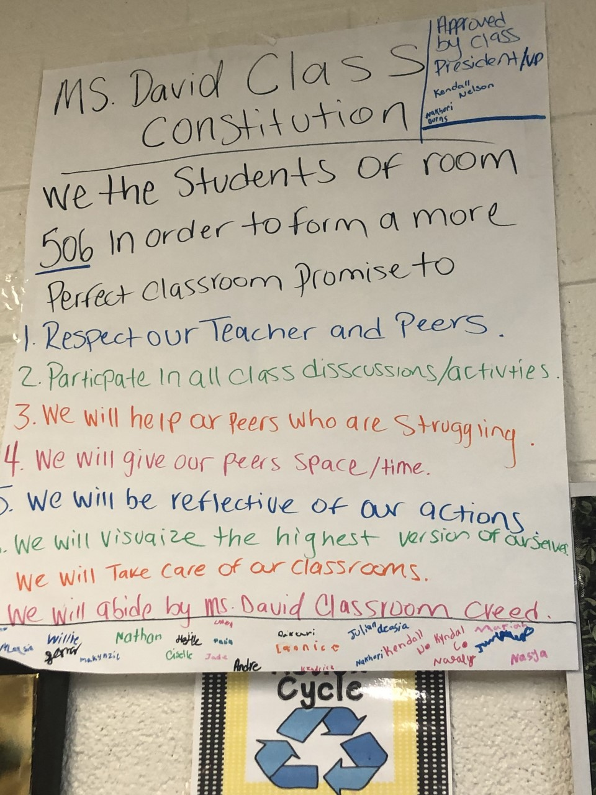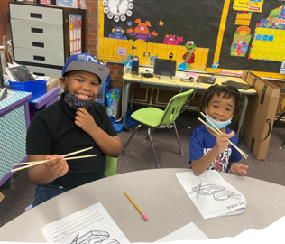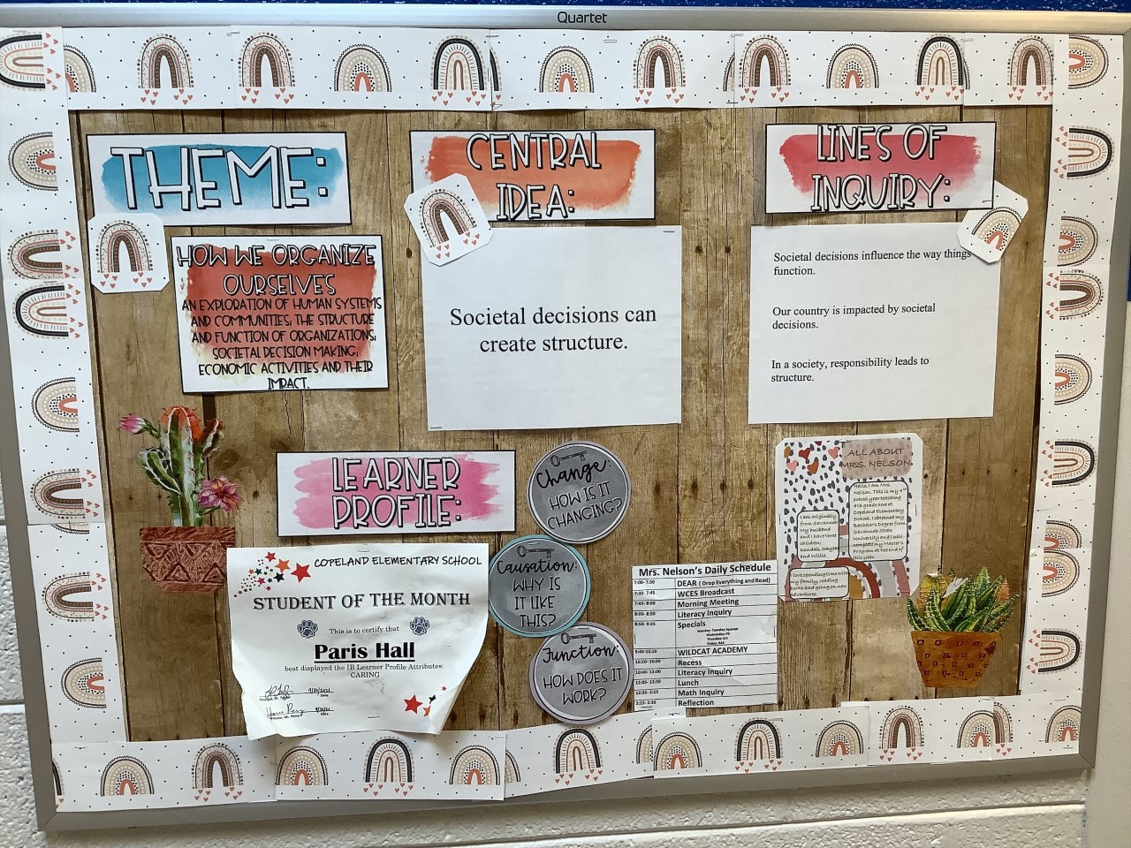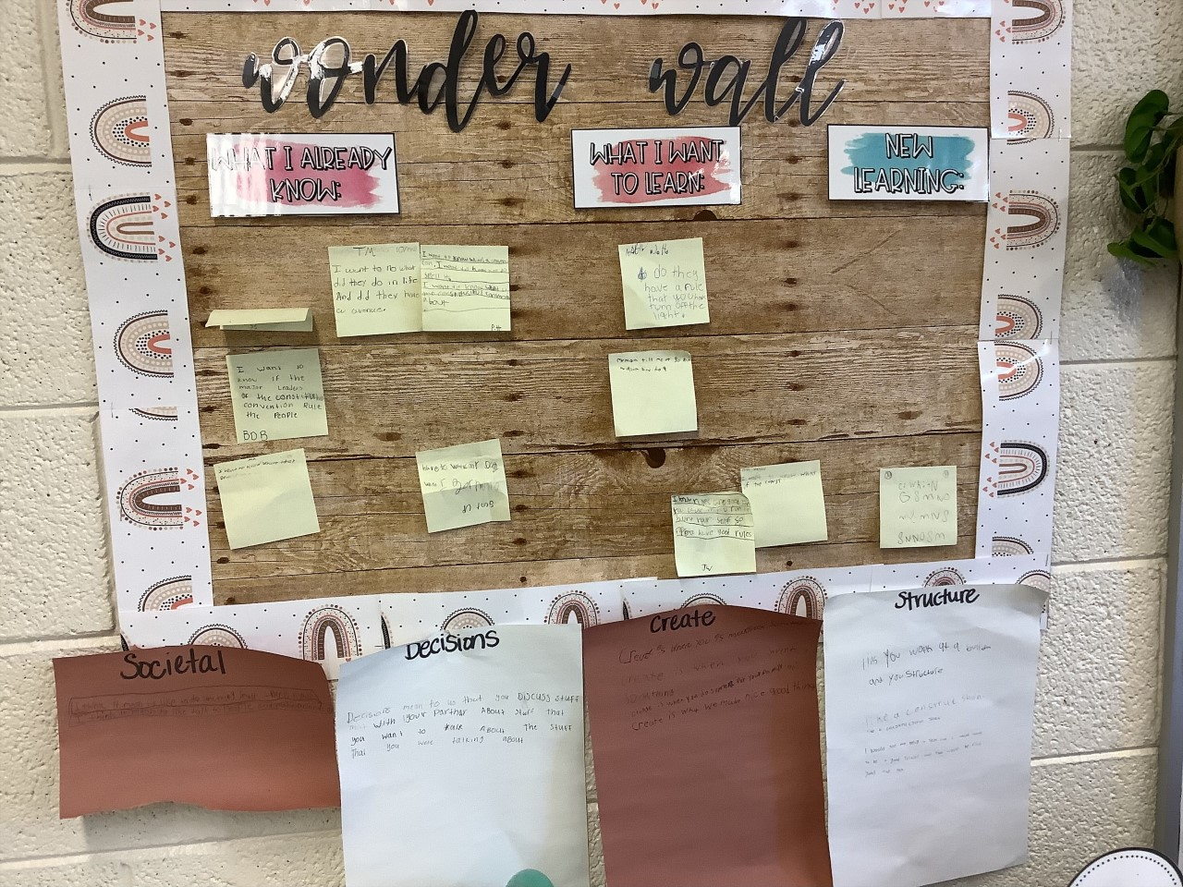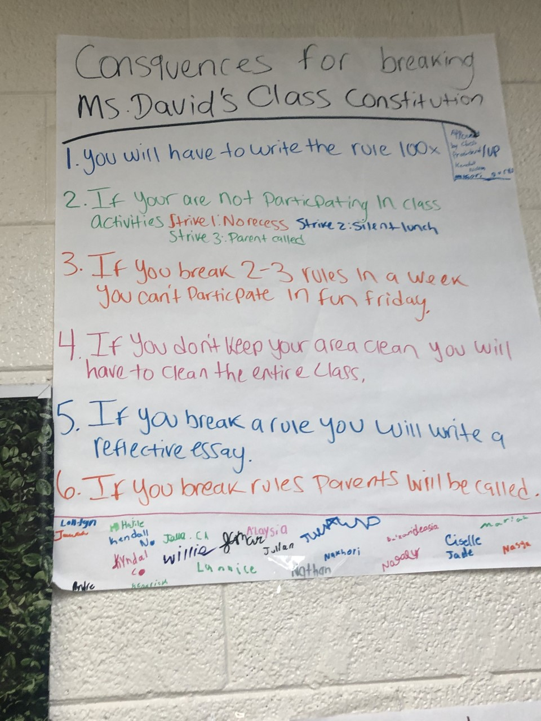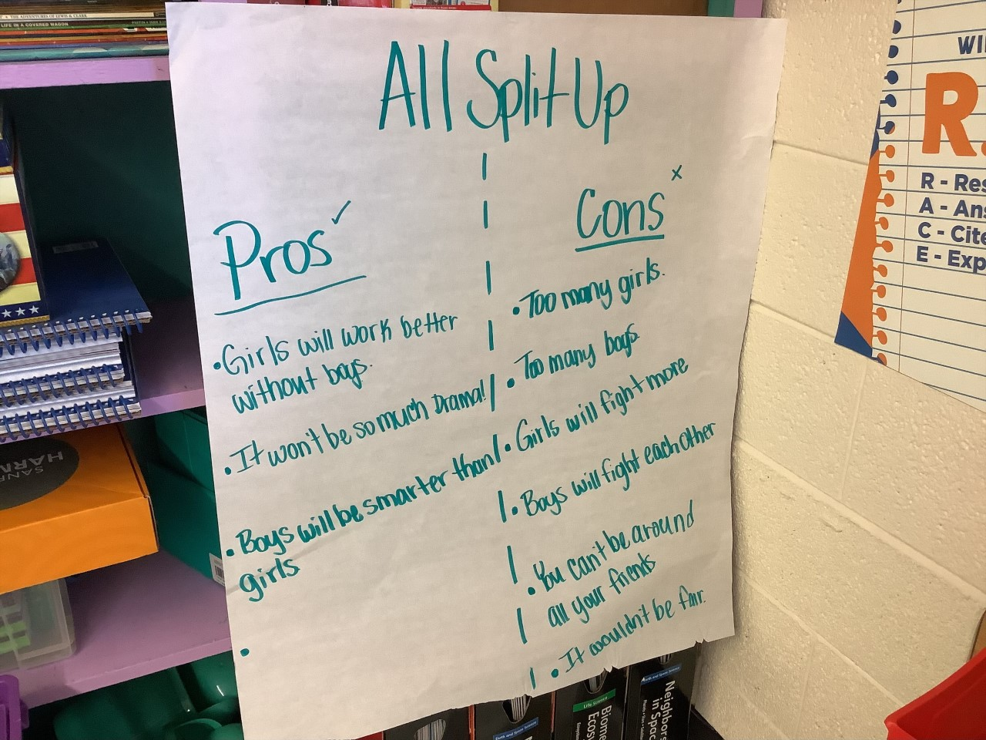

**Scroll Down for Unit Standards**

Unit Standards:

ELA:
4RL2: Theme

4RI3 – Events/Procedures/Ideas
4W2 – Informative Text

Math:
4.OA.3- Multistep word problems
4.NBT.5- Multiply a whole number of up to four digits by a one-digit whole number, and multiply two two-digit numbers
4.NBT.6- Find whole-number quotients and remainders with up to four-digit dividends and one-digit divisors
4.NF.2- Multiply a fraction by a whole number

Science:
S4L1 – Roles of Organisms

Social Studies:
SS4H2 – Constitution

