Westside High School - Weekly Plan to Align Lessons (Week At a Glance) – 2024-25
Teacher: Jennifer Bass Subject: ELA Course: Grade: 9th Date(s): 4/28-5/2
Standard: ELAGSE9-10W2 Write informative/explanatory texts to examine and convey complex ideas, concepts, and information clearly and accurately
ELAGSE9-10W2.a Introduce a topic; organize complex ideas, concepts, and information to make important connections and distinctions; include formatting (e.g., headings), graphics (e.g., figures, tables), and multimedia when useful to aiding comprehension. Through the effective selection, organization, and analysis of content.
ELAGSE9-10W2.b Develop the topic with well-chosen, relevant, and sufficient facts, extended definitions, concrete details, quotations, or other information and examples appropriate to the audience's knowledge of the topic.
ELAGSE9-10W4 Produce clear and coherent writing in which the development, organization, and style are appropriate to task, purpose, and audience. (Grade-specific expectations for writing types are defined in Standards 1–3 above.)
ELAGSE9-10W6 Use technology, including the Internet, to produce, publish, and update individual or shared writing products, taking advantage of technology's capacity to link to other information and to display information flexibly and dynamically.
ELAGSE9-10W7 Conduct short as well as more sustained research projects to answer a question (including a self-generated question) or solve a problem; narrow or broaden the inquiry when appropriate; synthesize multiple sources on the subject, demonstrating understanding of the subject under investigation.
ELAGSE9-10W8 Gather relevant information from multiple authoritative print and digital sources, using advanced searches effectively; assess the usefulness of each source in answering the research question; integrate information into the text selectively to maintain the flow of ideas, avoiding plagiarism and following a standard format for citation.
Assessment: ☐ Quiz ☐ Unit Test ☒ Project ☐ Lab ☐ None ☐ Essay
 | Learning Target  (What) | Opening  (10 - 15 Mins) | Work-Session  (20 - 25 mins) | Closing  (5 - 10 mins) | Criteria for Success  (How)
 |  | (Include at least one/two Formatives*in any part of the lesson as needed)
Monday | Testing Schedule (1,5,6)  No Freshman Classes | Testing Schedule (1,5,6)  No Freshman Classes | Testing Schedule (1,5,6)  No Freshman Classes | Testing Schedule (1,5,6)  No Freshman Classes | ☐ I can research information about a country outside of the United States.  ☐ I can answer questions about a country using research.  ☐ I can keep track of the websites I use for research.  ☐ I can organize my information into a presentation.  Tool(s) for Success Criteria:  ☐ Rubric  ☒ Self-Assessment  ☒ Checklist  ☐ Peer Assessment  ☐ Exemplars/Non-Exemplars  ☐ Other: _______________
Tuesday | I am learning how to do research. | Testing Schedule (1,5,7)  Read the following quote. What are your thoughts?  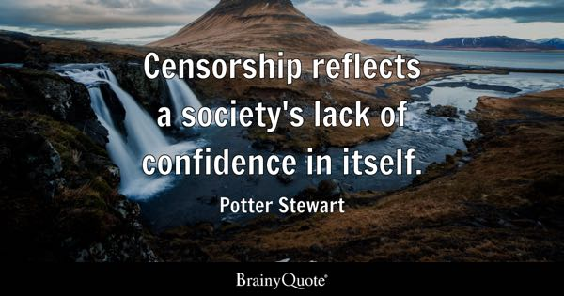 | Work on project | How does your country censor information?
Wednesday | I am learning how to do research. | What percentage of your project is done? | Finish project (due at the end of class) | What is one new thing you learned from doing this project?
Thursday | I am learning how to use my time to complete assignments. | Read the following quote and answer the question.  What does this quote mean? Provide an example to support your thought.   | Work on missing assignments | Are you currently passing?
Friday | I am learning how to use my time to complete assignments. | What do you need to complete in class today to be passing? | Work on missing assignments  All missing assignments are due Monday, May 6! | Reminder, all missing assignments are due Monday!
Formatives *☒ Exit Ticket/Final Stretch Check ☐ Quick Write ☐ Dry Erase Boards – quick checks ☒ Think-Pair-Share ☐ Clip-board ☐ I-Chart ☐Concept Chart ☐ Other:
Literacy Strategies ☐ Anticipation Guide ☐ Extended Writing ☐ Socratic Seminar ☐ Jigsaw ☐ Thinking Maps ☐ Fishbowl ☐ World Cafe ☐ Interactive Note-book ☐ Other:

