Grade Level: PK Dates: 10/13-11/19
School Information  School: Copeland Elementary  School Code: 060043  Teachers: Hanley, Godbee  Buffer: November 19th – January 10th | Transdisciplinary Theme: How We Express Ourselves  Segment of Theme: Feelings, express ideas, beliefs and values  Over Arching Concept: Creativity
Section 1: Overview
- Central Idea: Visual art is a tool to create and express ideas.
- Key Concepts: Connection, Causation, Perspective
- Guiding Related Concepts: | - Lines of Inquiry: | - Teacher Questions (Guided Questions):
cultures  expression  creativity  Visual Art  Folk songs and dances | Different cultures create different types of art.  People express themselves in different ways.  Art has different meanings for different people. | DOK Level 3 & 4  - What traditions does your family have? (birthdays, holidays, etc.)  - How many different traditions do we do at school?  - What do you think a tradition is?  - What kind of art do you see around the holidays?  - What the word “art” means to you?  - What are different ways of expressing ourselves?  - How does art have different meanings for different people?
- Prior Content Knowledge: | - Assessing the Lines of Inquiry:
Music time in the classroom, drawing pictures, collages, clothing and art likes and dislikes. | How will you assess student’s understanding of the lines of inquiry?  - KWL chart on traditions  - Discussions on traditions  - Using different materials to create an art project in class.  - Demonstrating different dances in different cultures  - Matching game- matching traditions to a specific holiday
Section 2: What Are Our Target Goals?
- Concept Based Summative Assessment: | - Targeted Approaches to Learning (highlight 3): | - Targeted Learner Profile Attributes (highlight 2):
- Grab and go art- setting out supplies and having the children create an art piece and explain what they made.  - Interpret Dancing to express ourselves  - Art work interpretation project | Social Skills, Research Skills, Communication Skills. Thinking Skills, Self-Management Skills | well-balanced, caring, principled, open-minded, risk taker, knowledgeable, communicator, reflective, thinker, inquirer
Section 3: What Assessments will be provided in this unit of inquiry?
- Pre-Assessments:  What assessment will be given at the beginning of the unit to inform current understanding | - Formative Content Based Assessments:  What assessments will be given to monitor student learning of content? | - Summative Content Based Assessments:  What assessments will be given for students to show mastery of unit content?
- KWL chart on ways to express ourselves  - Read Same Same but Different and discuss what happens in the book  - Draw a picture and discuss how your picture is art  - Matching game on holidays (to see what the students know about the holidays) | - Painting Pumpkins  - Paper Plate Turkey project  - Ms. Mahon (Art Teacher) will come to the classroom to do an art project with the students.  - Daily read alouds on Family Traditions and Holidays / Discussion  - What We Wear by Maya Ajmera read aloud / book discussion  - Classroom observations of students during centers using art materials  - Virtual field trip to an art museum- What was your favorite art piece? (Discussion) | Through students’ journaling about their favorite celebration, teachers will assess understanding of various holidays and customs.  Through class discussions students will demonstrate an understanding that celebrations are based on events that happened long ago.  Through the study of celebrations teachers will observe students’ use of newly acquired vocabulary (i.e. names of food items, artifacts, dances, historical people, and events)  Students are able to connect artifacts, music, crafts, and food to the corresponding region or cultural celebration
Section 4: How will we Facilitate Learning?
- Provocation:  How will interest into this unit be sparked? | - Learning Experiences:  What activities/experiences will help facilitate the learning? | - Evidence of Differentiation:  How will the learning experiences be adjusted to different learning styles/abilities?
Provocation – The teacher will share pictures of children showing different types of emotions.  Students will have the opportunity to share their personal emotions.  Provocation: Teachers model the importance of sharing and how to use art materials in centers.  Questions:  - What traditions does your family have? (birthdays, holidays, etc.)  - How many different traditions do we do at school?  - What do you think a tradition is?  - What kind of art do you see around the holidays? | Week 1:  Provocation – The teacher will share pictures of children showing different types of emotions.  Students will have the opportunity to share their personal emotions.  Students will draw a picture of a emotion of their choice. The teacher will label the picture of the student’s emotion based on the student’s description.  Students discussed emotions and why do we have emotions.  Read alouds once a day connected to the unit – Emotions  123 My Feels and Me, The Emotions book;A Little Story, Theo’s Mood, The Way I Feel, and When I am Angery  Week 2:  Provocation: Teachers model the importance of sharing and how to use art materials in centers.  Students will paint a pumpkin and use art materials to create an art project.  Students will engaged in a virtual field trip to an art museum. https://www.youtube.com/watch?v=mQMlZHpo6w0  Read alouds once per day connected to Visual Arts  The Day the Crayons Quit, I Am An Artist, Mouse Paint, Scribble Stones, Not A Box  Week 3:  Virtual Field Trip – Types of Dances from Around the World- https://www.youtube.com/watch?v=jYG3s6Iu-SI  In House Field Trip- Mr. Brown teaching the students how to do dance like the Copeland Wildcats step Team  Read alouds once a week related to dance – How Do You Dance, Giraffes Can’t Dance, Jingle Dancer, Nutcracker  Week 4:  Students learned how appearance can be used to express oneself.  Students will use the home living center to explore how to use clothing and accessories to express oneself.  Read alouds once a week about appearance:  Clothes and Many Cultures, Let’s Celebrate, What We Wear, Hair Love, Marvelous Me  Week 5  Teachers will expose students to types of celebrations, customs, artifacts, foods, and songs through literature and short videos.  Teachers will introduce unit vocabulary such as celebration, food names, clothing items, culture, people groups, tradition/customs, harvest, religion/beliefs, names of cultural objects pertaining to each celebration.  International celebrations such as Rosh Hoshana, Ramadan, Halloween, Dia de los Muertos, Diwali, Kwanzaa, Hanukkah, Christmas, Las Posadas, Chinese New Year, Passover, Easter, Valentine’s Day, St. Patrick’s Day, Mother’s Day, Kodomo No Hi (Japanese Children’s Day), Cinco de Mayo, Earth Day, Independence Day, etc. Customs will be studied using artifacts, books, foods, music and dance. | Para will be available to assist as needed – Small group and one on one assistance.  Additional time can be set aside for students who need it  Modifications to assignments as needed
- Learning Experiences in Specials:  How are Specials Courses able to connect to this unit? | - Local/National/Global Connections:  How can we connect the content to local/national/global issues? | - Student Action:  What learning experiences support potential student-initiated action?
Visual Art in the Classroom:  Art Center  Special’s Center | Display local artists work  Invite a local artist to visit  Discuss art that brings awareness (climate change, poverty, hunger)  Virtual Field Trip | Students paint their own art pieces  Students create an art piece that is meaningful to them
- Student Agency and Play:  What learning experiences provide students with voice, choice and ownership? What play opportunities will be provided by Kindergarten/Pre-K? hands on/STEAM for K-5? |  | - Resources:  Which resources will you and the students use? This may include people, places, technologies, learning spaces and physical materials.
Art center- materials to create self regulated art  Dress up center- clothing that represents self expression  Science center- litter to use for art projects  Library center- books- I am Enough, The way I Feel, Anywhere Artist, I ain’t gonna paint no more,A line is a dot that went for a walk, let’s paint |  | Art Museum field trip- https://www.youtube.com/watch?v=mQMlZHpo6w0  Maybe Something Beautiful- https://www.youtube.com/watch?v=nL5TzKaDXzA  Arthur’s Birthday- story Book  Holiday songs-YouTube  Line Dances- YouTube  Chart Paper  Markers  Paper  Promethium Board  Art materials (glue, stickers, form pieces, and collage materials)
Section 5: Reflection (2021-2022)
- Reflect on learning experiences:
Godbee-The students enjoyed listening to stories about emotions and making pumpkin pictures about their feelings. The students learned what to do when they are feeling sad (look at a picture of their family), mad ( stomp it out like a dinosaur), happy ( do the happy dance) and afraid ( hold a teddy bear). The students also learned a lot at the art museum and how different materials can be used to create art. The students enjoyed learning how to do simple step moves from Mr. Brown.

Hanley- The students enjoyed learning about different traditions from our classmates and how students from around the world do holidays. The students learn that art comes in many designs, forms, and shapes by going a virtual tour of an art museum. The students participated in discussions and drawing pictures on how we feel when we are happy, sad, mad, and afraid. The students also learn that dancing is a form of a way to express ourselves.
- How were the tasks differentiated to meet different learning styles? |  | - How did the learning experiences and strategies we used throughout the unit help to develop and show students understanding of the central idea?
Godbee- We used pre-cut out pumpkins for the students who could not cut their pumpkin out. Materials to use to make their emotional pumpkin was place in small bins so the students had access to their own supplies.  Hanley- Materials were pre-cut for students to draw faces on how they were feeling for the day. Pictures of children being happy, sad, mad, and afraid were place around the room, so children could see the emotions that the teacher was discussing. |  | Godbee- The learning experiences helped the students learn that the word “Art” is just not drawing a picture, but how we express ourselves through music, dance, and how we dress. The students got a chance to experience drawing a picture, making collages, dressing in different clothes, and learning different dances.  Hanley- The learning experiences from this unit really engage the children’s learning about having them experience open-ended art projects, virtual tour of a museum, and learning dances from other cultures.
- What learning experiences best supported students’ development and demonstration of the attributes of the learner profile and approaches to learning? |  | - How effective were the summative assessments in measuring student learning? What, if any, changes need to be made to the assessments?
Godbee- Expressing our feelings by talking about how we feel and drawing a picture that reflects that feeling. Going on a virtual tour at an art museum looking at all the different types of art work.  Hanley- Setting up dramatic play as a dance studio with different kind of clothes and playing different type of music so the students could freestyle dance. Going on a virtual tour at an art museum and making an art project with Ms. Mahon (Art teacher). |  | Godbee/Hanley- The summative assessments were effective because the students were able to add to the KWL chart weekly and if questions arose during the week, we added those questions to our charts. The journaling or drawing pictures of our experiences d really during the course of this unit really showed how the students learned from the experiences that were represented to them. The matching celebrations showed us what the students knew prior to going into the unit and at the end of the unit we did the matching game again to show what we learn about different celebrations.
- What student-initiated inquiries (questions) arose from this unit of inquiry? |  | - What student action arose from this unit of inquiry?
Godbee-  How can trash be art?  Do all types of people have their own kinds of dances?  Do everyone celebrates with parties?  Hanley-  What does afraid mean?  What kind of dances do they do in Mexico?  Do you have use paint to make art? |  | Godbee- Students starting creating their own dance moves. They also started dressing in different dramatic play clothes to come up with different styles of dressing.  Hanley- Students created collages out of materials recyclable materials that were in the classroom. Students also came up with dances to do during music time.
- Any additional notes or changes that need to be considered next year?
Section 6: Picture Evidence
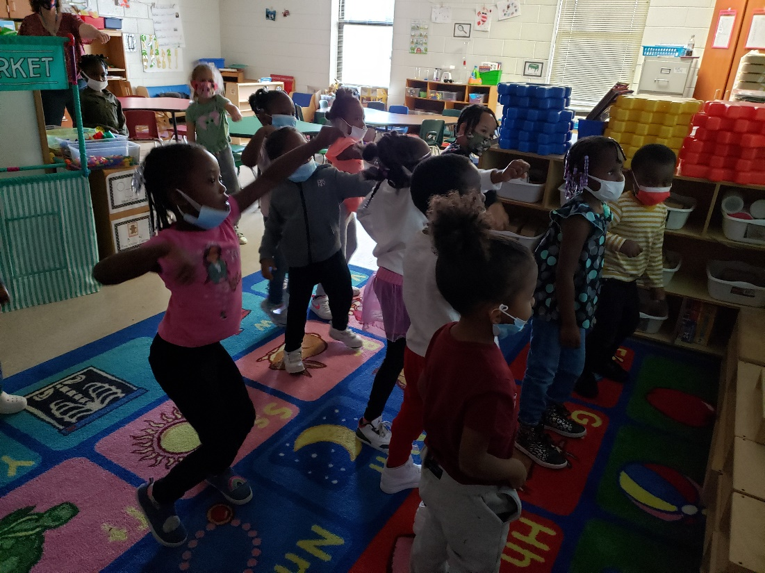
Learning how to step like our Copeland Wildcats Step Team

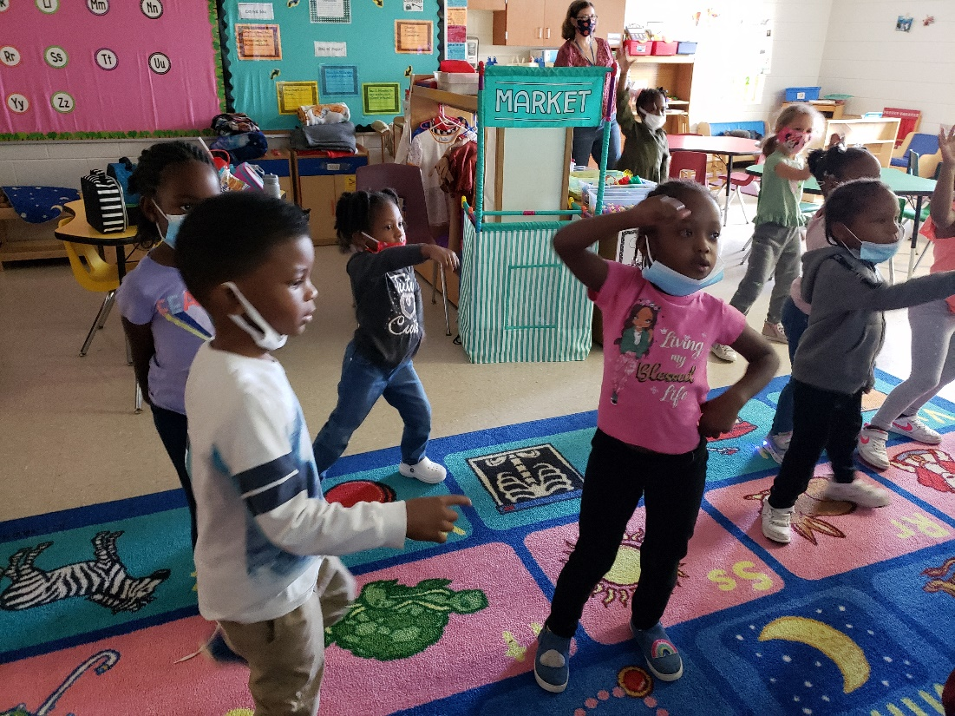
Doing the Nae, Nae

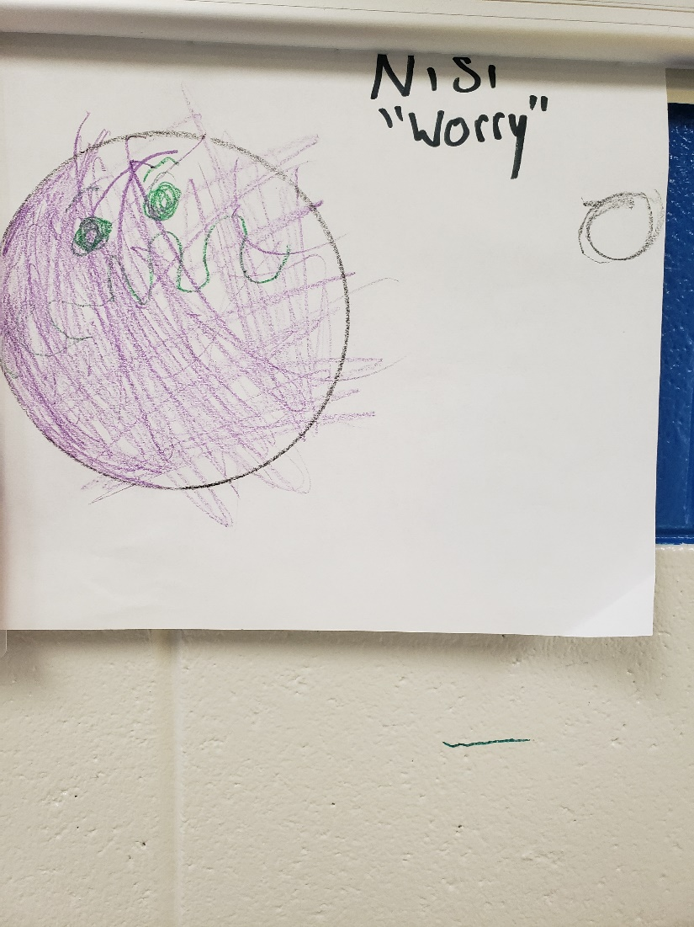

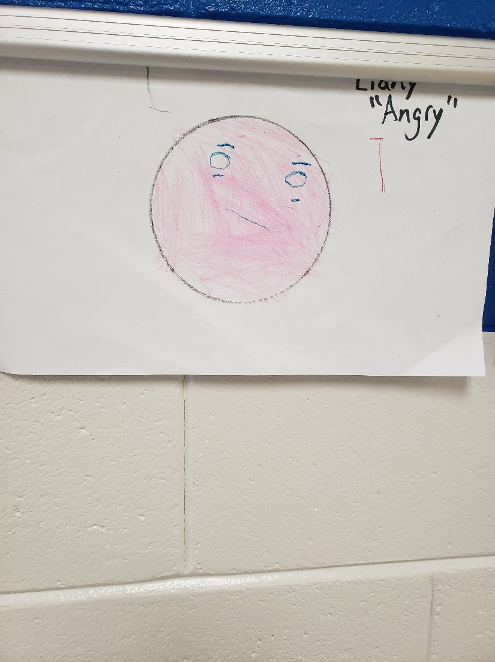
**Scroll Down for Unit Standards**

Unit Standards:

ELA:

Math:

Science:

Social Studies: SS1.4a, SS2.4b, SS4c

