Virtual Learning

September 7th & 8th

PE K-4th

**K – 2**

**Warm-up**

Cosmic Yoga – Select one

<https://www.youtube.com/user/CosmicKidsYoga>

**Activity**

Underhand Toss/Throw - Practice tossing an object (ball or a pair of socks) to a target. Try to make 10 successful throws.

**Cues**

Object in dominant hand

Step with opposite foot

Eyes on target, aim

Tick tock

**3rd & 4th**

**Warm-up**

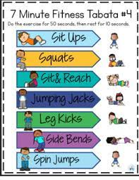

**Activity**

Among Us (Fitnessgram Review)

<https://www.youtube.com/embed/hJ5zUjSpA5Y>