**6th Grade ELA**

Hello Future 6th Graders!  
This summer, you’ll be using ReadTheory, an online program designed to help you grow as a reader by practicing reading comprehension skills at your own level. Think of it like a workout for your brain. The more you practice, the stronger your reading skills will become!

What to Do:

* Log into the ReadTheory platform.
* Complete the 7 assigned reading lessons.
* Finish the 3 comprehension quizzes that go along with the lessons.
* Your goal is to complete 2 - 3 passages each week to maintain good progress and growth.

As you pass the quizzes, the reading passages will adjust to match your skill level — and challenge you as you improve!

Create your account with <https://readtheory.org/app/sign-up/role> using any login credentials (i.e. gmail, office, clever, personal). You will have to give some personal information (name & age).

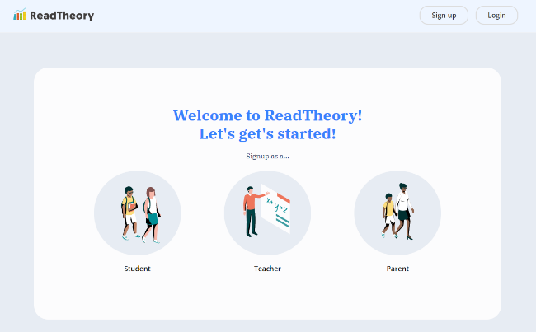

Once you have accessed to the platform, you will need to click on the drop down box in the top right corner of the screen next to your name and click on "My Teachers."

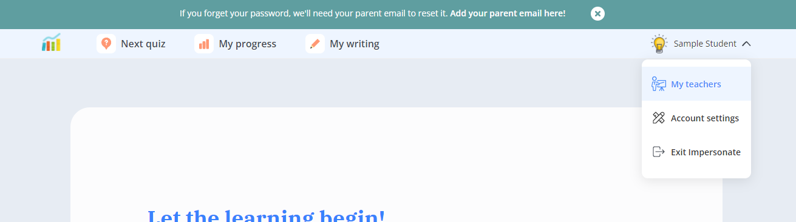

On the next page, you should use the code GS2FACC7 to join my class.



When you first sign up, it will give you a diagnostic assessment to determine what Lexile level to start you on.   
You will click "Next Quiz" at the top any time you want to keep working. It does save your progress if you don't finish the quiz in one sitting, and you can monitor your progress and writing feedback on those respective tabs at the top of the screen.

Once you have joined the class, your ELA teacher will assign a weekly activities that will tell you how many passages to do each week, which will look like this (but it will not be 5):

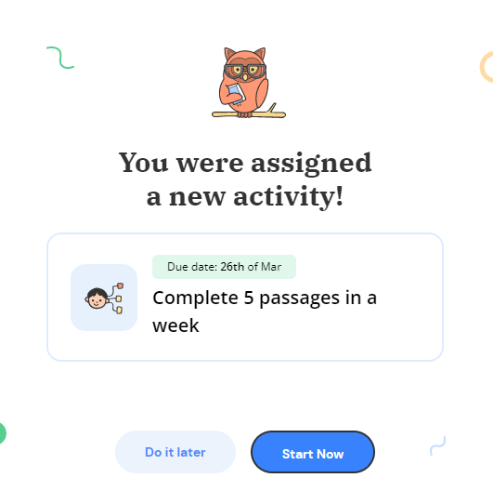

Throughout the summer, your teacher will provide feedback on written responses.