**Wilkinson Gardens Elementary School**

### Parent and Family Engagement Policy and Plan for Shared Student Success

*2024-2025 School Year*

#### 1925 Kratha Drive

*Augusta, GA 30906*

<https://www.rcboe.org/wilkinson>

*Revised: March 30, 2024*

**What is Title I?**

Wilkinson Gardens Elementary is identified as a Title I school as part of the Every Student Succeeds Act (ESSA). Title I is designed to support State and local school reform efforts tied to the challenging State academic standards to improve teaching and learning for students. Title I programs must be based on effective means of improving student achievement and include strategies to support family

**School Plan for Shared Student Achievement**

**What is it?**

This is a plan that describes how Wilkinson Gardens Elementary will provide opportunities to improve family engagement to support student learning.

Wilkinson Gardens Elementary values the contributions and involvement of parents and family members to establish an equal partnership for the common goal of

improving student achievement. This plan describes the different ways that

Wilkinson Gardens Elementary will support family engagement and how parents can help plan and participate in activities and events to promote student learning at school and at home.

## How is it revised?

Wilkinson Gardens Elementary School invited all parents to attend our annual School Forum last spring to review and revise this parent and family engagement policy, as well as the schoolwide plan, our school-parent compact, and the family engagement budget. Additionally, parent input and comments regarding this plan are welcome during the school year through an online form. The plan is posted on our school website for parents to view and submit feedback throughout the year. All parent feedback received during the year will be used to revise the plan for the next school year. We also distribute an annual survey online and by school webpage to ask parents for their suggestions on the plan and the use of funds for family engagement. Parents and family members can also give feedback during several parent meetings and activities during the school year including our annual Community Cares event.

## Who is it for?

All students participating in the Title I, Part A program, and their families are encouraged and invited to fully participate in the opportunities described in this plan. Wilkinson Gardens Elementary will provide full opportunity for the participation of parents and family members with limited English, with disabilities, and migratory children.

engagement. All Title I schools must jointly develop with parents and family

members a written parent and family engagement

policy.

**Where is it available?**

At the start of the year, the plan is included in the student handbook given to all students. The plan will be posted on the school website and social media. Parents can also retrieve a copy of the plan in the Parent Resource Center.

***2024-2025 District Goals***

Goal 1: During the 2022 -23 school year, we will utilize technology and Richmond County school system Instructional Framework to increase academic achievement across all tested content areas by 3%.

Goal 2: During the 2022 -23 school year, through our Induction Support Program we will increase the percentage of highly effective teachers and leaders retained in the Richmond County School System by 3%.

Goal 3: During the 2022 -23 school year we will increase the graduation rate from 73.77% to 75% by a continued focus on the strategy map and working to produce graduates that meet the Richmond County system Profile of a Graduate

***2024-2025 School Goals***

Goal 1: Increase the number of students in third, fourth, and fifth grades who are proficient or above in reading by 5 percentile points as measured by the Georgia Milestones EOG assessment.

Goal 2: Increase the number of students in third, fourth, and fifth grades who are proficient or above in math by 5 percentile points as measured by the Georgia Milestones EOG assessment.

Goal 3: By the end of the 2023-2024 school year, parental involvement in school-based academic activities will increase from 3 to 9 by implementing a monthly academic parent night.

**School-Parent Compacts**

As part of this plan, Wilkinson Gardens Elementary and our families will develop a school-parent compact, which is an agreement that parents, teachers, and students will develop that explains how parents and teachers will work together to make sure all our students reach grade-level standards. The compacts will be reviewed and updated annually based on feedback from parents, students, and teachers during the Community Cares event and the school Forum.

# Let us Get Together!

Wilkinson Gardens Elementary will host the following events to build the capacity for strong family engagement to support a partnership among the school, parents, and the community to improve student academic achievement.

***Open House –08/01/24***

Meet your child’s teacher and our friendly and helpful school staff for the year.

***Annual Title I Meeting – August 2024***

We invite you to an evening of learning and sharing about our Title I program, including our parent and family engagement policy, the schoolwide plan, the school-parent compacts, and parents’ requirements.

***October Parent Meeting (Math) - TBA***

Learn about how to help your student with academics and learn about helpful resources.

***November Parent Meeting (ELA) - TBA***

Learn about how to help your student with academics and learn about helpful resources.

***December Parent Meeting (Book Give Away) – TBA***

Come and learn about how to help your student with academics and learn about helpful resources.

***January Parent Meeting (STEAM) - TB*A**

Learn about how to help your student with academics and learn about helpful resources.

***February Parent Meeting (Black History) – TBA***

Learn about how to help your student with academics and learn about helpful resources.

***March*** ***Title I Parent Meeting—TBA***

A forum for parents and family members to participate in roundtable discussions with the principal and staff regarding the schoolwide plan, parent and family engagement policy, school-parent compacts, and the family engagement budget.

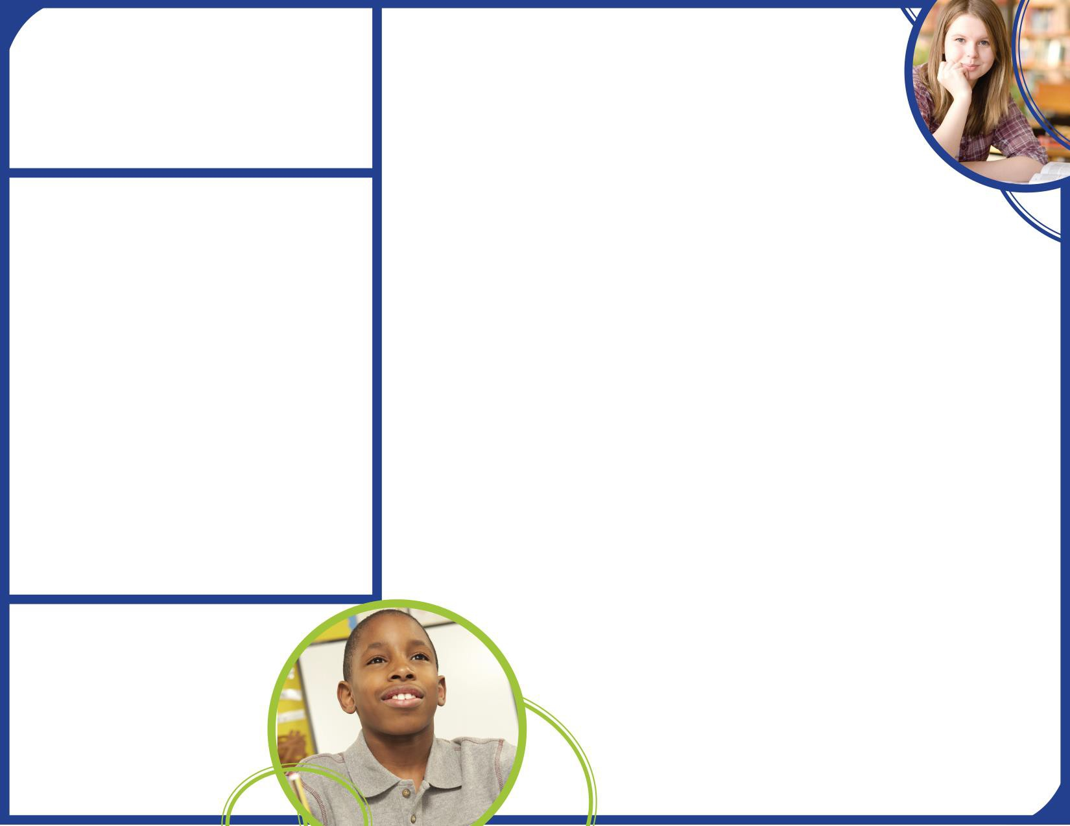**Parent Success Center**

Come visit the Parent Success Center to check out books, study materials, and activities to use at home with your child. Computers are available for parents to explore the Parent Portal and educational resources.

**Parent and Family Engagement**

Wilkinson Gardens Elementary believes that family engagement means the participation of parents and family members in regular two-way, and meaningful communication involving student academic learning and other school activities, including ensuring:

* That parents play an integral role in assisting their child’s learning.
* That parents are encouraged to be actively involved in their child’s learning.
* That parents are full partners in their child’s education and are included as appropriate in decision making and on advisory committees to assist in the education of their child the parents are

Wilkinson Gardens Elementary is committed to helping our

parents and families attend the family activities listed in this policy. Please call or email us if you need help with childcare or transportation to participate in our programs.

Trina Berry 706-737-7219 ext.: 4772

[berrytr@boe.richmond.k12.ga.us](mailto:allende@boe.richmond.k12.ga.us)

# Wilkinson Gardens is Branching Out!

Wilkinson Gardens Elementary will take the following measures to promote and support parents and family members as an important foundation of the school in order to strengthen the school and reach our school goals. We will:

* + Provide parents information in a timely manner about Title I and the rights of parents to be involved. Provide written notice to all parents in regard to the identification of WGES as a Title I School Improvement School.
  + Share information on the school website and in the school newsletter for parents to understand the school’s academic standards and assessments as well as the ways parents can monitor their child’s progress.
  + Communicate with all families and the community on a regular basis regarding school-wide events and activities, through phone messages, school website, and flyers.
  + Works with our parents to develop relevant training and helpful presentations to educate our staff on the importance of parental involvement.
  + Provide necessary materials and handouts for parents at conferences, meetings, and activities to help parents work with their child to improve their child’s achievement.
  + Collect feedback from parents at all events in order to respond to parents’ requests for additional support for parental involvement activities



Find out more about our school on our webpage! <https://www.rcboe.org/wilkinson>

# Share Your Thoughts

We want to hear from you. If you have any suggestions or if there is any part of this policy that you feel is not satisfactory with the students’ and the school’s goals for academic achievement, please provide us with your comments in the space provided and leave this form in the Main Office:

Name: (optional)

Telephone Number: (optional)