Grade Level: 3rd Grade Dates: Feb 22-March 18
School Information  School: Copeland Elementary  School Code: 060043  Teachers: Gist, Denson, Rozier, Brace  Buffer: | Transdisciplinary Theme: Sharing the Planet  Segment of Theme: Communities and the relationships within and between them.  Over Arching Concept: Pollution
Section 1: Overview
- Central Idea: Awareness and human actions impact the environment in which we live.
- Key Concepts: Perspective, Responsibility, Reflection
- Guiding Related Concepts: | - Lines of Inquiry: | - Teacher Questions (Guided Questions):
Beliefs  Responsibility  Values  Adaptation  Ecosystems  Environment  Recycle  Conservation  Habitat | - Pollution effects our environment in many ways.  - There are methods to protect our natural resources.  - There are things I can do to participate in conservation efforts. | DOK Level 3 & 4  - What is pollution?  - How does pollution occur?  - How does pollution effect our environment?  - What can we do to reduce pollution?  - What are the sources of pollution?  - What is litter?  - What effect does pollution have on plants and animals?  - Why it is important to protect natural resources?  - Why is it important to stop the landfill from filling up quickly?  - Why is it important to recycle?  - What are the three R’s of conservation? And what do they mean?  - How does conservation actually protect plants and animals?  - What are some ways I can participate on the conservation effort?  - What human activities affect pollution?  - How does pollution effect the habitats/regions in Georgia?  - What plants and animals are in each habitat?  Student Questions from previous year:  - Why does trash have to go to the Sea  - Why is pollution bad?  - How does the pollution get in the air?
- Prior Content Knowledge: | - Assessing the Lines of Inquiry:
Students would need to have an understanding that living things have adaptations that help them survive in their environments and the Georgia Regions.  They will also need to understand the concept of comparing and contrasting so that they can see what are similar issues and different ways people around the world deal with pollution. | How will you assess student’s understanding of the lines of inquiry?  Students will be assessed by their research explaining the 3 R’s of recycling.  Students will also be assessed by of their methods chosen to protect natural resources by their proposal letter and reflection.  Students will complete a KWL chart showing that they have learned several ways that pollution effects our environment.  Inquiry Journals  Students will present their public service announcements message to the class and the school.  Students will complete a reduce, recycle, and reuse sort it activity and reflection
Section 2: What Are Our Target Goals?
- Concept Based Summative Assessment: | - Targeted Approaches to Learning (highlight 3): | - Targeted Learner Profile Attributes (highlight 2):
(Week 2/3)Ongoing.... Students will work with Ms. Shoemaker to make a public announcement to get others involve to have a Copeland Cleanup | Social Skills, Research Skills, Communication Skills. Thinking Skills, Self-Management Skills  - Communication skills – Students will present on the GA habitats  - Social Skills – Students will participate in collaborative group and partner discussions.  - Self-Management Skills – Students will  - Research Skills – Students will research the habitats of GA  - Thinking Skills – Comprehension | well-balanced, caring, principled, open-minded, risk taker, knowledgeable, communicator, reflective, thinker, inquirer
Section 3: What Assessments will be provided in this unit of inquiry?
- Pre-Assessments:  What assessment will be given at the beginning of the unit to inform current understanding | - Formative Content Based Assessments:  What assessments will be given to monitor student learning of content? | - Summative Content Based Assessments:  What assessments will be given for students to show mastery of unit content?
District unit Pre-test Canvas  District Unit post test  Kahoot  Blooket  Group Discussions | Unit Informal Checks-Canvas  Exit Tickets  Station Work activities  Seesaw Reflection videos  Class Discussions  KWL charts  Graphic organizers | Students will create a society with classmates:  What will they eat.  How will they obtain food.  What kind of clothing will they wear.  What kind of shelter will they have?  What kind of art does the society create?  What are laws/rules?  Can it be fantasy or Realistic
Section 4: How will we Facilitate Learning?
- Provocation:  How will interest into this unit be sparked? | - Learning Experiences:  What activities/experiences will help facilitate the learning? | - Evidence of Differentiation:  How will the learning experiences be adjusted to different learning styles/abilities?
Students are given a bucket of clean water. Pollutants are added into the water (oil, trash, food, etc.). Students are then asked to clean the water.  Pollution Activity: Clean bucket Water Activity  - Students will be provided materials to investigate how to clean polluted water  Watch video “The Great Pacific Garbage Patch?” https://www.youtube.com/watch?v=1qT-rOXB6NI | Week One: Pollution  TUNING IN  - Pollution Activity: Clean bucket Water Activity  - Watch video “The Great Pacific Garbage Patch?” https://www.youtube.com/watch?v=1qT-rOXB6NI  - Students will be given a Theme Chart to analyze each component of Sharing the Planet  - Teacher will play a Myon book called “Green Park” - To gain a better understanding of how important it is to take care of their environments.  - Through discourse teacher/students we will focus on the key concepts to drive inquiry  - In groups the students will create 3 rules following the “Green Park” in how they can clean up their community and Copeland.  - Students will look around their school, neighborhood, rivers or lakes to determine if they see litter and air pollution.  Week Two: Recycling  FINDING OUT/SORTING OUT  - Gallery Walk of recycling, reducing, reusing  - Students will Think-Pair-Share about the importance of recycling  - Students will add one of their wonderings on the Wonder Wall  - Students will research and explain the 3 R’s (reduce, reuse, and recycle) (print GPS book)  - Students will sort magazine cut outs into 3 categories reduce, reuse, and recycle and create a collage  - Students will research recycling laws and practices in Europe as well as recycling laws and practices in the United States  - Students will compare and contrast recycling laws/practices - Students will write a summary of their findings or create a digital presentation using SeeSaw or PowerPoint (Student Choice: Written Summary, SeeSaw Video, PowerPoint)  - Discuss the importance of recycling as a method of protecting the environment because it saves resources and landfill space  Week 3: Habitats  FINDING OUT/SORTING OUT  - KWL chart about Habitats: Focus on K and W  - Jigsaw Each group will be given a habitat to explore the different plants and animals associated with their Habitat  - Students will research their habitats in a small group setting  - Students discuss in pair share or small groups of four ways that humans have negatively impacted the habitats(environment)  - Students will research ways that humans can positively impact plants and animals in the habitats in Georgia  DRAWING CONCLUSIONS/REFLECTING AND ACTING  - Students will use the information they have learned in class, at home, and in the media center to work on their culminating project.  School Project: Daily News broadcast about Protecting the Planet (reduce, reuse, recycle)  Week 4 Habitats  TUNING IN  - Review L of KWL chart.  - Continue Jigsaw. Students will focus on the features and adaptations and how the animals use these to survive in their habitats  FINDING OUT/SORTING OUT  - Students will continue researching information for culminating project. (Environment Choice Board)  GOING FURTHER  - Students will participate in cooperative group task.  DRAWING CONCLUSIONS/REFLECTING AND ACTING  - Students will write a letter to a community or government leader about the importance of protecting plants and animals in the Georgia habitat of their choosing.  Week 5 Habitats  TUNING IN  - Two Facts and a Fib activity: Student teams will identify the habitats and the animals that are associated with each.  FINDING OUT/SORTING OUT  - Students can participate in a Graffiti Board activity---Key Word or Key Question of the day is posted and students will draw or write ideas related to the key word.  GOING FURTHER  - Students will continue working on and finalizing individual projects.  DRAWING CONCLUSIONS/REFLECTING AND ACTING  - Students reflect in their Inquiry journals about key words or question(s) of the day.  Week 6 Conservation  TUNING IN  - (Wed.) Protecting Our Planet  https://www.youtube.com/watch?v=sMvZURCDlWA  FINDING OUT/SORTING OUT  - Students create a water usage chart in their Inquiry Journal  GOING FURTHER  - Students continue working on and finalizing individual project.  DRAWING CONCLUSIONS/REFLECTING AND ACTING  - Students will generate a list of ways to conserve water. Participate in Collaborative groups review and Reflection of the list they created.  Lava Lamp Activity:  Students will create a lava lamp to help reduce the use of electricity. | Para, EIP teacher or Sped teacher will work with small groups as needed or lead a group of learners that may need additional support.  Concept based summative assessment will be modified as needed.  Leveled station activities  Reading selections based on student Lexile level  Students will be given graphic organizers to assist with keeping up with the information gathered during research. Students will also be given a choice on how they would like to present the information learned, through seesaw, flip grid or a written essay or report.  Student choice for presenting learning: SeeSaw video, FlipGrid or PowerPoint, Written Summary
- Learning Experiences in Specials:  How are Specials Courses able to connect to this unit? | - Local/National/Global Connections:  How can we connect the content to local/national/global issues? | - Student Action:  What learning experiences support potential student-initiated action?
PE: In P.E. we will explore the many different methods and materials that can be used to improve our physical abilities.  Spanish Ss will learn the Spanish vocabulary about natural resources. Ss will make a poster to describe different ways to protect their environment.  Art: Students will discuss landscaping as an art form as well as recycled art. Students will design and paint decorative pots for the garden. | Recycling in Europe vs recycling in the United States  Students can also compare and contrast with what students in the classroom, and their representative country participates in recycling. | Conservation Efforts – learning more about saving animals such as turtles, whales and dolphins  Students potentially starting to recycle more at home  Taking better care of our school and our playground – picking up trash
- Student Agency and Play:  What learning experiences provide students with voice, choice and ownership? What play opportunities will be provided by Kindergarten/Pre-K? hands on/STEAM for K-5? |  | - Resources:  Which resources will you and the students use? This may include people, places, technologies, learning spaces and physical materials.
Students will participate in two hands on projects:  Pollution bucket Activity- Students will be placed in groups and see the effects of pollution by seeing various products be poured into clean water. Students will then be asked to make the water clear again.  Recycling Galley Walk  Students will go outside to police our school grounds and pick up trash. Students will then sort trash for recycling.  Public Service Announcements.  Students will be placed in groups to explain ways to tackle pollution and recycling at our school and local environment. They will create a public service announcement that will be aired during the school announcements.  Pollution Jigsaw Information Booklets to Share:  Students will create informational guide to pollution. Students were to include the type of pollution, the definition, What causes the pollution and ways they can prevent the pollution. Students also were to include illustrations of their choice. |  | What people, places, audio-visual materials, related literature, music, art, computer software, etc, will be available?  Websites  http://nationalgeographic.com  http://lcweb2.loc.gov/ammem  http://www.pollution.com  http://www.recycle.com  http://www.epa.gov/recyclecity/  http://www.thomasrecycling.com/kids.html  http://www.epa.gov/kids/  www.brainpop.com  Polution  Books  Saving Earth’s Resources  Pollution and Conservation  Protecting Resources  Recycle, Reuse  Smoky Mountain Mystery  Regions of GA Virtual Fieldtrip www.gpb.org/blogs/education-matters/  Mrs. Shoemaker – Media Specialist – Books on recycling, pollution and the environment
Section 5: Reflection (Write the year, change font color for each year)
- Reflect on learning experiences:
Rozier- Students were able to participate in several learning experiences. These learning experiences consisted of participating in a “What’s in the Bag?” activity, watch a video on how to recycle in Germany, compare and contrast Germany to the U.S, complete a sort it activity, and make homemade lava lamps. Students had the opportunity of participating in a variety of activities that fit their learning styles/ needs.

Murdaugh-Gist- Students connected with this unit theme through different learning experiences. The learning experiences included educational videos, gallery walks ( I see, I think, I wonder) Next year because of this inquiry, we might investigate our local manufacturing plants a little further as the students connected their neighborhoods in which they live to how the environment if affected.

Denson- Students really enjoyed the various learning experiences that took place during this unit. Because of their interest in pollution of the ocean we did a hands on learning experience to see if we could clean an oil spill out of the ocean. In this activity the students used a cotton ball, paper towel, syringe and finally dawn dish washing liquid to try and clean the ocean. The students also enjoyed making their Public service announcements. Student agency was demonstrated when they chose whether they wanted to work together or with a group.

Brace-Students enjoyed this unit. They were interested in the different types of pollution and the effects of those pollutants on people and animals. Students read articles on the different types of pollutions. One of the unit opening videos was The Great Pacific Garbage Patch by National Geographic. This students were very concerned about the harm the waste was doing to ocean life.
- How were the tasks differentiated to meet different learning styles? |  | - How did the learning experiences and strategies we used throughout the unit help to develop and show students understanding of the central idea?
Rozier- The tasks were differentiated to meet different learning styles by having students participate in different learning experiences that consisted of different approaches. For example, students who are kinesthetic learners had the opportunity to complete a sort it activity that consisted of cutting and gluing ways to recycle, reduce, and reuse. Students that were both auditory and visual learners enjoyed watching a video on how to recycle in another country which allowed for them to think on how this process is in their native country.  Murdaugh-Gist- Differentiation was included in the unit lessons with support from the co-teachers of the special needs students. Modeling of writing prompts were given to students who needed support. Students were also able to access the unit vocabulary when completing the tasks and assignments. Students were able to work in collaborative groups and also with peer buddies on activities that included a scavenger hunt about recycling. Students had experiences of turn and talks, group interviewing and reflecting. Students authored and illustrated their understanding of Sharing the planet by creating informational booklets on pollution ( air, land, and water).  Denson- The task were differentiated to meet the different learning styles by having multi-sensory activities. Students also were able to use their choice of learning when it came to their PSA. Additionally students who needed assistance were offered assistance by peers and myself.  Brace-Differentiated learning styles were met based upon ability levels of the students. Example: Books related to the unit of study were available for the students on different lexile levels. Students were able to research topics of interest using a choice board. The choice activities were based upon the multiple intelligences.  Student differentiation was enhanced by the student conversation throughout the study of the unit. Students were engaged by asking questions and researching topics that were new to them. |  | Rozier- Students understood the central idea of awareness and human actions impact the environment in which we live. Students had the opportunity to discuss ways we can promote awareness of recycling, reducing, and reusing. Students suggested on having recycle bins around the school to also promote awareness. They were also able to view how human actions affect the environments.  Murdaugh-Gist – Students made real world connections within their own neighborhoods in relation to our central idea and key concepts form and change. They discussed how they see, and smell pollution when they step out of their front doors. They were able to connect that they pollution was coming from factories that are located close to their homes and school. Students shared how some of them actually have recycling pick-ups in their neighborhoods that are separate from the regular trash pick-ups which help the environment.  Denson-The students were able to see how everything we do as citizens affect the environment. They were also able to notice that the things that are causing pollution in the environment are everyday items that we use and don’t discard properly, like soda cans, plastic straws, and oil. Students also were able to display this by asking people to recycle during their Public Service announcements.  Brace-Students became more proactive by recycling at home. They talked to their parents about the importance of recycling. Students shared recycling tips with the school community by making flyers to post in the hallway.
- What learning experiences best supported students’ development and demonstration of the attributes of the learner profile and approaches to learning? |  | - How effective were the summative assessments in measuring student learning? What, if any, changes need to be made to the assessments?
Rozier- Students had the opportunity to collaborate and socialize with their groups when sorting which strategy fit into the 3R’s categories. Also when completing the lava lamps students were able to see the reaction between how oil and water layers on top of each other. Turn and talk activities were also constructed during and after the German recycling video.  Denson- The learning experience that supported my students was the Oil spill clean-up activity. This activity was added because of the students inquiry based on our read aloud and supported their thinking skills. They had to determine what items would work and why. The other activity was the grab bag activity where they had to pick an item and then they discussed what was similar about these items supported their communication skills. They determined that the items were trash and pollution. s. .  Murdaugh-Gist – Students worked in collaborative groups during the jigsaw activity utilizing research skills to research their pollution type topic. Students also were communicators when they engaged in a pair share table talk topic of sharing types of pollution they saw enroute to school and or at school. Students completed classroom activities and reflections on pollution and ways to save the environment.  Brace- The students enjoyed participating in the activities related to the book---One Plastic Bag by Isatou Ceasay. After listening to the book and watching related videos the students researched recycling information regarding plastics and pollution. Students took action by bringing to schools recyclables.(teacher took recyclables home to be recycled) Discussions about starting a school recycling program are being researched for the next school year. |  | Rozier- The summative assessments in measuring the student consisted of students creating a mini PSA that consisted of a plan of action towards Copeland Cleanup. Moving further, I would have students create poster boards to post around the school and to actually demonstrate how to recycle within the classroom and school.  Denson- The summative assessment was completing the Public service announcements, which allowed the students an opportunity to share what they have learned and solicit the help of others on various topics. Students also showed understanding of what was pollution and how we as a community can help to lessen the problem.  Murdaugh-Gist – Students completed a summative assessment of an informational guide to pollution. Students were to include the type of pollution, the definition, What causes the pollution and ways they can prevent the pollution. Students also were to include illustrations of their choice.  Brace- The most informative student assessments were those that occurred after the daily lessons when students were able to have discussions about specific topics. Students learned how to write Cornell Notes as a part of the student assessment process.
- What student-initiated inquiries (questions) arose from this unit of inquiry? |  | - What student action arose from this unit of inquiry?
Rozier- Can we recycle here at school? Why do they have a fine if they don’t recycle in Europe? How do we reduce the usage of electricity in our homes?  Denson-Students wondered how the animals in the ocean were affected? How many pounds of trash there was in the world? What could we do to stop pollution?  Murdaugh-Gist – Students inquiries included the following buring questions:  What will happen to the world if we don’t stop pollution?  Why do factories pollute the my neighborhood?  Can anyone recycle?  What is the correct way to recycle?  Brace-  How does pollution impact the environment?  What can I do to help make the future better?  How does air pollution impact my health?  What is the most polluted country in the world? |  | Rozier- Students decided to take their knowledge further on reduce, reuse, and recycle and create a plan to keep our school clean and ways we could work together to do so.  Denson- The Student action that arose from the unit of inquiry is students started paying attention to the various items they put in the trash. A few of the students begin to tell their parents and recycle at home. The also started using refillable water bottles.  Murdaugh-Gist – In our Sharing the Planet Unit; students became more socially aware of pollution and littering. They began reminding each other to take care of their environments in the classroom, playground, and cafeteria. Students began cleaning up more and picking up trash when they spotted it.  Brace-Students made their families more aware of things they could do to help protect the planet. Students made flyers about recycling. Students talked about things they could do now to help make their planet a healthier place to live. Students had discussions about putting forth the effort to not waste as much.
- Any additional notes or changes that need to be considered next year?
Section 6: Picture Evidence
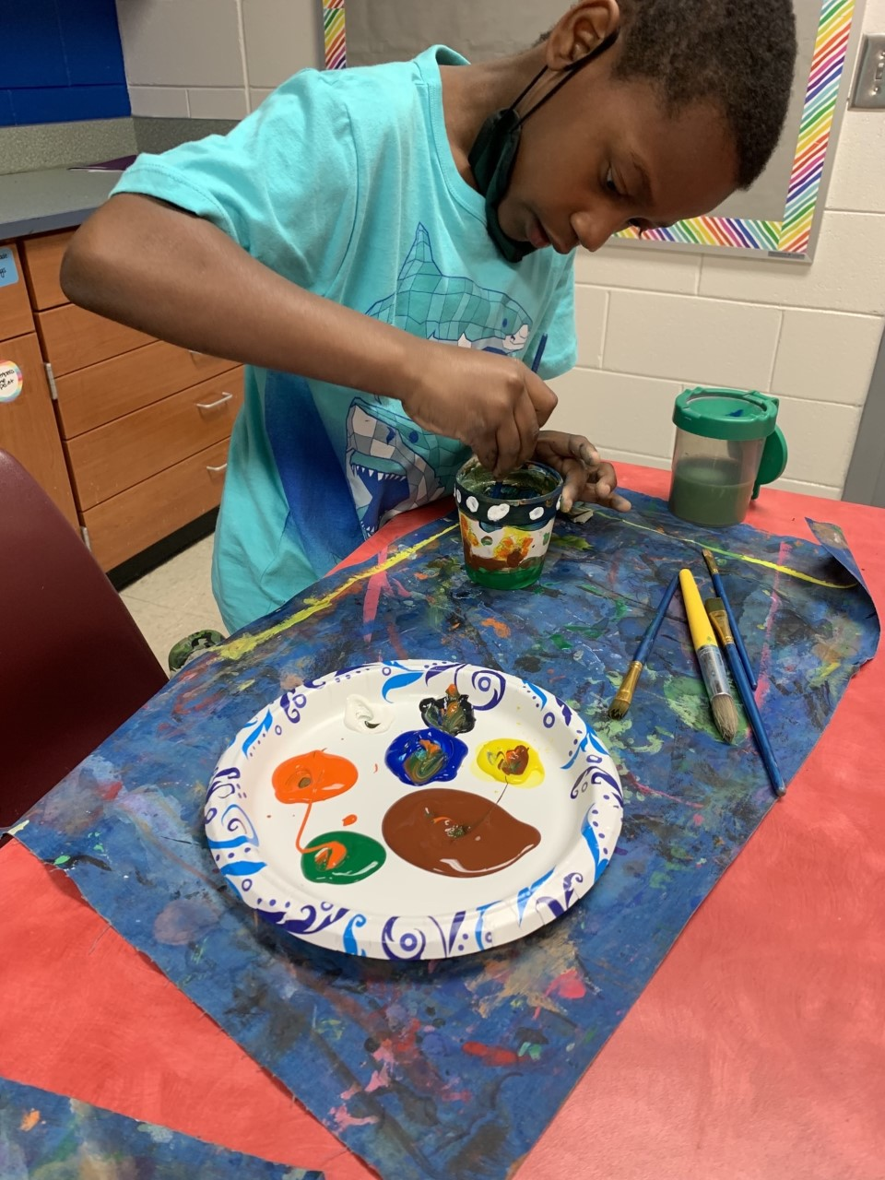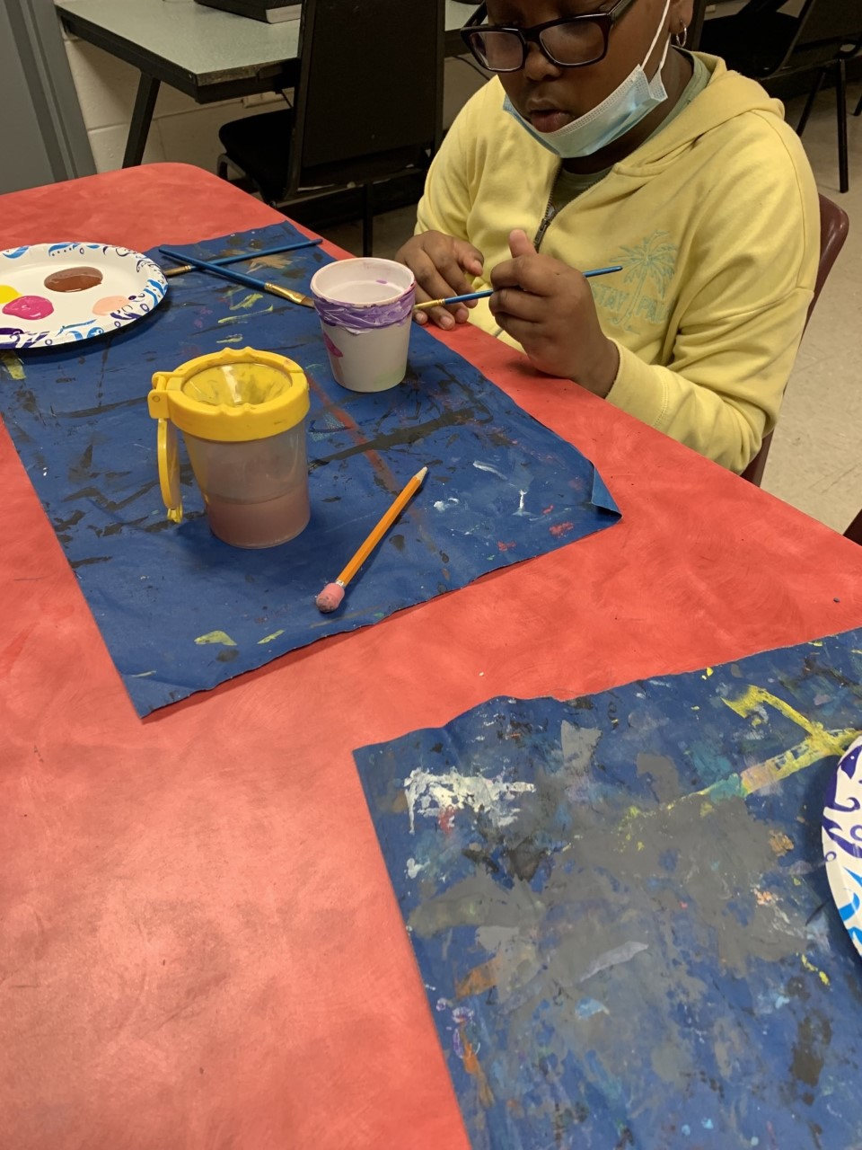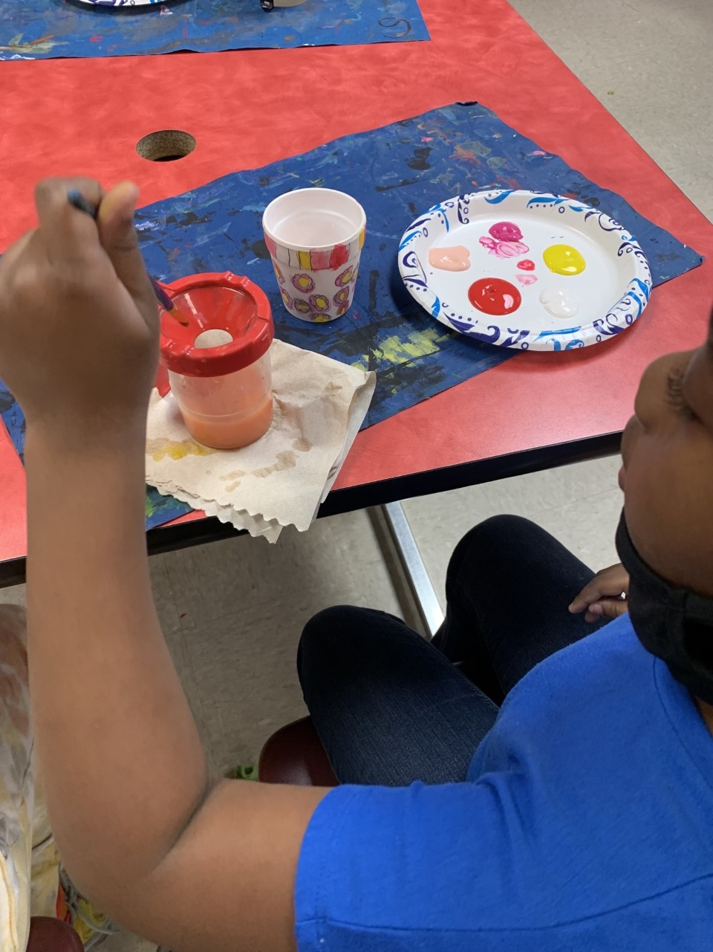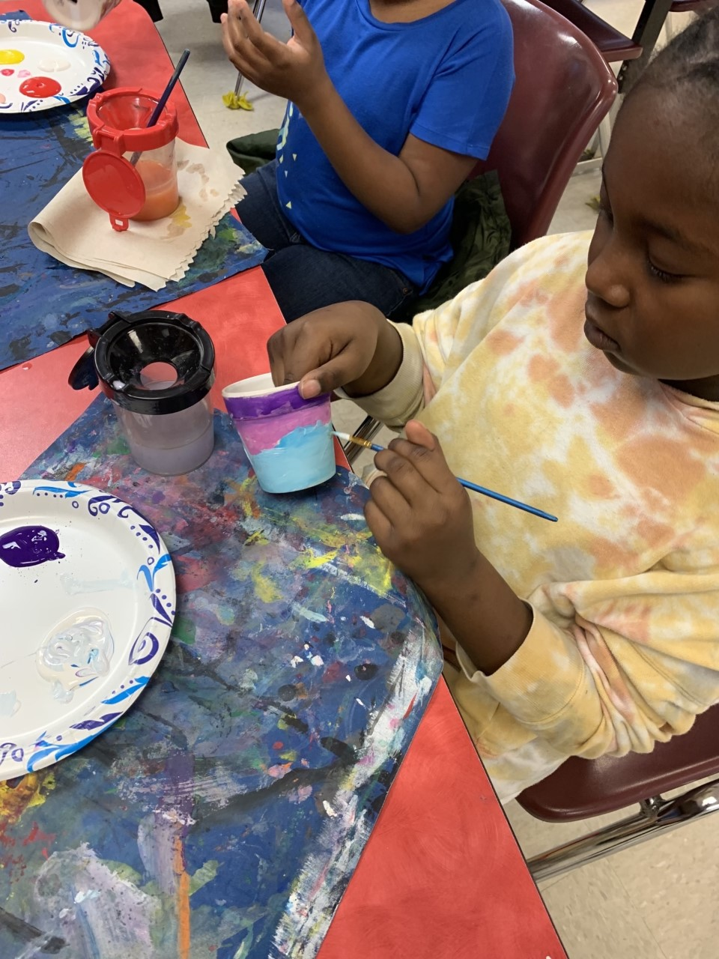
**Scroll Down for Unit Standards**

Unit Standards:

ELA:3RL.9
3Rl.7

Math:

Science:

Social Studies:
SS3H1-all
SS3G3

