Grade Level: Second Grade Dates: February 7 – March 11
School Information  School: Copeland Elementary  School Code: 060043  Teachers: Brown, Echols, Huggins, Timmons, and Ginn  Buffer: | Transdisciplinary Theme: Where we are in Place and Time  Segment of Theme: Personal Histories  Over Arching Concept: Change
Section 1: Overview
- Central Idea : The impact of the past helps shape the future
- Key Concepts: Form , Function and Causation

- Guiding Related Concepts: | - Lines of Inquiry: | - Teacher Questions (Guided Questions):
Structure, Change and Source | Evidence of past civilizations can be used to make connections to present day society.  Landforms vary depending on the region.  Historically figures adapt and influence our perspective of cultures today. | DOK Level 3 & 4 ( 4-6 Questions)  How do the topographical features of Georgia impact where and how we live?  In what ways are the five regions of Georgia similar and different?  Explain why are so many of Georgia’s cities and towns built near rivers.  Where can you locate each river and region on the map?
- Prior Content Knowledge: | - Assessing the Lines of Inquiry:
- Students will already be familiar with some land forms.  - Students will know the city that they live in as well as the state and capital. Students will be familiar with Savannah River.  - Students will know about compare and contrast  - Informational Writing and Opinion Writing | How will you assess student’s understanding of the lines of inquiry?  Why are so many Georgia towns and rivers settled around built near rivers?  Students will complete landform concept project and 5 regions assessments.  Describe how the regions in which these historical figures lived affected their lives and compare these regions to the region in which the students live (  Mary Musgrove and Tomochichi ).
Section 2: What Are Our Target Goals?
- Concept Based Summative Assessment: | - Targeted Approaches to Learning (highlight 3): | - Targeted Learner Profile Attributes (highlight 2):
What are the possible ways of assessing students’ understanding of the central idea? What evidence, including student-initiated actions, will we look for?  Landform Project : Students will create a diorama of the different landforms and rivers of each region  Georgia Tourism Brochure: Students will work in groups to create a brochure that attracts visitors to one major geographic region of Georgia.  Choices: Diorama, Poster Board, Digital Presentation  Assessment tool- Teacher Observation/Rubrics | Social Skills, Research Skills, Communication Skills. Thinking Skills, Self-Management Skills | well-balanced, caring, principled, open-minded, risk taker, knowledgeable, communicator, reflective, thinker, inquirer
Section 3: What Assessments will be provided in this unit of inquiry?
- Pre-Assessments:  What assessment will be given at the beginning of the unit to inform current understanding | - Formative Content Based Assessments:  What assessments will be given to monitor student learning of content? | - Summative Content Based Assessments:  What assessments will be given for students to show mastery of unit content?
Standards Mastery I-Ready  Studies Weekly Assessment  - Students will analyze a photo using the 5 W’s and an H strategy. (This strategy can be repeated with all 3 historical figures).  - Share an image with the students and allow students time to study the image. Give students time to reflect.  - Students will use 2 of the W’s and an H to ask questions about the image. Have students record their questions in their notebook or they can add them to a wonder wall. Discuss and chart student responses as a whole class. Use these questions as a springboard. | (KWL charts, gallery walks, quizzes)  Venn Diagram: Students will compare and contrast different regions  Gallery Walks: Showing students pictures of the topic of the day, students will come up with questions to research  Share and Reflect Question of the Day/Ticket out the door: Reflection question dealing with what was talked about that day  Writing Informational Text: Students will write informational text based on topics worked on throughout the unit.  Studies Weekly Quizzes  SeeSaw  5 Regions Assessments  5 Regions Booklet | Performance matters, benchmark, Standards Mastery I-Ready  Social Studies Weekly Assessment –  SeeSaw – Writing Assessment
Section 4: How will we Facilitate Learning?
- Provocation:  How will interest into this unit be sparked? | - Learning Experiences:  What activities/experiences will help facilitate the learning? | - Evidence of Differentiation:  How will the learning experiences be adjusted to different learning styles/abilities?
Gallery Walk of the different landforms and have students just tell what they see, think, and wonder on sticky notes.  Show children a map of Georgia that is split up into the different region and have the students inquire about the different features on the map. | Tuning In Week 1  - Students will play a game to discover word associations for the word “culture”  - Students will go on a gallery walk and observe the landforms in the different regions.  Regions: For each region of Georgia, students will research landforms and animals within the region and the culture of that region  Station Activity: Region Booklet – Students will create a booklet with a page for each region that includes the landforms for each region.  Read Alouds Georgia My State Geographical Regions – All Five Regions (Text)  Students will color and label a class map  Students will be split into groups. Each group will have a region and section of the map. Students will research their assigned region and design their map using important facts and important historical figures. Students will assemble the map as a class and each group will have the opportunity to share their region. Students may refer to their region booklet for additional facts and information  Research Skills: Students will have the opportunity to research the different regions and the landforms that are developed in each regions and what kind of wild life live in each region  Finding Out Week 2  Create three columns on your board labeled see, think, wonder. Have the students look at the picture on the cover. Have volunteers tell what they see as you write their responses down. Have students highlight the rivers on the map. Next, have students tell what the picture makes them think about doing. Finally, ask what the students still wonder about before reading the article. Enrichment: Have these students create a large version of the Georgia map and tell the class about the rivers.  Sorting Out Week 3  Students will learn of Georgia Regions through a See-Think-Wonder - Students observe the image of Georgia Regions and tell what they see in it, what it makes them think, and what they still wonder about it. English Language Learner: Create flash cards for students depicting beach, ocean, mountain, valley, ridge, and plateau. Help students create an image to correspond with each word.  Students will use a Circle Map - draw two concentric circles. In the center, write Georgia Regions. In the outer circle, write about the different regions. Draw a small picture to illustrate each region. Below Level/Developing: Have student use only drawings instead of words to describe each of the regions on the Circle Map. English Language Learner: Circle the different regions on the map that the student should write on the Circle Map. Gifted and Talented Learner: Student chooses a region and researches to become the class expert. Report information learned to the class.  Going Further Week 4  Region Project: Students will get to choose a region from the learning and tell different elements of that region  Landform Project : Students will create a diorama of the different landforms and rivers of each region  Georgia Tourism Brochure: Students will work in groups to create a brochure that attracts visitors to one major geographic region of Georgia.  Choices: Diorama, Poster Board, Digital Presentation  Assessment tool- Teacher Observation/Rubrics | Stations – Small group and teacher station for remediation and acceleration purposes.  Individual teacher assistance.  EIP teacher assistance for small groups  RAE – Remediation, Acceleration, Enrichment during specials segment  Choice Board for assignments  - Possible scaffolds:  - Before starting activity, practice asking questions using the 5 W’s and an H.  - Model your thinking as you start questions with the 5 W’s and an H  - Make sure the prompts are posted for the students to refer to as they study the image.
- Learning Experiences in Specials:  How are Specials Courses able to connect to this unit? | - Local/National/Global Connections:  How can we connect the content to local/national/global issues? | - Student Action:  What learning experiences support potential student-initiated action?
Art  Students will be learning and creating art as it relates to other cultures and their traditions.  Students will be creating various landforms in GA using Paper Mache. Students will build on previous knowledge of landforms. Each group will construct a different landform.  PE  2nd grades unit 4 central idea is the impact of the past helps shape the future. In P.E we will focus on students’ past and current physical level and students will form goals for the future physical level they would like to reach. We will focus on building endurance to reach our future physical fitness goals. Students will use the key concept of reflection and by the end of this unit students will reflect on their initial goal and then determine if building physical endurance has shaped their future physical fitness. | James Oglethorpe, Tomochichi, and Mary Musgrove (use the link below)  Global Connection – The Savannah River past and present  Recycling in the Savannah River  Thurmond Lake and the Reservoir – provides energy to GA and SC and how we get power from the reservoir.  Phinizy Swamp  https://lor2.gadoe.org/gadoe/file/158b509d-b90e-4e93-9f0c-022284ec7810/1/Social-Studies-2nd-Grade-Unit-4-Sample-Unit.pdf  Community Connection:  - Augusta WaterWorks - https://www.augustaga.gov/2771/Utilities  - Augusta Utilities  - Georgia Power Company  - Savannah River Site | Region Project: Students will get to choose a region from the learning and tell different elements of that region  Landform Project : Students will create a diorama of the different landforms and rivers of each region  Georgia Tourism Brochure: Students will work in groups to create a brochure that attracts visitors to one major geographic region of Georgia.  Choices: Diorama, Poster Board, Digital Presentation  As a result of their learning students may be prompted to visit the various regions of Georgia such as the Savannah River, Phinizy Swamp and Thurmond Lake. Students may share their own experiences with these landforms.
- Student Agency and Play:  What learning experiences provide students with voice, choice and ownership? What play opportunities will be provided by Kindergarten/Pre-K? hands on/STEAM for K-5? |  | - Resources:  Which resources will you and the students use? This may include people, places, technologies, learning spaces and physical materials.
Students will have the opportunity to create the landforms using papier Mache.  Students have a choice as it pertains to which region of Georgia they chose to study.  Students have choices in how they present their learning.  Choices: Diorama, Poster Board, Digital Presentation |  | Georgia My State Geographical Regions – All Five Regions (Text)  Appalachian Plateau  Valley and Ridge  Blue Ridge Mountains  Piedmont  Coastal Plain  Nearpod  One to one – student computers  Media Center – Each Region – Non fiction/informational text  Myon  Materials in visual Art  PBS – Georgia Regions  Maps of Georgia  https://lor2.gadoe.org/gadoe/file/158b509d-b90e-4e93-9f0c-022284ec7810/1/Social-Studies-2nd-Grade-Unit-4-Sample-Unit.pdf
Section 5: Reflection (Write the year, change font color for each year)
- Reflect on learning experiences:
Huggins-Students were engaged when learning about the different regions and were especially excited about Lookout Mountain in the Appalachian Plateau. Students loved making books on the regions and drawing pictures of things they found interesting in the different regions.
Ginn- Students loved drawing, and completing activities on the regions. They loved when I shared real life experiences with them like caverns, and white water rafting. They are excited about their project, and working with Ms. Mann(Art Teacher).
Timmons: Students were able to be introduced to the Georgia Regions through See-Think-Wonder, which let them see the different places that they were not familiar with that were so close to them. I believe that made the students interested in learning more about these places. Allowing them to research in groups for their projects allowed them to dive into the regions on their own to find out things that were interesting to them.
Echols- Students enjoyed exploring different regions the plants and animals. They created posters and models of the different regions.
Brown : Students enjoyed engaging in the learning activities about the regions and doing the group projects and learning from one another. My students were so engaged and they really enjoyed this unit.
- How were the tasks differentiated to meet different learning styles? |  | - How did the learning experiences and strategies we used throughout the unit help to develop and show students understanding of the central idea?
Huggins-Students did virtual field trips of the different regions, took notes on the regions, drew pictures of things they learned about in the regions, and did group assignments on the regions.  GInn- Students did research on regions. Students wrote paragraphs about regions. Students loved drawing pictures and doing the matching fill in the bank, glue, and sorting activity. The loved looking at different videos and pictures. In stations they loved working in Nearpod, Studies Weekly, and researching about landforms and regions.  Timmons: Students were able to create flash cards for different types of landforms found throughout the regions. Some students were able to write sentences and draw pictures to define the landforms while others just drew pictures of the landforms.  Echols- Students were given choices as to how they wanted to represent a region.  Brown: Students were able to take different atls and use it to engage in the learning of the regions, drawing pictures of the different landforms, and the students who were able to write they got to research and write about their different regions. |  | Ginn- Students were able to draw and write about their regions. They were able to complete inquiry-based activities to express what they have learned.  Huggins-Students were are able to express themselves through drawings, writings, and talking about the different regions.  Timmons:  Echols- students began to share places they or family had visited in Georgia.  Brown: The learning experiences were able to show that the students fully grasped the concept of how the past impacts the future. The comparing and contrasting of the regions and comparing how a region looked back the to how it is now.
- What learning experiences best supported students’ development and demonstration of the attributes of the learner profile and approaches to learning? |  | - How effective were the summative assessments in measuring student learning? What, if any, changes need to be made to the assessments?
Huggins-Students were engaged with the learning about Savannah in the Coastal Plain. Students liked knowing about the different animals and things to do in each region. Almost all students wanted to visit the Appalachian and Piedmont.  Ginn-Students were excited and engaged about learning of the differences of animals and landforms in the regions.  Timmons: Breaking the students into groups in having them do poster on a specific region allowed them to use communication and research skills. Using thinking skills, they were able to take these ideas they used in their groups to expand on an use for their brochure projects.  Echols- Since we were not able to take filed trips Teachers shared own experiences with [phots of regions they has visited, This personal experience helped students who had not traveled to understand the different places in our state. This encouraged them to explore using their computers!  Brown: The landform |  | Huggins: Students did a Georgia region assessment where they had to label the different regions on a picture of Georgia, Students interactively did the questions on Studies weekly for the regions. Students also did a quiz on different facts on the different regions.  Ginn- Students worked on comprehension quizzes about the regions. They wrote sentences and paragraphs. They completed a gluing activity of comparison of a multi-text of Appalachian and Coastal Plains. They will take the regions Assessment on next week, due to me having a professional learning.  Timmons: Assessment from Georgia Studies Weekly were good in measuring if the students were able to learn the facts on each specific region.
- What student-initiated inquiries (questions) arose from this unit of inquiry? |  | - What student action arose from this unit of inquiry?
Huggins- Students were surprised about what they could experience in the different regions because most have not left the Coastal Plain and those that have been to Atlanta were surprised that it was called the Piedmont. Students were excited to learn about the landforms, agriculture, animals, etc. Students really enjoyed talking about what they could do in each region especially the Piedmont because of the Georgia Aquarium, Coke Cola Factory, and other places.  Ginn- Students shared experiences of rhad a choice of how to present the regions and landforms that they have been in.  Timmons: Students were not aware that they were places in Georgia where they could go white water rafting and wanted to know how if we could go as a class. I pulled up a picture of Downtown Augusta when discussing the Savannah River and some students were familiar and others were not, which made them want to visit.  Echols- see above comment |  | Huggins-Students created projects based on the region they felt connected to base on what we learned about for the different regions.  Ginn- Students will turn in projects of their regions and landforms to share what they have learned.  Echols– Students had a choice of how to present their region project
- Any additional notes or changes that need to be considered next year?
Ginn- It would be great for students to experience more global connections.
Section 6: Picture Evidence
The date at the bottom of the picture is incorrect.
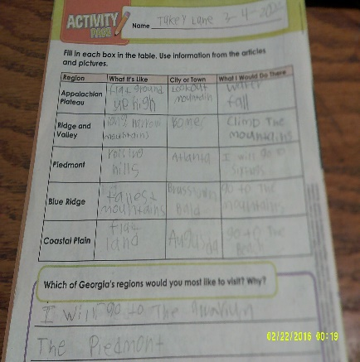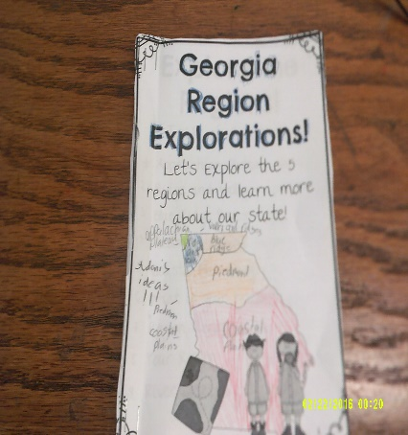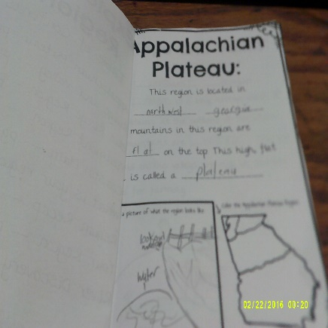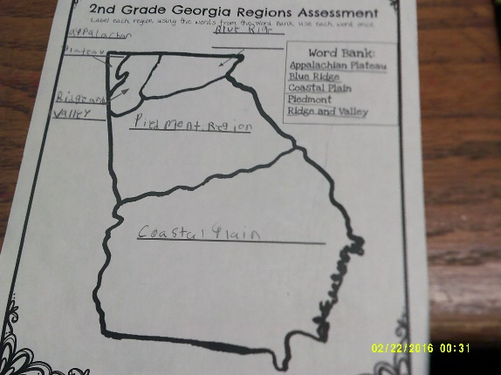
**Scroll Down for Unit Standards**

Unit Standards:

ELA: ELAGSE2SL3: Ask and answer questions about what a speaker says in order to clarify comprehension, gather additional information, or deepen understanding of a topic or issue.
ELAGSE2L2: Demonstrate command of the conventions of standard English capitalization, punctuation, and spelling when writing.
ELAGSE2W2: Write informative/explanatory texts in which they introduce a topic, use facts and definitions to develop points, and provide a concluding statement or section.
Priority reading standards
ELAGSE2RF3 Know and apply grade-level phonics and word analysis skills in decoding words.
ELAGSE2RL9 Compare and contrast two or more versions of the same story (e.g., Cinderella stories) by different authors or from different cultures.
ELAGSE2RI9 Compare and contrast the most important points presented by two texts on the same topic.
ELAGSE2RL4 Describe how words and phrases (e.g., regular beats, alliteration, rhymes, repeated lines) supply rhythm and meaning in a story, poem, or song.
ELAGSE2RI4 Determine the meanings of words and phrases in a text relevant to a grade 2 topic or subject area.
Writing
ELAGSE2W3 Write narratives in which they recount a well-elaborated event or short sequence of events, include details to describe actions, thoughts, and feelings, use temporal words to signal event order, and provide a sense of closure.

Math:

Science: N/A

Social Studies: SS2G1 Locate and compare major topographical features of Georgia and describe how
these features define Georgia’s surface.
a. Locate and compare the geographic regions of Georgia: Blue Ridge, Piedmont, Coastal
Plain, Ridge and Valley, and Appalachian Plateau.
b. Locate on a physical map the major rivers: Savannah, Flint, and Chattahoochee.
SS2G2 Describe the cultural and geographic systems associated with the historical figures
in SS2H1 and Georgia’s Creek and Cherokee in SS2H2.
c. Describe how the region in which these historic figures lived affected their lives and
compare these regions to the region in which students live.
d. Describe the regions in Georgia where the Creek and Cherokee lived and how the people
used their local resources.

