# **September 24 Meeting National Honors Society**

1. Attendance

2. Make sure you turn in Semester 1 Grades in January. There will be no meeting.

3. Volunteer Opportunities

a. Basketball and Wrestling Concessions do count

b. Need Volunteers for homework help, passing out snacks, “play time” (Heritage Academy downtown -December 2- 13th from 3-5:30 pm : K-5th grade)

*Address 333 Greene Street, Augusta, GA 30901

* Sign up using the form

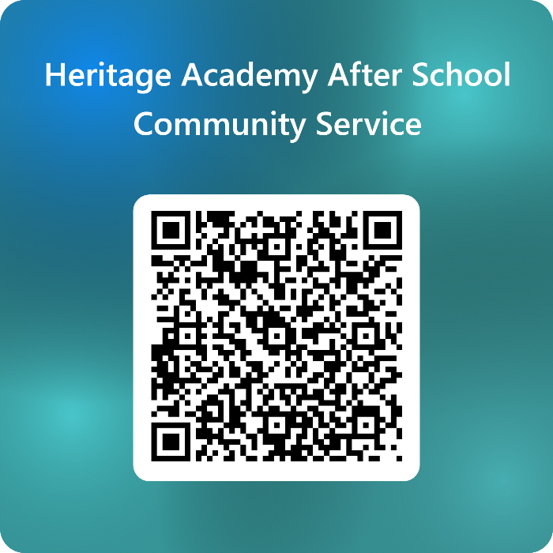

+

c. Can also donate peanut free snacks, markers, glue sticks, pencils, paper, colored pencils to Heritage Academy.

d. Toys for Tots?

e. MS Walk – Vote yes or no for (finish Line Celebration Team) this event on the whiteboard.

\***Saturday, March 15th** **2025**

e. See Wilmur for other events