**8th Grade Georgia Studies**

In the 8th grade, students will study the geography, history, government, and economy of Georgia. In order to prepare, upcoming 8th graders are being asked to visit the “Explore Georgia” site and order, **FREE OF CHARGE**, the “Georgia Official State Travel Guide” and the “Georgia State Parks & Historic Sites” brochure.

1. Visit the following site: <https://exploregeorgia.org/brochures/free-georgia-travel-guide>
2. **With your parents’/guardian’s permission**, please fill in your mailing information.
3. Where it asks, Would you like to order any additional Georgia brochures by mail, please select yes, then select “Georgia State Parks & Historic Sites”

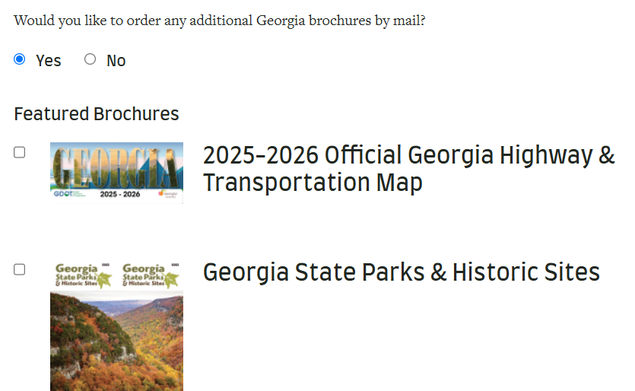

1. After receiving your brochures, have fun browsing through the information.
2. From the brochures, decide three places that you would like to visit. Write a separate, well-written paragraph for EACH place you chose, following this format:

* The first sentence should tell which place you chose
* two sentences giving general information about the place
* an explanation of why you feel this place would be enjoyable
* an explanation of who you would like to take with you to visit this place and why you would take them
* 8th grade students must write complete sentences with a capital letter at the beginning of each sentence and a punctuation mark at the end.