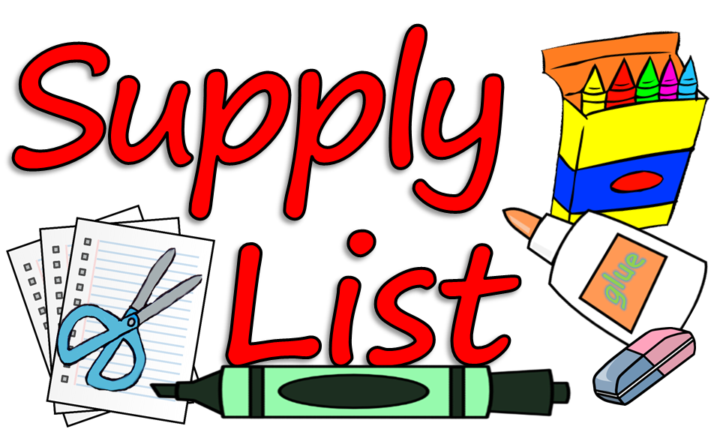

Antibacterial Liquid Soap

Clorox/Lysol Disinfectant Wipes

Hand Sanitizer

Baby Wipes

Kleenex

Standard Size Backpack

Family Photo \***will be posted inside of the classroom on our Classroom Family Tree\***

Full Change of Clothes \***please place in a Ziploc Bag with your child’s name\***

Individual snack each day

Plastic Water Bottle **\*please label with your child’s name\***

Blanket

1 – (24) - Count Box of Crayons

1 – (12) - Count Pack of Markers

1 – (12) - Count Pack of Colored Pencils

1 –(2) – Count of Glue Sticks

1 - 5” Pair Blunt Edge Scissors

1 – (4) – Pack of Play-Doh (Any Colors)

1 - Small Pencil Box

Zip Loc Bags – Gallon/Sandwich/Quart Sized

5 oz. Dixie Cups

2 – Yellow Plastic Pocket Folders

2- Blue Plastic Pocket Folders

1 – Pack of Dry Erase Markers