February 25

1. Attendance
2. If interested in running for Office, see me before leaving for an application.
3. March Heritage Academy Volunteering Afterschool until 4

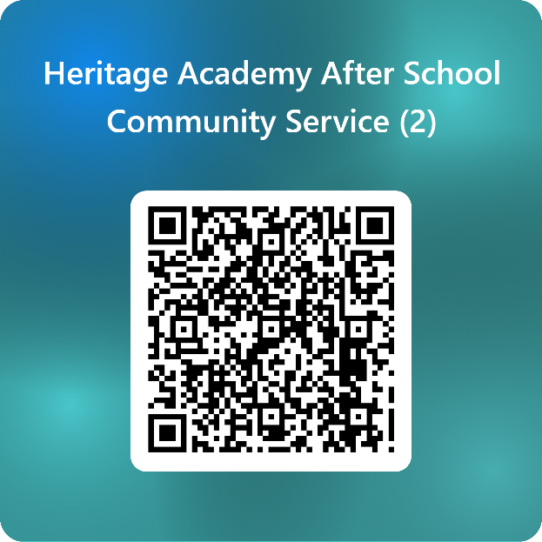

1. MS Walk : Saturday, March 15th, 2025
   1. Permission forms
2. REPORT CARDS Needed ASAP (I have to turn in names for cords on Friday!)
   1. Seniors: No grade verification (report card) no cords for grad!
   2. Seniors: I need a nice photo of you, what college you're going to/job, Field of Study (or if military branch), any scholarship information. This is for Induction. Want to celebrate ya’ll.
   3. ALL but especially SENIORS: Need your hours. No verification of community service means no cord!
3. Induction: April 23 5pm All invited!