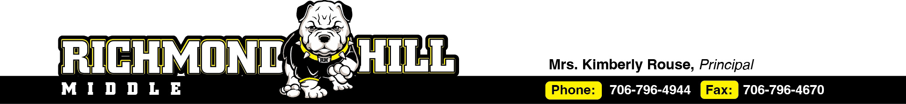

**Right to Know Professional Qualifications of Teachers and Paraprofessionals**

Date: **August 5, 2025**

Dear Parents,

In compliance with the requirements of Every Students Succeeds Act, the **Richmond Hill Middle School** would like to inform you that you may request information about the professional qualifications of your student’s teacher(s) and/ or paraprofessional(s). The following information may be requested:

* Whether the student’s teacher—
* has met State qualification and licensing criteria for the grade levels and subject areas in which the teacher provides instruction.
* is teaching under emergency or other provisional status through which State qualification or licensing criteria have been waived; and
* is teaching in the field of discipline of the certification of the teacher.
* Whether the child is provided services by paraprofessionals and, if so, their qualifications.

If you wish to request information concerning your child’s teacher’s and/ or paraprofessional’s qualifications, please contact Mrs. Kimberly Rouse (Principal)at [(706) 796-4944](https://www.google.com/search?q=richmond+hill+middle+school&oq=richmond+hill+middle+school&gs_lcrp=EgZjaHJvbWUqDggAEEUYJxg7GIAEGIoFMg4IABBFGCcYOxiABBiKBTIQCAEQLhivARjHARiABBiOBTIHCAIQABiABDIHCAMQABiABDINCAQQLhivARjHARiABDIHCAUQABiABDIGCAYQRRg8MgYIBxBFGD3SAQg0MjM5ajBqNKgCALACAQ&sourceid=chrome&ie=UTF-8).

Sincerely,

**Kimberly Rouse**

**Principal**