

**PYP Admissions Policy**

Copeland Elementary is a Candidate School* for the Primary Years Program (PYP) This school is pursuing authorization as an IB World School. These are schools that share a common philosophy—a commitment to high quality, challenging, international education that Copeland Elementary believes is important for our students.

*Only schools authorized by the IB Organization can offer any of its four academic programmes: the Primary Years Programme (PYP), the Middle Years Programme (MYP), the Diploma Programme, or the Career-related Programme (CP).  Candidate status gives no guarantee that authorization will be granted. For further information about the IB and its programmes, visit [www.ibo.org](https://ibo.org/)

**Mission**: The mission of Copeland Elementary is to provide globally diverse, rigorous, and relevant instruction to prepare…

**W**orldly

**I**nquiring

**L**imitless

**D**etermined

**C**aring

**A**ccountable &

**T**alented

**S**tudents

In collaboration with the Wildcat community.

**Vision**: Copeland Elementary will provide a well-balanced curriculum through the use of innovative teaching strategies and technology to meet the varied needs of students.

**Copeland Elementary School**

**Copeland Elementary School is a Title One Public School.**

Copeland Elementary is located in Augusta, Georgia. Our doors opened in September 1959 to serve the students in this diverse community. Today our school serves approximately 425 students in grades Pre-K through 5.

**Georgia Enrollment Requirements:**

Georgia law requires that children must be five years old on or before September 1 to enroll in kindergarten and six years old on or before September 1 to enroll in first grade in public schools. A child who has lived in another state for at least two years before moving to Georgia, and was legally enrolled in a public kindergarten or first grade in that state, may enroll in a Georgia public school kindergarten or first grade, provided the child will be five for kindergarten and six for first grade by December 31. Limited seats are available at various locations in pre-Kindergarten programs for preschoolers who participate in the annual Georgia Pre-K Lottery program. To qualify for pre-K, children must be four (4) years old by September 1.

**Participation in IB:**

Students at Copeland Elementary School will be educated following the IB philosophy which includes but is not limited to:

* Inquiry-based teaching
* Holistic and interdisciplinary education
* Character development through the IB learner profiles
* Teaching through global contexts through transdisciplinary units
* Internal assessment requirements

All students at Copeland Elementary participate fully in the IB Primary Years Program.

**Admissions Procedure:**

Admission into Copeland is based on the student’s district zone. Students must register each year and complete the enrollment paperwork verifying their address (Appendix A). Students who wish to attend Copeland but do not reside in Copeland’s zone may request a zone exemption under the School Choice Policy. Parents and students must complete the application process on the district’s website from November 1st – January 8th. Students who request a zone exemption for Copeland must be in good academic/behavior standing and the request must be approved by the school’s principal. Students who are zoned for Copeland but wish to attend another school must follow the same procedure. Choice schools offer academic programs aimed at increasing student achievement. Since Copeland is a PYP Candidate school, Copeland is a choice school.

**House Bill 251:**

Under a 2009 state law (O.C.G.A. § 20-2-2131), parents may request a transfer to another public school within their local school district to specified schools and grades designated as possibly having space available. In the RCSS, any school with an enrollment below 90% capacity will be considered a participating school. If a parent chooses to transfer a child to another school in the system, the law requires that they assume all costs and responsibilities related to the transportation of the child to, and from, the school as long as the child remains at that school. If a parent does not enroll their child/children in the school that they were approved to attend by the first week of school, the House Bill 251 approval becomes obsolete. Applications for HB251 may be completed each year from November 1st - May 1st.

**Transfer Students:**

Students new to Richmond County Schools, transfers from within the state of Georgia, and out-of-state transfers need the following documents:

* Latest copy of student's report card or withdrawal form from previous school (if applicable)
* Legal guardian's photo ID
* Social Security Card
* Proof of Residency
* Official Copy of Birth Certificate
* Completed Eye, Ear, and Dental Form**
* Completed Immunization Form**
* Home Language Survey
* Parent Occupational Survey

Transfers from within Richmond County Schools need the following documents

* Latest copy of student's report card or withdrawal form
* Legal guardian's photo ID
* Proof of Residency

**Hardships:**

If the student's family is residing in the dwelling of another individual, not due to economic reasons and/or undue hardships*, the person with whom the family is living and whose name matches the proof of residence must present these documents for enrollment:

* Notarized third-person affidavit of residency
* Photo ID of person with whom the family is residing
* Proof of Residency matching the name and address of person with whom the family is residing
* Inclusion of person with whom the family is residing as a contact on the registration form

*If the student's family is currently in transition and dealing with economic difficulties or other hardships, families are referred to the Homeless Liaison for additional assistance. The McKinney Vento, Title IX, Part A, ensures students experiencing homelessness have access to equal education and other services they may need (2021 Georgia Department of Education)

**Policy use and review:**

Copeland’s IB Admissions Policy is a working document that will be reviewed annually by the pedagogical leadership team (administrators, IB Coordinator, department chairs and interested teachers)

**Appendix A**

**REGISTRATION INFORMATION for Copeland Elementary Parents**

Effective for the 2020-2021 school year, ALL parents will register their children *ONLINE*. You may do this at your earliest convenience at home OR we will be available to assist you at the school BY APPOINTMENT ONLY each Tuesday and Thursday 11:00 am – 1:00 pm or 4:00 – 6:00 pm starting the week of August 10th through September 3rd. **If your child is attending the Online Academy, you must also register your student(s) for school for the upcoming school year.**

Please visit the Richmond County School System website at [www.rcboe.org](http://www.rcboe.org), click on the Parents tab and go to [Registration Central](https://www.rcboe.org/Domain/9228) for *all information* regarding registration for the upcoming school year. **\*\*IMPORTANT - Write down your Application Number\*\***

If you are not able to upload the documents required for registration, you must come to Copeland to provide those documents. *Your child will not have a schedule until all required documents are verified.* Please visit the [school’s website](https://www.rcboe.org/copeland) to select an appointment day/time. ***We ask that you attend this appointment by yourself to facilitate being able to social distance. If you are providing a notarized third-person affidavit of residency, both parties need to attend the registration appointment with their proper identification.***

**RETURNING STUDENTS**

* **NO Parent Portal account**: create one [here](https://campus.rcss-k12.org/campus/K12_Custom/cParent/index.jsp?appName=richmond) [you need students last 4 digits of their SSN and birthdate].

1. Login, click ‘More’, click ‘Online Registration’
2. Click ‘Existing Student Registration’
3. Click ‘Begin Registration’
4. Follow the prompts and answer ALL questions

* **HAVE Parent Portal account**: login in [here](https://campus.rcss-k12.org/campus/portal/richmond.jsp) and follow the same instructions above
* Required Documents:
  + Legal guardian photo ID
  + Proof of residence

**RCSS TRANSFER STUDENTS**

* Follow the information for **Returning Students** above
* Required Documents:
  + Legal guardian photo ID
  + Last report card or withdrawal form
  + Proof of residence

**NEW TO RICHMOND COUNTY**

* Register your child at [Registration Central](https://www.rcboe.org/Domain/9228) and follow the prompts; answer ALL questions
* Required Documents:
  + Legal guardian photo ID

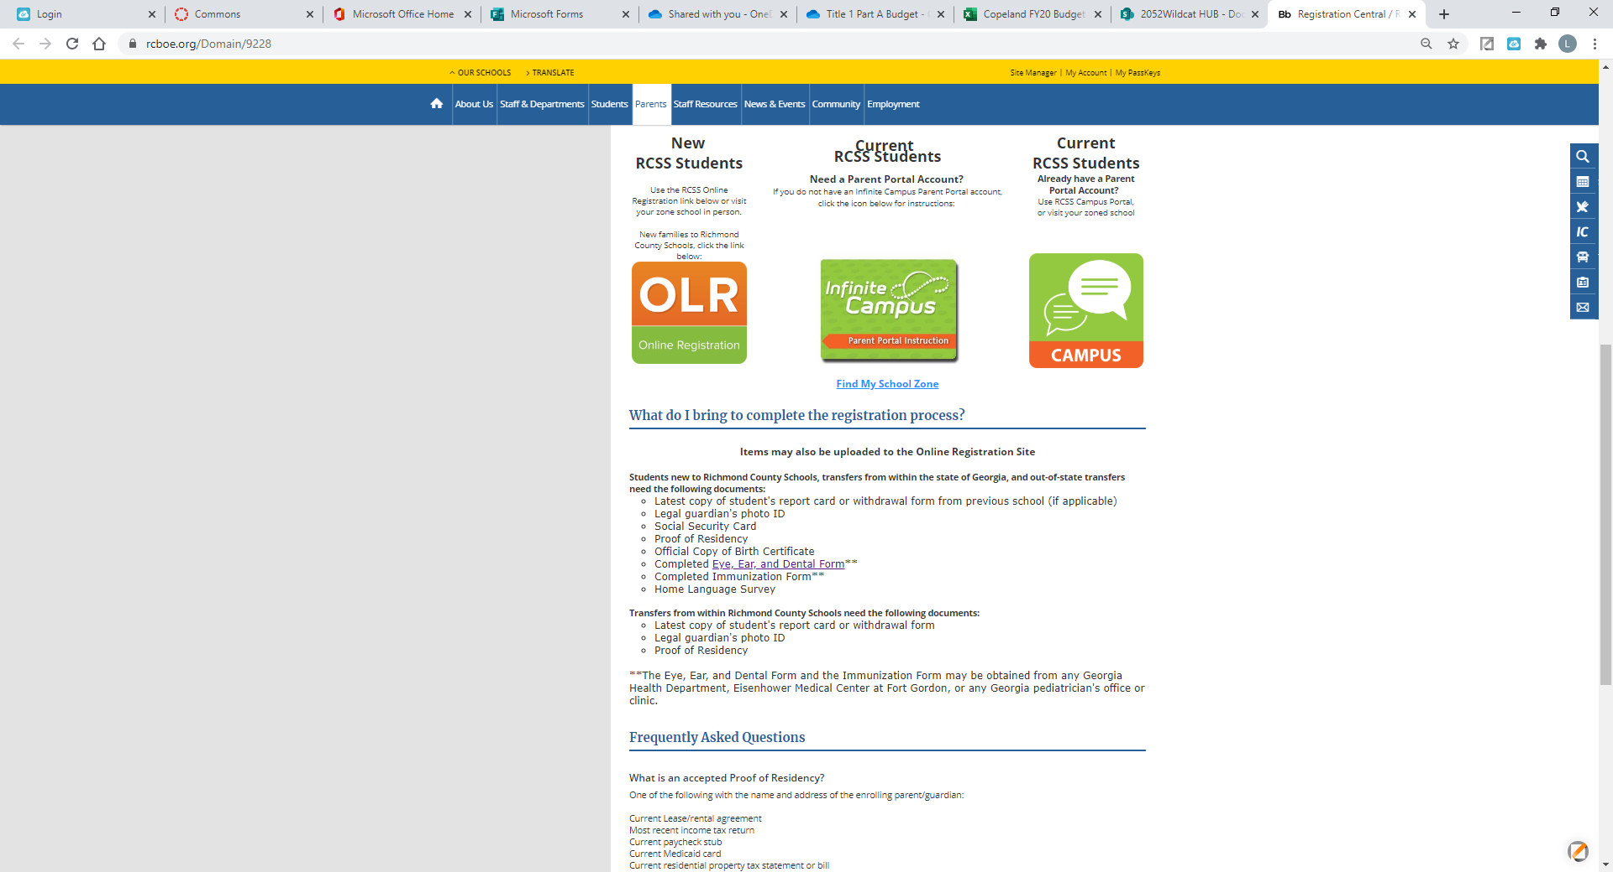

* + Last report card or withdrawal form
  + Social Security Card
  + Official copy of birth certificate
  + Completed Eye, Ear and Dental Form (form 3300)
  + Completed Immunization Form (form 3231)
  + Proof of residence

Revision: 11/09/2021

This policy was written by the PYP Coordinator. This policy was reviewed by the Data Specialist, Assistant Principal and IB Steering Committee.

Revision: 1/4/2022

The policy was reviewed by the faculty. Edits were submitted via Canvas.

Revision 2/23/2022

The policy was reviewed by the faculty. Edits were submitted via Canvas