Grade Level: Pre-K Dates: January 10,2022 to February 18, 2022
School Information  School: Copeland Elementary  School Code: 060043  Teachers: Ms.Godbee and Ms.Hanley  Buffer: | Transdisciplinary Theme: Where We Are in Place and Time  Segment of Theme: Technology, History  Over Arching Concept: Curiosity
Section 1: Overview
- Central Idea: Learning about the past can help us make connections to the present and future.
- Key Concepts: Change, Function, and Connection
- Guiding Related Concepts: | - Lines of Inquiry: | - Teacher Questions (Guided Questions):
Curiosity  Creativity  History  Researcher | An inquiry into how people change  An Inquiry into technology throughout history.  An inquiry into how new technology is developed. | DOK Level 3 & 4  How did people communicate before phones?  What are some ways technology will help us in the future?  How did people travel before cars?  How did people cook before stoves were invented?  Compare and contrast the way people dress today with the way people dressed in the past.
- Prior Content Knowledge: | - Assessing the Lines of Inquiry:
Playing dress up in Home Living center  Playing with different types of phones in centers  Playing with animals and cars in centers | How will you assess student’s understanding of the lines of inquiry?  - KWL chart on past and present technology  - Matching game of past and present technology  - Discussions on how people use to live in the 1800s, 1900s, and the 2000s  - Using different materials to create a mode of transportation from the past and present  - Using different materials to create clothing from the past and present.
Section 2: What Are Our Target Goals?
- Concept Based Summative Assessment: | - Targeted Approaches to Learning (highlight 3): | - Targeted Learner Profile Attributes (highlight 2):
Make a chart of past and present technology and how they are use.  Research project on how different modes of transportation was used in the past. | Social Skills, Research Skills, Communication Skills. Thinking Skills, Self-Management Skills | well-balanced, caring, principled, open-minded, risk taker, knowledgeable, communicator, reflective, thinker, inquirer
Section 3: What Assessments will be provided in this unit of inquiry?
- Pre-Assessments:  What assessment will be given at the beginning of the unit to inform current understanding | - Formative Content Based Assessments:  What assessments will be given to monitor student learning of content? | - Summative Content Based Assessments:  What assessments will be given for students to show mastery of unit content?
KWL chart on past and present technology  Matching games of clothes from the past and present  Drawing a picture of a modes of transportation from the past and present  Reading Transportation: Then and Now by Robin Nelson | Making collages of out magazine cutouts of clothes from the past  Drawing pictures of different modes of transportation from the past and present  Using technology from the past to communicate in writing (Type Writer) and in speaking (Phones made out of cups and string)  Daily Read Alouds on past and present  Center play with past and present clothes and technology. | Having weekly discussions on past and present things and how they are alike and how they are different.  Weekly journaling of thing we have learn about the past and present.  Completing our KWL chart on what we have learned from the unit.  Redoing our matching game of clothes from the past and present to see if our matches have changed
Section 4: How will we Facilitate Learning?
- Provocation:  How will interest into this unit be sparked? | - Learning Experiences:  What activities/experiences will help facilitate the learning? | - Evidence of Differentiation:  How will the learning experiences be adjusted to different learning styles/abilities?
Provocation – The teacher will share pictures of children from the 1800s and 1900s.  Students will have the opportunity to share how the children from this era dress different from them.  Questions:  How did people communicated before phones?  Will technology improve in the future?  How did people get around before cars?  How did people cook before stoves were invented?  How did people’s style of dressing change through the 1800s and 1900s? | Week 1:  Provocation – The teacher will share pictures of children from the 1800s and 1900s.  Students will have the opportunity to share how the children from this era dress different from them.  Students will draw a picture of their favorite clothing item from the 1800s. The teacher will label the picture of the drawing based on the student’s description.  Students discuss clothes form the 1800s, 1900s, and 2000s and the importance of wearing clothes.  Read alouds through the week connected to the unit – Clothing  My Very First Book About Clothes, What We Wear, Clothes  Week 2:  Students compare and contrast clothing from the past to the present  Students will make a collage of clothing from the past and present with cut outs of different clothing from each era.  Students will engaged in a virtual tour of Life as a Child in the 1800’s  https://www.youtube.com/watch?v=gVxad8R4Nig  Students will use the home living center to explore how to use clothing from different eras.  Read alouds through out the week connected to Clothes  Where Did My Clothes Come From, Let’s Dress, Joseph Had a Little Overcoat  Week 3:  Provocation: Teachers model the importance of technology from past and present in centers.  Virtual Tour of past technology https://www.youtube.com/watch?v=3CMS9xnBRkc  Read alouds through out the week related to past technology – Technology: A Bite Size World, Inventors Who Changed the World (Little Heroes)  Week 4:  Students will create phones from cups and string to see if the phones work like in the past.  Students will make a chart on how technology has change from the past to the present.  Read alouds through the week about technology:  Click, Clack, Moo, Most Important Inventions of All Time  Week 5  Teachers will present different modes of transportation from the past to the present.  Virtual Tour 1 of past and present transportation- https://www.youtube.com/watch?v=U-r-xHln6nE  Virtual Tour 2 of past and present transportation- https://www.youtube.com/watch?v=25IaUQ_oUyM  Make a chart on comparing and contrasting different modes of technology.  Read alouds through the week about modes of transportation: Rereading of Transportation: Then and Now, Little Blue Truck | Para will be available to assist as needed – Small group and one on one assistance.  Additional time can be set aside for students who need it  Modifications to assignments as needed  Provocation: Teachers model the importance of technology from past and present in centers.
- Learning Experiences in Specials:  How are Specials Courses able to connect to this unit? | - Local/National/Global Connections:  How can we connect the content to local/national/global issues? | - Student Action:  What learning experiences support potential student-initiated action?
Visual Art in the Classroom:  Art Center  Special’s Center | Display local pictures of our community from the past and present.  Discuss how past and present community brings awareness (climate change, poverty, hunger)  Virtual Tours | Students create their own collages of fashion from the past and present.  Students create a chart of how modes of transportation has change or stayed the same of the years.  Students may choose to incorporate clothing or technology into their imaginary play.
- Student Agency and Play:  What learning experiences provide students with voice, choice and ownership? What play opportunities will be provided by Kindergarten/Pre-K? hands on/STEAM for K-5? |  | - Resources:  Which resources will you and the students use? This may include people, places, technologies, learning spaces and physical materials.
Art center- materials to create self regulated collages  Dress up center- clothing that represents past and present fashion  Block center- different types of transportation  Library center- books- Fashion magazines, My Very First book about Clothes, What We Wear, Click, Clack Moo, Little Blue Truck |  | Chart Paper  Markers  Paper  Promethium Board  Art materials (glue, stickers, form pieces, and collage materials)  Life as a Child in the 18th Century- https://www.youtube.com/watch?v=gVxad8R4Nig  Long Ago and Now- https://www.youtube.com/watch?v=U-r-xHln6nE  History of Transportation- https://www.youtube.com/watch?v=25IaUQ_oUyM
Section 5: Reflection (Write the year, change font color for each year)
- Reflect on learning experiences:
Godbee-The students learn about past technology and present technology by playing with technology of the past and the present. By learning what names and functions of each technology and by playing a matching game and having discussions on the technology.
Hanley- Students were able to explore old technology during center and discussion time. They enjoyed the hands on experience.

- How were the tasks differentiated to meet different learning styles? |  | - How did the learning experiences and strategies we used throughout the unit help to develop and show students understanding of the central idea?
Godbee- By using charts, stories, and adding real items to centers help students learn about different technology from the past and watching a video on how children use to dress in different decades, help students learn the materials. These activities help visual and audio learners.  Hanley- We used pictures, small group and para support. |  | Godbee-Discussions about the different technology of past and present was evident that the students understood what the technology was about and how it was use. Putting past and present technology in different centers help the students make connections of the discussions we had about technology.  Hanley- Students were able to explore old technology during center and discussion time. They enjoyed the hands on experience.
- What learning experiences best supported students’ development and demonstration of the attributes of the learner profile and approaches to learning? |  | - How effective were the summative assessments in measuring student learning? What, if any, changes need to be made to the assessments?
Godbee- Develop an understanding- We use a KWL chart to ask the question “What do we want to learn?”  We put different technologies of past and present to show how they function, how they are connected, and how the technology has changed over the years.  The students became thinkers because we had to think about how technology can help us in everyday usage, how technology has changed over the years, and how can we use technology. We also became researchers because we had to research some of the older technology to see what their functions were in the past.  Hanley- We used Mind Maps to draw a web showing the growth of different items, such as the telephone.  We used old technology in each of our centers such as a phone book in the writing center and a walkman in the listening center. |  | Godbee- I think by showing pictures of the technology of past and present and having a discussion of what we think they do before we introduce the central idea will help the teacher prepare more on what the students know and what we need to teach the students about the technology.  Hanley- Having grandparents come in to talk to the children about the technology they used throughout their lives would have been a great way to include the community and families in this lesson.
- What student-initiated inquiries (questions) arose from this unit of inquiry? |  | - What student action arose from this unit of inquiry?
Godbee  How do you use a typewriter? We demonstrated how a typewriter works.  Can a typewriter be like a computer? We research to see if a computer was an improvement on the typewriter.  How does a phone work? We research to see how a phone works and what it takes to make a phone call.  Hanley- Hanley- Typewriter- “how do you delete a mistake?”  Walkman- “what if I want a new song?” |  | Godbee- While in centers, a group of students had different types of phones of past and present. The students were discussing how to use a dial up phone. One said, “ Push the buttons”, “Press the call button”, “Search your contact list”, and “I am going to just facetime my friend ‘.  Hanley- Students used old technology to play with in center time in the correct way and pretended to be in the past.
- Any additional notes or changes that need to be considered next year?
Section 6: Picture Evidence
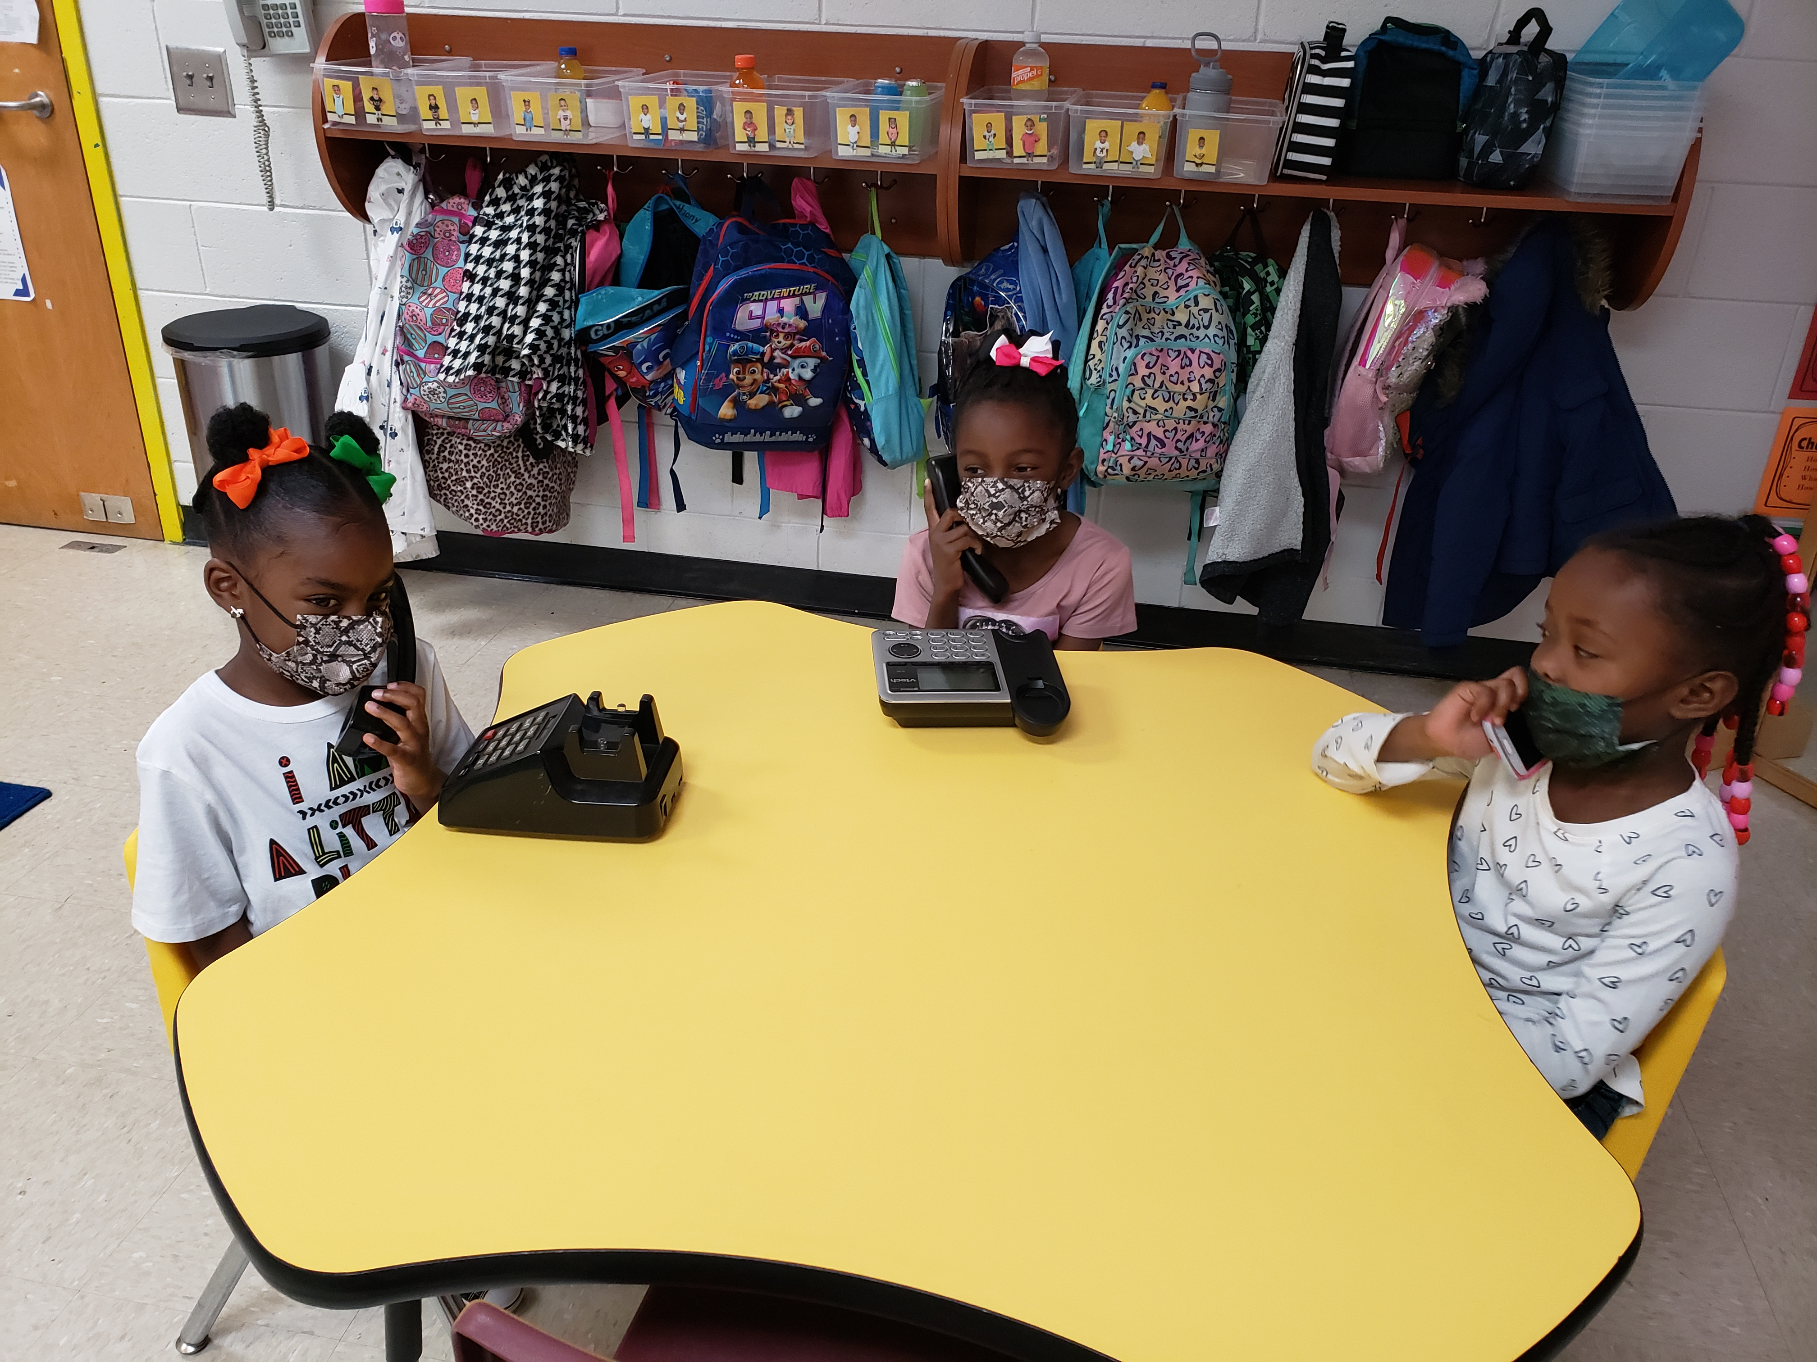
**Scroll Down for Unit Standards**

Unit Standards:

ELA:

Math:

Science:

Social Studies:
SS5.4a
SS5.4b
SS4.4d
SS1.4b

