Grade Level: PK Dates: 2/1-2/25
School Information  School: Copeland Elementary  School Code: 060043  Teachers: Hanley, Godbee  Buffer: N/A | Transdisciplinary Theme: How We Organize Ourselves  Segment of Theme: Human made systems  Over Arching Concept:Identity
Section 1: Overview
- Central Idea: measurement helps us understand our surroundings
- Key Concepts: Perspective, Form
- Guiding Related Concepts: | - Lines of Inquiry: | - Teacher Questions (Guided Questions):
Counting  Bigger or smaller | An inquiry into:  Types of measurement  Information gathered from measuring | DOK Level 3 & 4  Which object is longer?  How many blocks long is the table?  Will this object fit inside a smaller object?  Is it good to be small? Why?  What would happen if an object is too big, too small? How could we fix it?  Compare and contrast longer and shorter objects: nature objects, shoes, student height, ect)
- Prior Content Knowledge: | - Assessing the Lines of Inquiry:
Clothes sizes  Shoe sizes  Taller  shorter  Longer  Bigger | How will you assess student’s understanding of the lines of inquiry?  Students can sort objects from shortest to longest. (length)  Students can sort objects from smallest to largest (weight)  Students can name and use tools to measure the length and weight of objects.
Section 2: What Are Our Target Goals?
- Concept Based Summative Assessment: | - Targeted Approaches to Learning (highlight 3): | - Targeted Learner Profile Attributes (highlight 2):
Create a tallest to shortest poster with pictures of objects.  Students use counting blocks to measure their shoe. | Social Skills, Research Skills, Communication Skills. Thinking Skills, Self-Management Skills | well-balanced, caring, principled, open-minded, risk taker, knowledgeable, communicator, reflective, thinker, inquirer
Section 3: What Assessments will be provided in this unit of inquiry?
- Pre-Assessments:  What assessment will be given at the beginning of the unit to inform current understanding | - Formative Content Based Assessments:  What assessments will be given to monitor student learning of content? | - Summative Content Based Assessments:  What assessments will be given for students to show mastery of unit content?
Show students pictures of big vs small objects have them label the big object.  Ask students how many blocks long is the object at their seat. Students will count out loud. | Math center  - Measuring tape, scale, cooking scale  Observe students during these activities and discuss their measurements. | Measure a ruler with two types of units  Line up shortest to tallest  Label larger vs small objects  Draw a large tree and a small tree
Section 4: How will we Facilitate Learning?
- Provocation:  How will interest into this unit be sparked? | - Learning Experiences:  What activities/experiences will help facilitate the learning? | - Evidence of Differentiation:  How will the learning experiences be adjusted to different learning styles/abilities?
Watch sorting and matching https://www.youtube.com/watch?v=4EFLltiMTmk  Read Small Medium Large by Elizabeth Bennett | Offer a selection of apples in varying sizes. Using string and child safety scissors, the teacher will demonstrate how to wrap the string around the middle of each apple, cutting the length when it meets.  Nature walk-Take along two paper bags, with one labelled “small” picturing a fingernail and the other labelled with “big” and an illustration of a hand. Ask students to find nature items and decide if they are big or small, placing them in the correct bag.  Math Center – Measuring tape, ruler, scale, cooking scale – students will practice measuring the length, height, weight of various objects.  Daily read alouds on big vs small  - How big is a foot  - Measuring Penny  - Actual size  - How big is a whale?  Students will collect various objects and create a tallest to shortest poster using the various objects. Students will put their objects in order of shortest to longest. (Summative Assessment) | Small group and individual instruction with para.  Modified activities for students as needed: ex precut string in apple activity.  Rephrasing/reteaching concepts for students in small group or individually as needed
- Learning Experiences in Specials:  How are Specials Courses able to connect to this unit? | - Local/National/Global Connections:  How can we connect the content to local/national/global issues? | - Student Action:  What learning experiences support potential student-initiated action?
PE Teacher will allow use of gym for height jumping activity, Students jump a small cone and a large cone and measure the distance of the jump.  Students will measure each other using a measuring tape and determine who is taller | Discuss how different units of measurement are used in different countries, Kilometers vs miles | Students measure each other against the wall to see who's taller  Students point out big vs small things outside and inside the classroom  Students will take a nature walk and choose objects that are smalls and large. Students will sort their objects into bags. Students will have the choice on what objects they chose for their bags.
- Student Agency and Play:  What learning experiences provide students with voice, choice and ownership? What play opportunities will be provided by Kindergarten/Pre-K? hands on/STEAM for K-5? |  | - Resources:  Which resources will you and the students use? This may include people, places, technologies, learning spaces and physical materials.
Game- Mother May I (small medium and large step)  High/Low jump rope  Lego- build large vs small, tall vs short  Science center- measuring tape, scales  Library- measurement books  Dress up- large vs small food and baby dolls  Writing- collage materials tall vs short  Math Centers |  | Books- How big is a foot  Measuring Penny  Actual size  How big is a whale?  Small medium large  Scales  Measuring tape  Unifix cubes  Rulers  Gym for cone activity  Outdoors/playground area for nature walk
Section 5: Reflection (Write the year, change font color for each year)
- Reflect on learning experiences:
Godbee- The students really learning and using different materials to measure objects in the classroom. The students started the lesson by reading a book on measurement and then going over basic then technique about measuring. The students were put into small groups and learn how to use different things to measure items. The students’ favorite activity was measuring the heigh of a classmate. Overall, I think the lessons taught the students about measuring and the students had fun doing the activities.

Hanley- The class enjoyed learning about how measurement is used the real world. They learned what tools are used to measure and why measurement is important.

- How were the tasks differentiated to meet different learning styles? |  | - How did the learning experiences and strategies we used throughout the unit help to develop and show students understanding of the central idea?
Godbee- In the small groups, we use different tools to things such as a rulers, math manipulatives, scales, and graphs. The students got a chance to use each of the tools and then pick which one they like the best to move from one small group to another to measure the items. For example, student A was going to measure a classmate on the floor. Student A decided to use bear counters to line up beside the classmate to measure the classmate from head to toe, when student B came along and decided to use rulers to measure the same classmate from head to toe.  Hanley- We used pictures to demonstrate how to measure. Small groups with the support of a para and sped teacher as well as modeling and hand over hand assistance at times. |  | Godbee- By using different tools to measure different things in the classroom, it help students understand that people in the world use different use tools or things to measure items. This unit showed the students how in different countries how they use string to measure, how in America, we use measuring tape or rulers to measure items. It also taught our students of community helpers who use measurement as part of their careers.  Hanley- Students learned how and why measurement is used in the real world. They learned what jobs require measurement and hobbies such as cooking.
- What learning experiences best supported students’ development and demonstration of the attributes of the learner profile and approaches to learning? |  | - How effective were the summative assessments in measuring student learning? What, if any, changes need to be made to the assessments?
Godbee- The learning experiences that help the students learn about measurement was the different small groups that involved the students using different tools to measure. The students got a chance to use string, rulers, measuring tapes, scales, and math manipulatives to measure things. The activity that really got the students interesting in measuring was the activity were the students measured each other. They really enjoyed using different tools to measure their classmates.  Hanley- The measurement tools being available during center time was one of the most successful activities. Students were able to explore the tools and measuring different objects. |  | Godbee- The summative assessments really showed if the students grasp the concept of the big and small and the length of things. The students got a chance to draw a big tree and a small tree and we also found a game on iXL that the students could pick the largest and smallest items. I think no changes need to made to the assessment.  Hanley- The summative assessments showed not only if the students grasped the concept of measuring but also their counting and 1:1 correspondence skills.
- What student-initiated inquiries (questions) arose from this unit of inquiry? |  | - What student action arose from this unit of inquiry?
Godbee- The students ask:  How does an architect use tools to measure?  Can we use water bottles to measure?  How do people in Africa measure things in their homes?  Hanley- Can we cut this smaller to fit?  What if I lost my ruler?  That block looks heavier |  | Godbee- During center time, the students use materials in the math area to measure items such as tables, shelves, friends, and the classroom floor.  Hanley- During center time students started guessing which of two objects was taller, used scales to measure weight and stood on a scale to see how much they weigh.
- Any additional notes or changes that need to be considered next year?
No
Section 6: Picture Evidence
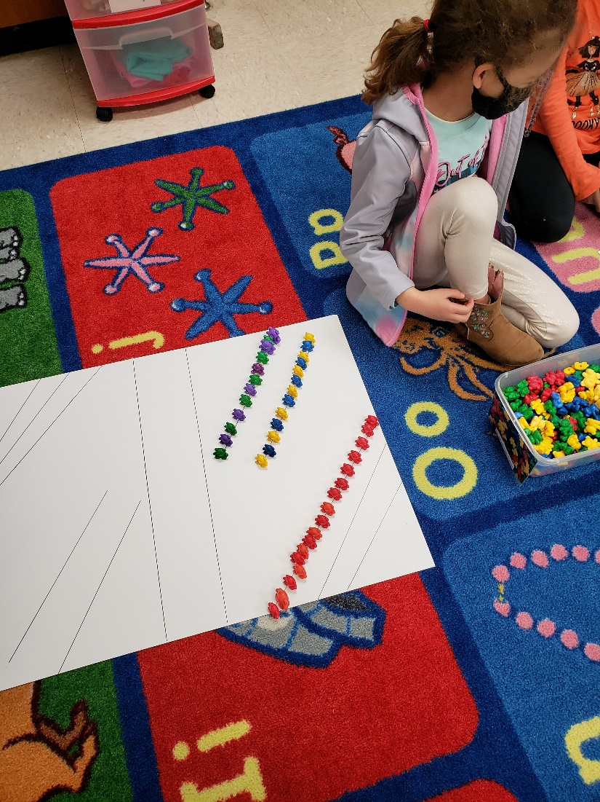

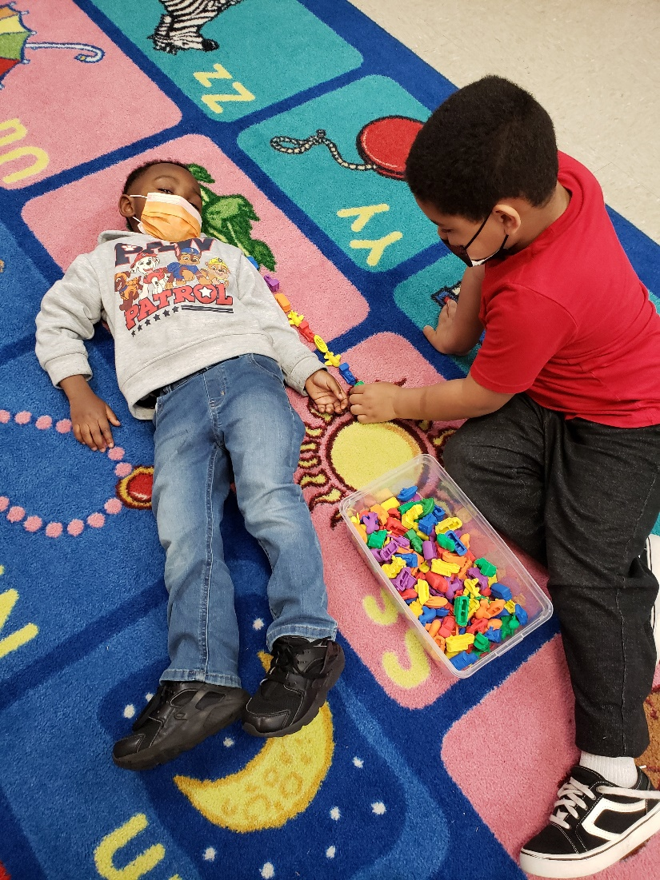
**Scroll Down for Unit Standards**

Unit Standards:

ELA:

Math: CD-MA3.4a Uses mathematical terms to describe experiences involving measurement.

CD-MA3.4b Compares objects using two or more attributes, such as length, weight and size.

Science:

Social Studies:

