|  |  |  |
| --- | --- | --- |
| **K**= What I already KNOW about the Montgomery Bus Boycott | **W**= What I would like to learn about the Montgomery Bus Boycott | **L**= New information learned about the Montgomery Bus Boycott |
|  |  |  |

Georgia Standards of Excellence:

SSSocIC2: Analyze social change processes in a society

I CAN STATEMENT:

I can analyze social change processes and in a society.

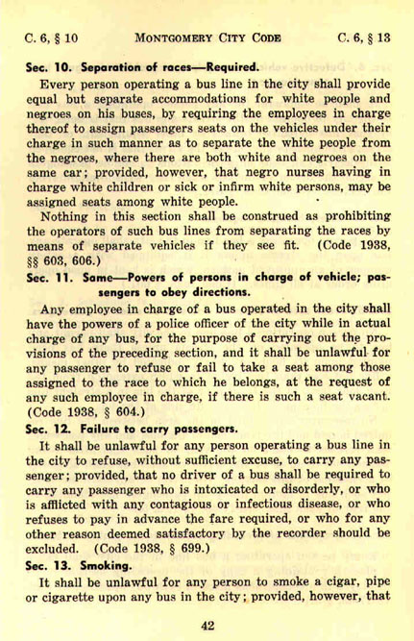

Points of Discussion:

How can everyday people organize to transform a community?

Does the general public regard Rosa Parks as a historical figure or more of a legend?

Who is Claudette Colvin and why is she left out of the mainstream historical narrative?

Did the citizens of Montgomery achieve justice, social transformation, and/or reconciliation as a result of their nonviolent direct action?

Some have described the Montgomery bus boycott as the beginning of the civil rights movement. Is that an accurate description? How should the boycott be situated in the broader African American freedom struggle? How should it be told?

<https://gpb.pbslearningmedia.org/resource/cdc9c86b-3888-4812-a708-3a879a31d77a/the-civil-rights-movement-taking-a-stand/>

MONTGOMERY BUS BOYCOTT

|  |  |  |  |
| --- | --- | --- | --- |
| PROBLEM | PROPOSED SOLUTIONS | OBSTACLES TO ACHIEVING SOLUTIONS | RESULTS OF MOVEMENT |
|  |  |  |  |