Setting up Mobile app Option for

Multi-Factor Authentication

The easiest verification method to use is the Microsoft Authenticator mobile app. Instead of typing in a 6-digit code, It's just one click. Roaming fees are not incurred when using the mobile app.

1. Download and install Microsoft Authenticator app on your mobile device

Install the latest version of the Microsoft Authenticator app, based on your operating system:

* **Google Android.** On your Android device, go to Google Play to download and install the Microsoft Authenticator app.
* **Apple iOS.** On your Apple iOS device, go to the App Store to download and install the Microsoft Authenticator app.

1. Using your computer, set up the Microsoft Authenticator app

Step 1:

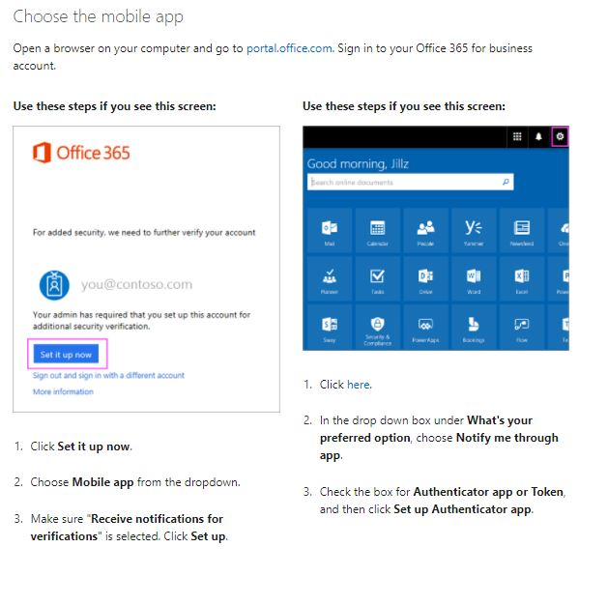

Step 2:

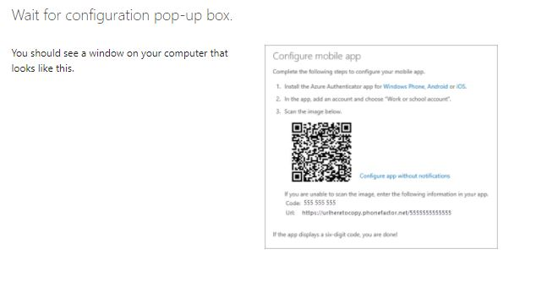

Step 3:

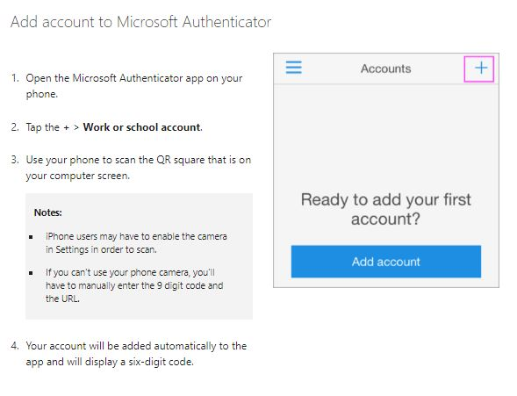

Step 4:

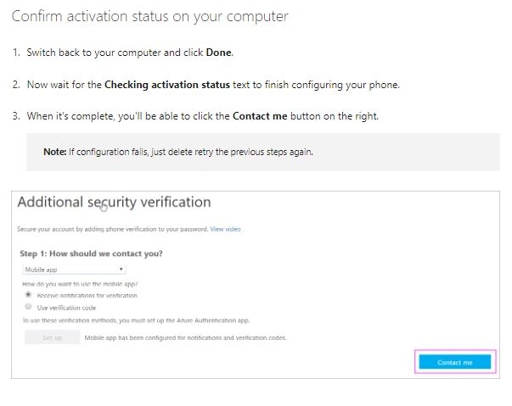

Step 5:

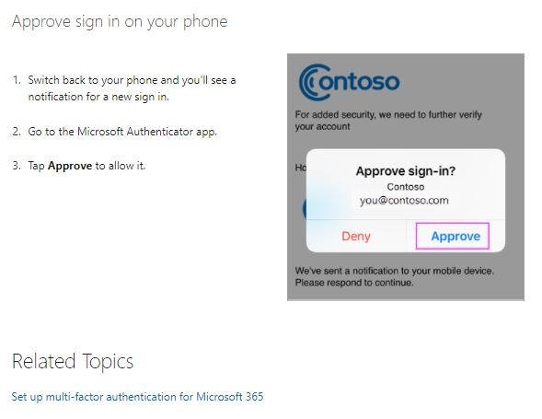

Step 6:

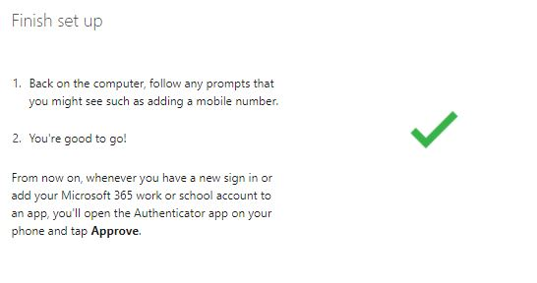

Step 7. The End