

HHS BOYS BASKETBALL TRYOUTS

2023-2024

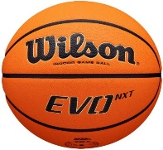

* Any young men interested in trying out for basketball that are not currently playing a fall sport, need to pick up a packet from Coach Streetman in room #237 from October 11-October 17, 2023.
* Completed packets are due by **October 19, 2023.** Students will not be able to attend tryouts without turning in completed packet **on time.** Packets will not be accepted during tryouts.
* Tryouts are from **October 23, 2023-October 25, 2023 from 2:30-4:15 in the old gym.**  Students are to enter through the weight room door. Please bring shoes for the track and the gym.
* Students must academically eligible, and have a current physical on file.

Coach Billterrenice Streetman, Varsity Boys Basketball Head Coach

Coach Henry Graham, Junior Varsity Boys Basketball Head Coach & Varsity Boys Assistant Coach

Coach Robert L. Jones, Varsity and Junior Varsity Boys Assistant Coach

Coach Adrienne Stuckey-Terry, Varsity and Junior Varsity Boys Assistant Coach