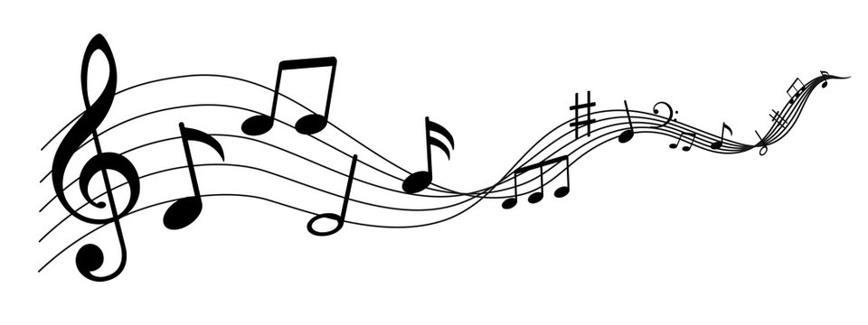

**Standards for Band**

MSBB.CR Improvise, compose, and arrange music within specific guidelines.

MSBB.PR.1 Sing alone or with others

MSBB.PR.2 Perform on instruments through a varied repertoire of music, alone and with others

MSBB.PR.3 Read and identify elements of notated music

MSBB.RE.1 Listen to, analyze, and describe music

MSBB.RE.2 Respond to music and music performance of themselves and others

MSBB.CN.1 Understand relationships between music, other arts, other disciplines, varied contexts, and daily life

**Welcome to**

**Belair Band**

**WELCOME**

Welcome the Belair Band program! My name is Mrs. Salomone and I am so excited to continue this amazing journey of offering band to our middle school students.

I am glad you are on this journey with us. Music does so much for our brain and for our soul. Music teaches us discipline and dedication, it teaches us to read and interpret a completely different language, while at the same time, allows us to play our emotions for ourselves and for others.

There are so many opportunities that are available for our students to participate in at the Middle School Grades, but also in high school and then on into college as scholarships and other performance opportunities arise. My goal is for students to learn to play and love music in the Middle Grade Level, but also become lifelong musicians.

**Grade Scale:**

A - 90-100   
B - 80-89   
C - 75-79   
D - 70-74   
F - Below 70

**Grade Weights:**

60% Minor Grades

40% Major Grades

**Class Materials:**

1 in. black binder with clear cover

1 composition notebook

Pencil Pouch

Pencil & Highlighter (any color)

Instrument

Essential Elements Book 1

**Contact Me:**

The fastest line of communication between home and school will be through Class Dojo or Email:

salomgr@boe.richmond.k12.ga.us

**Consequences:**

Nonverbal Warning

Verbal Warning

Student Conference

Parent Contact

Detention

Referral

**Class Expectations:**

I will use self-control over my actions

I will remain on task and on time

I will demonstrate acceptance of others and their difference.

I will respect my school, peers, and teachers

I will be flexible and open-minded about changes

**Performing Arts Classes at Belair K-8**

6th Grade- Beginning Band

7th Grade- Intermediate Band

8th Grade- Advanced Band

Name: Mrs. Gretchen Salomone

Room: 207

Email: salomgr@boe.richmond.k12.ga.us



[This Photo](https://commons.wikimedia.org/wiki/File:Pencil_clipart.svg) by Unknown Author is licensed under [CC BY-SA](https://creativecommons.org/licenses/by-sa/3.0/)

 

**Cut, Sign, & Return**

Please sign below to indicate that you have read and reviewed the class expectations and overview in this syllabus.

______________________________ ____________________________________

Student Signature Parent Signature

Is there anything you would like me to know about your child?

**Late Work**

Students will receive a 5 point deduction for each day that an assignment is turned in late- up to 5 days. After the 5th day, late assignments will not be accepted. Please make sure to turn assignments in on time.

**Grading Policy**

Minor Grades (60%)- Minor grades will be daily classwork and homework (usually started in class).

Major Grades (40%)- Performance and other assessments.

100-90=A 89-80=B 79-75=C 74-69=D 70 & Below= F

Please note, for any grade with a 60, please read the notes in the grade book.

**Technology in the Classroom**

Students will use technology in the classroom. Canvas will be utilized throughout the year for assignments and information.



[This Photo](https://commons.wikimedia.org/wiki/File:Pencil_clipart.svg) by Unknown Author is licensed under [CC BY-SA](https://creativecommons.org/licenses/by-sa/3.0/)

**Behavior Expectations**

Where Falcons Lead, Excellence Follows. Students are expected to SOAR at Belair.

**S**- Have self-control over my actions at all times.

**O**- On task & On Time in all that I do

**A**- Acceptance of others & their differences

**R**- Respectful to my teachers, peers, and school

Please see the SOAR matrix for more details on these expectations.