How to get to your class session:

1. Go to <https://www.rcboe.org/>
2. Click on the Student’s tab 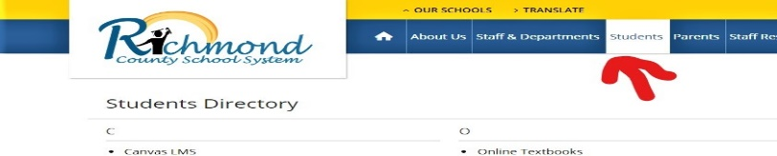
3. Click on Launchpad

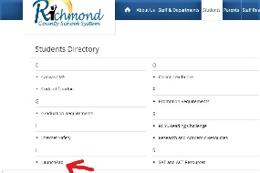

1. Enter student’s user name and password

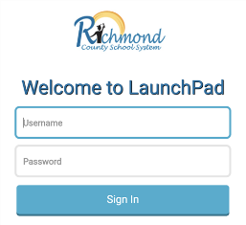

1. Click on the Canvas App



1. Click on Ms. Bussey’s Homeroom icon, (HR)