Booker T. Washington and W.E.B. Dubois
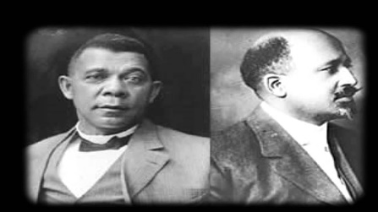

ENGAGEMENT PERIOD
BELL RINGER: Analyze the image and explain the creators intended meaning. | 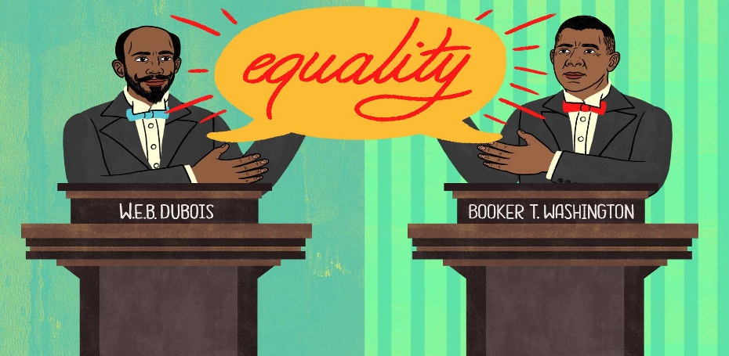
GEORGIA STANDARDS OF EXCELLENCE:  UNITED STATES HISTORY  SOCIOLOGY | SSUSH13: Evaluate efforts to reform American society and politics in the Progressive Era.  SSSocC3: Analyze social structure and interaction within society.
I CAN STATEMENT | I CAN compare and contrast the philosophies of Booker T. Washington and W.E.B. DuBois and then decide which gentleman was a stronger advocate for African Americans during the “Progressive Era.”
KEY VOCABULARY | Compromise of 1877  New South  Jim Crow Laws  Lynching  Booker T. Washington  W.E.B. DuBois  Atlanta Compromise Speech  Souls of Black Folks

EXPLORE, EXPLAIN, AND ELABORATE
QUICK NOTES
Civil War Ends in 1865

Reconstruction lasts from 1865-1877

Early years of Reconstruction produces 13th Amendment that ends slavery, 14th Amendment which grants citizenship rights to African Americans, and finally the 15th Amendment that gives African American men the right to vote.

Hiram Rhodes Revels of Mississippi becomes the first African American to serve in the U.S. Senate. Joseph Rainey would be elected to the House of Representatives from South Carolina, making him the first Black man to serve in Congress. Jefferson Long is the first African American to be elected to Congress from the state of Georgia.

However, once the Compromise of 1877 passes and removes all federal troops from the South, former Confederate leaders and sympathizers would regain political power in the Southern legislatures and essentially erase the progress produced during the early years of Reconstruction.

Poll taxes, literacy tests, and other obstacles were put in place to prevent Blacks from voting.

The KKK had support of local officials and terrorized anyone who voted Republican.

Lynching became a widespread form of terrorism against African American

Plessy v. Ferguson (1896) made separate but equal the law of the land.

The aforementioned historical conditions led to the emergence of two gifted but different African American leaders, Booker T. Washington, and W.E.B. DuBois.

VIDEO
https://www.youtube.com/watch?v=MLkyCAcizdk
https://www.youtube.com/watch?v=zHn-vSTMOWE

READING PASSAGE
Two great leaders of the black community in the late 19th and 20th century were W.E.B. DuBois and Booker T. Washington. However, they sharply disagreed on strategies for black social and economic progress. Their opposing philosophies can be found in much of today’s discussions over how to end class and racial injustice, what is the role of black leadership, and what do the ‘haves’ owe the ‘have-nots’ in the black community.

Booker T. Washington, educator, reformer, and the most influential black leader of his time (1856-1915) preached a philosophy of self-help, racial solidarity, and accommodation. He urged blacks to accept discrimination for the time being and concentrate on elevating themselves through hard work and material prosperity. He believed in education in the crafts, industrial and farming skills, and the cultivation of the virtues of patience, enterprise, and thrift. This, he said, would win the respect of whites and lead to African Americans being fully accepted as citizens and integrated into all strata of society.

W.E.B. DuBois, a towering black intellectual, scholar and political thinker (1868-1963) said no–Washington’s strategy would serve only to perpetuate white oppression. Du Bois advocated political action and a civil rights agenda (he helped found the NAACP). In addition, he argued that social change could be accomplished by developing the small group of college-educated blacks he called “the Talented Tenth:”

“The Negro Race, like all races, is going to be saved by its exceptional men. The problem of education then, among Negroes, must first of all deal with the “Talented Tenth.” It is the problem of developing the best of this race that they may guide the Mass away from the contamination and death of the worst.”

The divergent philosophies of Washington and DuBois have been the subject of numerous debates for over a century. While Washington was perceived as an accommodationist, his message of self-reliance resonated with many that examined his legacy. However, his critics cite that his acceptance of social injustices directed towards African Americans was detrimental to the progress of Blacks in the South. While DuBois is often praised for his insistence on political and social equality for African Americans, his detractors note that his “Talented Tenth” strategy was designed to benefit only Blacks that would be classified as elitists. So here in lies the question, which man was truly the better advocate for the progress of African Americans?

Booker T. Washington vs. W.E.B. DuBois Venn Diagram: Complete the Washington vs. DuBois Venn Diagram. Only include the following the diagram: Their backgrounds, their education, and a description of their efforts to advance the well being of African Americans.


STUDENTS WILL NOW EXAMINE PRIMARY SOURCE DOCUMENTS RELEVANT TO THE WRITINGS OF BOOKER T. WASHINGTON AND W.E.B. DUBOIS!
Document A: Booker T. Washington (ORIGINAL)
Ignorant and inexperienced, it is not strange that in the first years of our new life we began at the top instead of at the bottom; that a seat in Congress or the state legislature was more sought than real estate or industrial skill; that the political convention or stump speaking had more attractions than starting a dairy farm or truck garden.
A ship lost at sea for many days suddenly sighted a friendly vessel. From the mast of the unfortunate vessel was seen a signal, “Water, water; we die of thirst!” The answer from the friendly vessel at once came back, “Cast down your bucket where you are.” A second time the signal, “Water, water; send us water!” ran up from the distressed vessel, and was answered, “Cast down your bucket where you are.” And a third and fourth signal for water was answered, “Cast down your bucket where you are.” The captain of the distressed vessel, at last heeding the injunction, cast down his bucket, and it came up full of fresh, sparkling water from the mouth of the Amazon River. To those of my race who depend on bettering their condition in a foreign land or who underestimate the importance of cultivating friendly relations with the Southern white man, who is their next-door neighbor, I would say: “Cast down your bucket where you are”— cast it down in making friends in every manly way of the people of all races by whom we are surrounded….
Cast it down in agriculture, mechanics, in commerce, in domestic service, and in the professions…. No race can prosper till it learns that there is as much dignity in tilling a field as in writing a poem. It is at the bottom of life we must begin, and not at the top.
To those of the white race who look to the incoming of those of foreign birth and strange tongue and habits for the prosperity of the South, were I permitted I would repeat what I say to my own race, “Cast down your bucket where you are.” Cast it down among the eight millions of Negroes whose habits you know, whose fidelity and love you have tested… As we have proved our loyalty to you in the past, in nursing your children, watching by the sick-bed of your mothers and fathers, and often following them with tear-dimmed eyes to their graves, so in the future, in our humble way, we shall stand by you with a devotion that no foreigner can approach, ready to lay down our lives, if need be, in defense of yours, interlacing our industrial, commercial, civil, and religious life with yours in a way that shall make the interests of both races one. In all things that are purely social we can be as separate as the fingers, yet one as the hand in all things essential to mutual progress.
Source: Excerpt from Booker T. Washington’s ‘Atlanta Compromise’ speech, 1895.

Document B: W.E.B. DuBois (ORIGINAL)

Easily the most striking thing in the history of the American Negro since 1876 is the ascendancy of Mr. Booker T. Washington. It began at the time when war memories and ideals were rapidly passing; a day of astonishing commercial development was dawning; a sense of doubt and hesitation overtook the freedmen's sons, —then it was that his leading began. Mr. Washington came, with a simple definite programme, at the psychological moment when the nation was a little ashamed of having bestowed so much sentiment on Negroes [during Reconstruction], and was concentrating its energies on Dollars….

Mr. Washington's programme practically accepts the alleged inferiority of the Negro races…. Mr. Washington withdraws many of the high demands of Negroes as men and American citizens….
In answer to this, it has been claimed that the Negro can survive only through submission. Mr. Washington distinctly asks that black people give up, at least for the present, three things, —
First, political power,
Second, insistence on civil rights,
Third, higher education of Negro youth, and concentrate all their energies on industrial education, and accumulation of wealth, and the conciliation of the South. This policy has been courageously and insistently advocated for over fifteen years, and has been triumphant for perhaps ten years. As a result of this tender of the palm-branch, what has been the return? In these years there have occurred:
1. The disfranchisement of the Negro.
2. The legal creation of a distinct status of civil inferiority for the Negro.
3. The steady withdrawal of aid from institutions for the higher training of the Negro.
His doctrine has tended to make the whites, North and South, shift the burden of the Negro problem to the Negro's shoulders and stand aside as critical and rather pessimistic spectators; when in fact the burden belongs to the nation, and the hands of none of us are clean if we bend not our energies to righting these great wrongs.

Source: W. E. B. DuBois, The Souls of Black Folk (Chicago, 1903).

Writing Assessment: Upon reading the philosophies of Washington and DuBois, please write a response that answers the following question:
Whose ideas were the most conducive for bringing about true equality for African-Americans during the Progressive Era? Please support your response with evidence from this document. You cannot say “both,” you must choose one or the other!
_________________________________________________________________________________________________________________________________________________________________________________________________________________________________________________________________________________________________________________________________________________________________________________________________________________________________________________________________________________________________________________________________________________________________________________________________________________________________________________________________________________________________________________________________________________________________________________________________________________________________________________________________________________________________________________________________________________________________________________________________________________________________________________________________________________________________________________________________________________

EVALUATION:
Write two bullet points relevant to Booker T. Washington and two bullet points relevant to W.E.B. DuBois!

