Schoolwire Cheat Sheet

Remember all teachers must have: Contact Information, a Copy of the Syllabus for each subject taught, and be sure to Update Assignments regularly

Step 1: To Login go to the top right of the Westside homepage and click Sign In

Step 2: Use your Richmond County Username (your email WITHOUT @boe.richmond.k12.ga.us) and Password

Step 3: Click on Site Manager in the top right corner
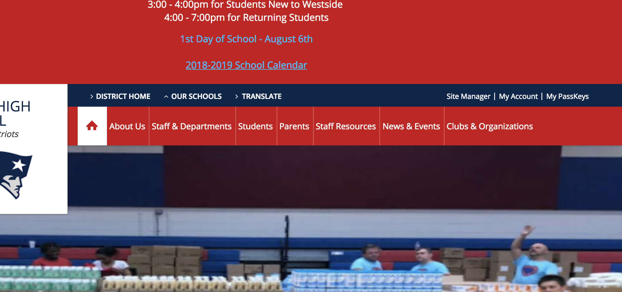

Step 4: Click on the Welcome Page that I have setup for you. If you don't see the Welcome Page email me ASAP!

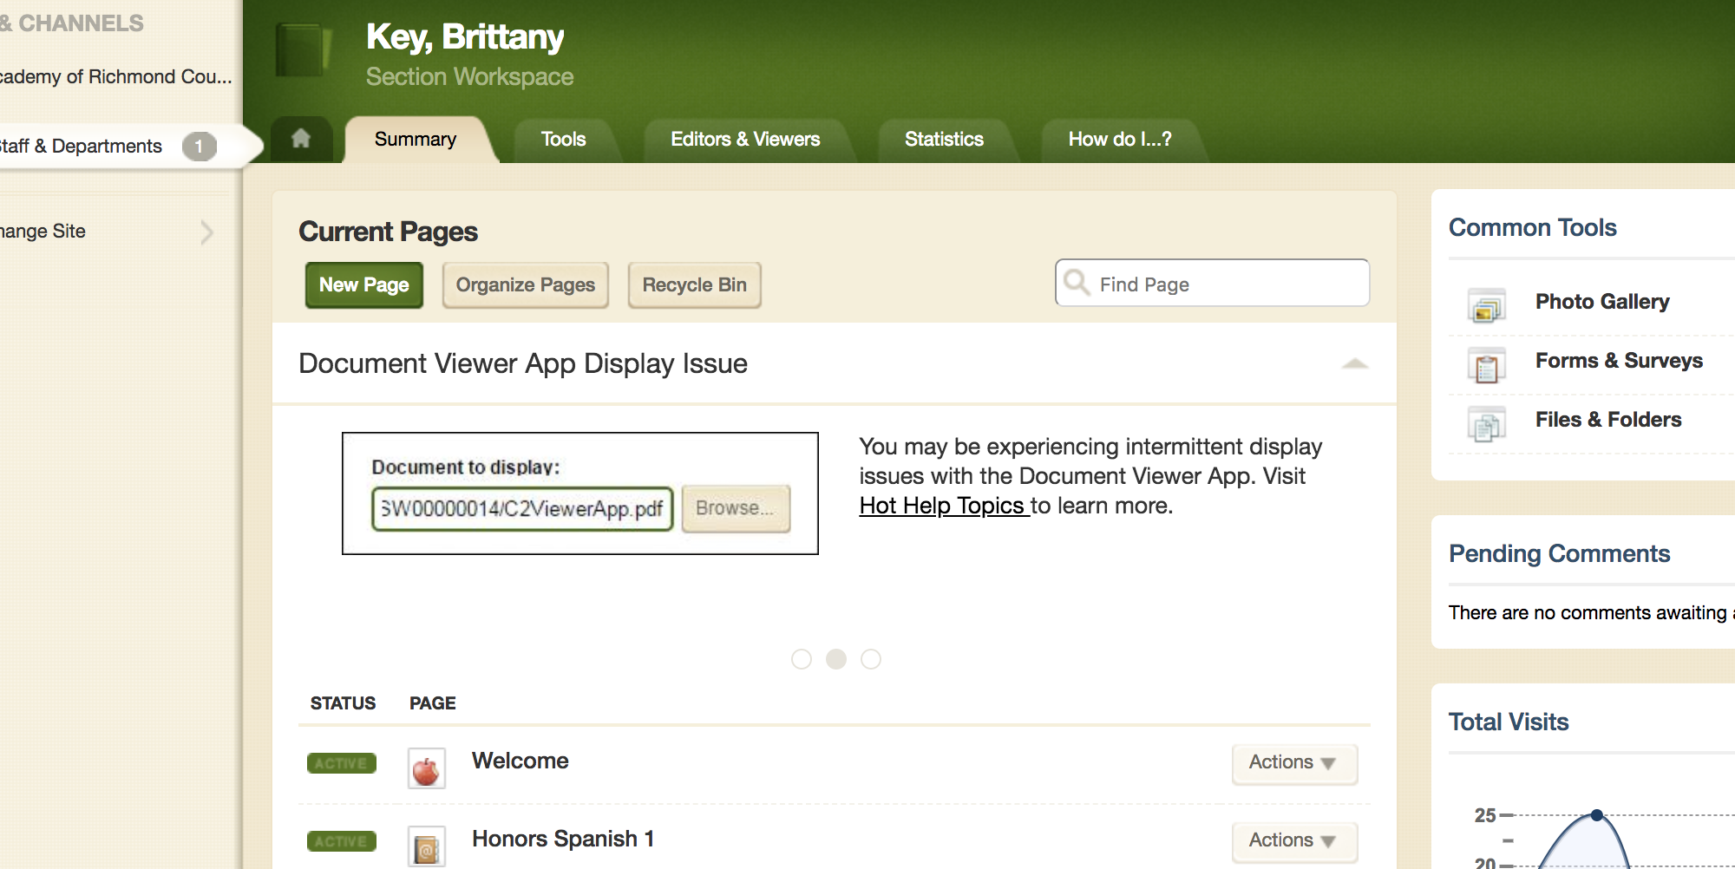

Step 5: You will see different Apps that you can edit on your page. There should be 3 different ones: Assignments, Contact, and Announcements. If you don't see these please let me know.

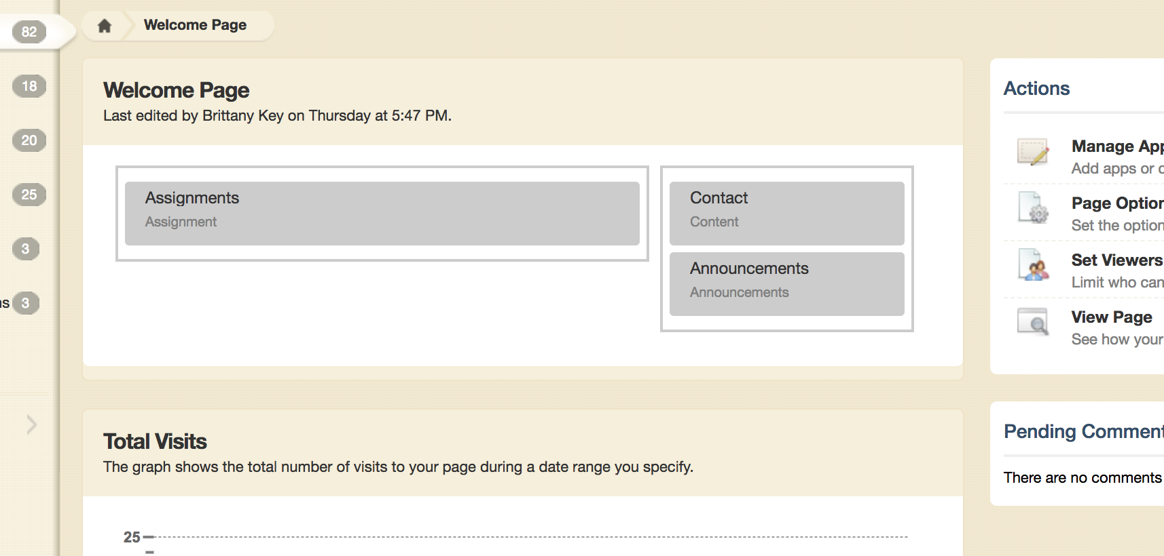

Step 6: Click on Contact and it should open up to a blank box you can type information into. Add your name, email/phone (if you have one and make sure to include ext), and what subjects you teach. If you would like to add a picture of yourself, you can do so as well.

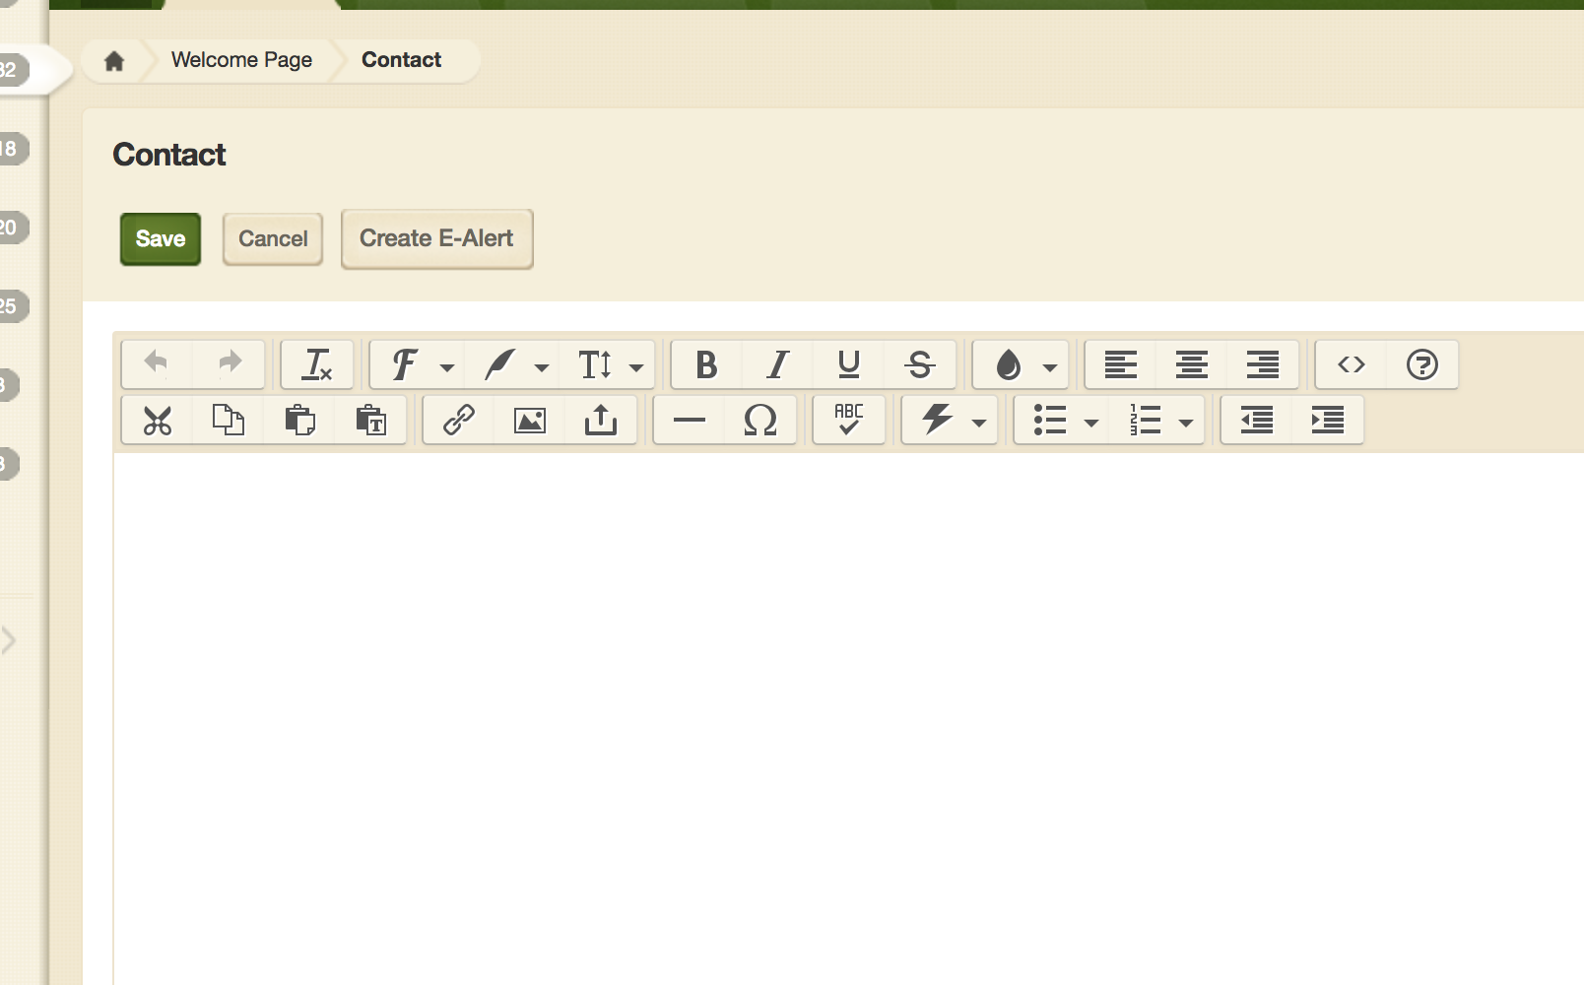
To add a link
To add a picture

Step 7: To update Assignments, click on that App. Then click New Assignment. Enter the information that applies to the assignment and click Save.
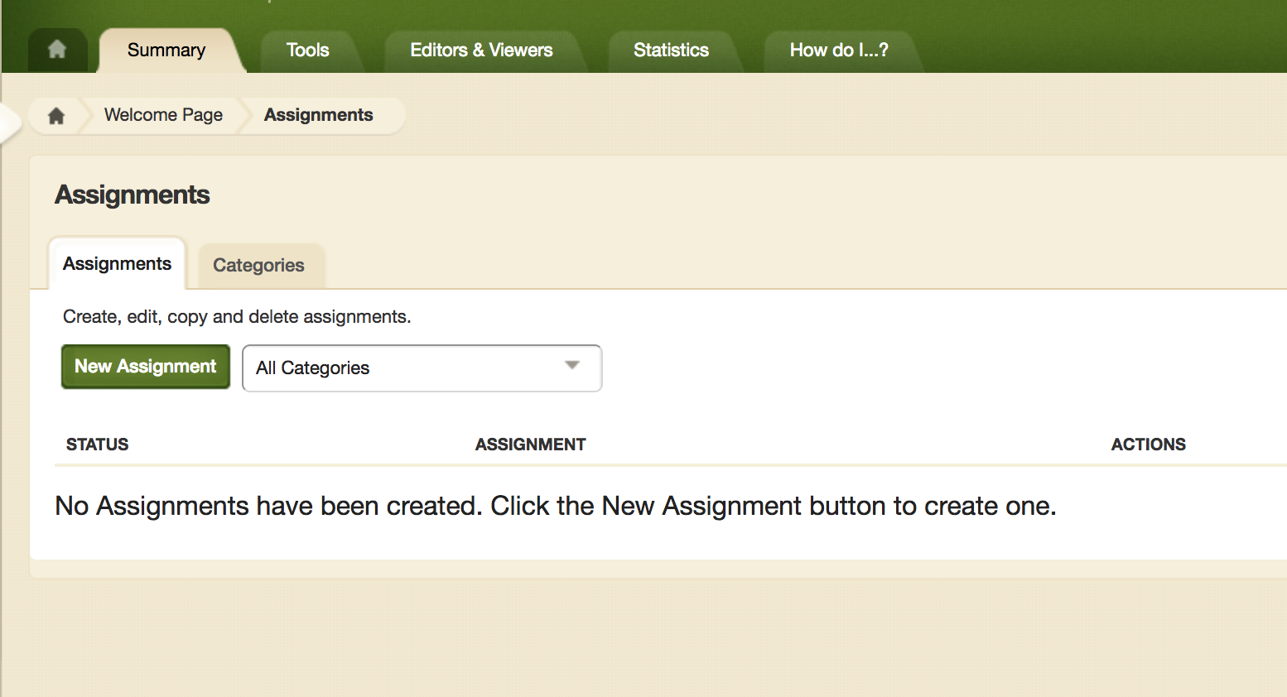
To Add a Syllabus/Subjects Taught on Separate Pages

Step 1: Make sure you are on the homepage of your site. If you aren't you can click the little house in the top left.

Step 2: Click New Page. For now, I would title the page the Subject Syllabus. For example: World History Syllabus.
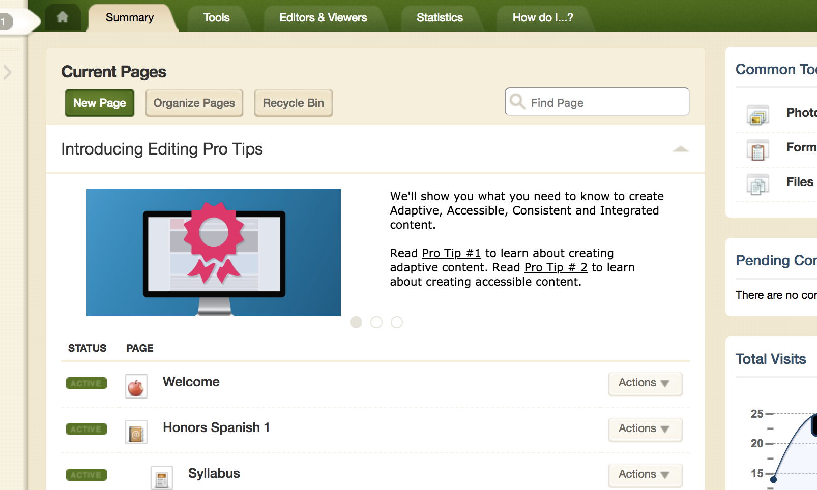
Step 3: Select Document Viewer Page, then click Save & Continue.

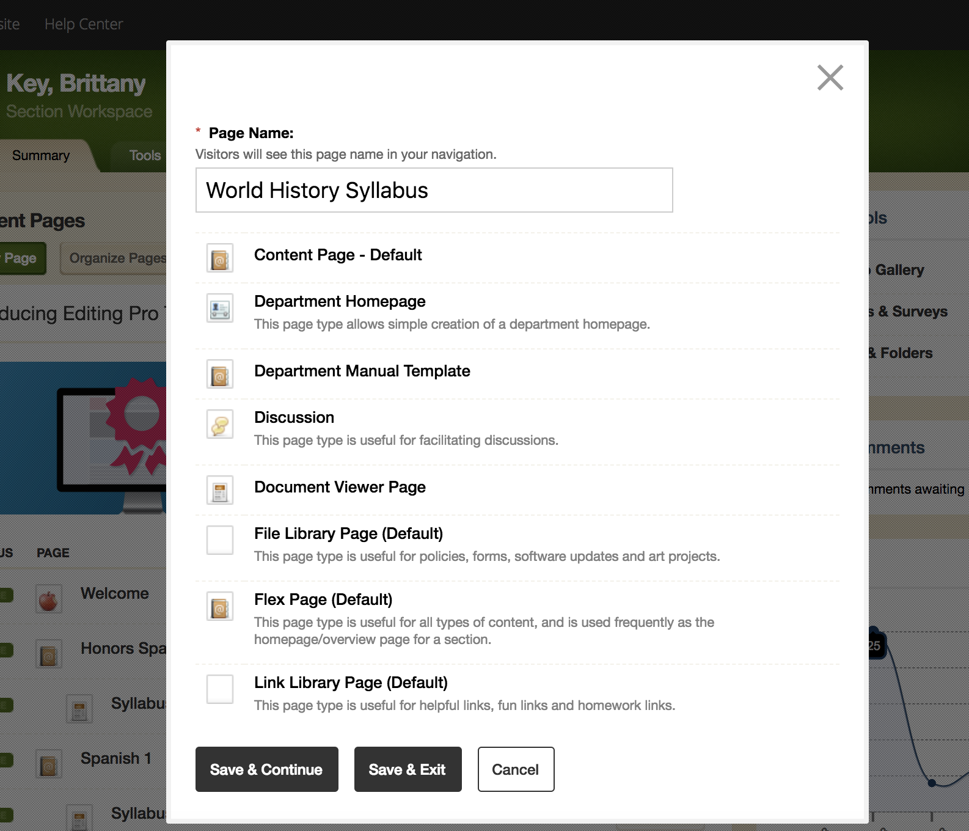

Step 4: Click on the gray box that says Document Viewer App. Then select file from your computer that contains your syllabus. Repeat these steps as needed for all subject areas you teach.

