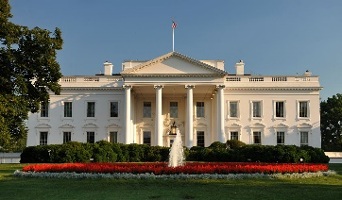

U.S. HISTORY SMALL GROUP EOC REVIEW QUESTIONS

SET #2 (L. Johnson-Ford)

Directions: Use the *A Nation Conceived in Liberty* textbook (Chapters 17 and 18) to answer the questions in the chart on a separate sheet of paper.

|  |  |  |
| --- | --- | --- |
| LYNDON B. JOHNSON | RICHARD M. NIXON | GERALD R. FORD |
| After his election in 1964, President Johnson declared a “War on Poverty.” Describe the purpose of two of his “Great Society” programs, Medicare and Medicaid.  Explain the connection between the Selma to Montgomery March and the signing of the Voting Rights Act of 1965.  Describe the impact of television on the violence against African-Americans in the South and the realities of the Vietnam War. | Describe how the events of the Watergate scandal led to the resignation of President Richard M. Nixon.  While the Women’s Liberation Movement stated in the early 1960’s, it reached its peak during the Nixon Administration. Describe some of the goals of the National Organization for Women (NOW)  Explain how the Supreme Court’s decision on July 24, 1974 in the *U.S. v. Nixon,* viewed Presidential privilege in its ruling. | Explain the unique circumstances that led to the ascension of Gerald Ford to the American presidency.  Explain why many Americans were displeased with President Ford’s decision to pardon former President Nixon.  Describe how former Georgia Governor Jimmy Carter’s status as a Washington “outsider,” helped lead to Gerald Ford’s defeat in the 1976 Presidential election. |