Grade Level: 3 Dates: Oct 12- Jan 4.
School Information  School: Copeland Elementary  School Code: 060043  Teachers: Gist, Denson, Rozier, Brace  Buffer: None | Transdisciplinary Theme: Who We Are  Segment of Theme: Human Relationships and Communities  Over Arching Concept: Past vs. Present
Section 1: Overview
- Central Idea: Knowledge of our past connects to our present.
- Key Concepts: Function-Behavior and communication Connection-relationships and interdependence Perspective-opinions and subjectivity
- Guiding Related Concepts: | - Lines of Inquiry: | - Teacher Questions (Guided Questions):
-Relationship  -Experiences  -Environment  -Adaption | - The connection between humans, society, and environment affect each other.  - Our experience past and present influences how we adapt to our environment.  - Where you live can affect the perspective of others. | DOK Level 3 & 4  -How does where we live shape how we live?  -What makes up a group’s culture?  - How were early American Indian cultures alike and different from one another?  - How are regions of North America alike and different? - Why did American Indians settle in the regions with which they are identified?  - How do the contributions of early American Indian cultures remain visible in our lives today?  -Why did some Native American nations create permanent villages, while others remained nomads?  -How do people interact with the world?  - How did American Indians in different regions use their environments?  - How did the environment help to affect food, clothing, and shelter of American Indians?  - What other aspects of culture are shaped by the environment?  -How do American Indians of today contribute to American life, especially culturally?
- Prior Content Knowledge: | - Assessing the Lines of Inquiry:
Students would need to know the concept of an environment. : Past and Present builds on earlier learning about Indian cultures in Kindergarten (Thanksgiving), 1st grade (Sacagawea), and 2nd grade (Creeks, Cherokees, and Sequoyah.) | How will you assess student’s understanding of the lines of inquiry?  -Students will be assigned a region to explore in groups to be able to write and to teach others the experience of the Native Americans from their region.  - Individual research on a tribe: Use the list of tribes within each region (see below) and find out more about the tribe you chose. Use the tribe organizer sheet to collect information, including categories of Clothing, Shelter, Environment, and Food.  – Regions group :Students bring together their individual tribal information results and discuss them. Create a chart paper that synthesizes information found into a regional summarizer. This is a good opportunity for students to make generalizations based on specifics they have found. Share regional information generalizations with the entire class, as students note regional variations in their journals.  Students will write a paragraph summarizing what they learned about the tribes in their region and how they interacted with their environment.
Section 2: What Are Our Target Goals?
- Concept Based Summative Assessment: | - Targeted Approaches to Learning (highlight 3): | - Targeted Learner Profile Attributes (highlight 2):
Students will create a society with classmates (group activity) :  Name of the society  What will they eat.  How will they obtain food.  What kind of clothing will they wear.  What kind of shelter will they have?  What kind of art does the society create?  What are laws/rules?  How will they make money  Can it be fantasy or Realistic  Choice Board: (Flip Grid, Powerpoint, poster etc.) | Social Skills, Research Skills, Communication Skills. Thinking Skills, Self-Management Skills  Research  Communication  Thinking | Inquirer, communicator, open-minded,  open-minded, risk taker, knowledgeable, communicator, reflective, thinker, inquirer
Section 3: What Assessments will be provided in this unit of inquiry?
- Pre-Assessments:  What assessment will be given at the beginning of the unit to inform current understanding | - Formative Content Based Assessments:  What assessments will be given to monitor student learning of content? | - Summative Content Based Assessments:  What assessments will be given for students to show mastery of unit content?
District Unit Pre-Test –Canvas  District Unit Post Test  Kahoot  Group Discussion | Unit informal Checks- Canvas  Exit Tickets  Station Work Activities | Seesaw activities –formal and informal assessments  District Unit Pre-Test –Canvas  District Unit Post Test  Kahoot  Group Discussion
Section 4: How will we Facilitate Learning?
- Provocation:  How will interest into this unit be sparked? | - Learning Experiences:  What activities/experiences will help facilitate the learning? | - Evidence of Differentiation:  How will the learning experiences be adjusted to different learning styles/abilities?
“The Rough Face Girl” the Native American Cinderella story  Photo- American Indian Conflict or Native American art  I see , I think, I wonder activities (pair share, and journaling)  Visit Smithsonian’s National Museum of the American Indian at http://www.nmai.si.edu/  Cherokee Language Chart  Students will be shown a video of Native American dance. Students will discuss what describe what they observe and make inferences to what the dance could represent. | I see , I think, I wonder activities (pair Shair, and journaling)  Week 1:  Provocations  - “The Rough Face Girl” will be read to introduce the Native American Culture.  Learning Experiences:  -Gallery walk- Students will view images of native Americans around the U.S and guess which tribes associate with each picture based.  -Writing Prompt  Week 2:  Visit Smithsonian’s National Museum of the American Indian at http://www.nmai.si.edu/  Select from among objects in the Smithsonian National Museum of the American Indian website by regions and have students visually analyze images to explore the cultural contributions of native people.  Reflection Questions:  - What material makes up the item?  - What does the object tell you about the tribe it represents?  - In what way does the cultural object reflect the tribe’s interactions with the environment?  Read: Buffalo Woman (Plains Indians) by Paul Goble  Students would then participate in a class discussion.  Week 3: Regions: Shelters. Show students American Indian American shelters on power point slide.  (Gallery Walk) American Indian Shelter Video:  https://www.youtube.com/watch?v=7xlEfyl2UsQ  Compare and Contrast shelters using Venn Diagram.  Independent Research:: https://cdn.studiesweekly.com/online/merlin_assets/worksheets/American%2BIndian%2BShelters.pdf  Week 4: Culture Art.  Provocation: Students will be shown a video of Native American dance. They will talk about clothing, shelter and resources,, https://www.youtube.com/watch?v=VPjYdfA_tLU.  Native American for Kids | An insightful look into the history of the Native Americans (Review)  https://www.youtube.com/watch?v=uxNDKlh-Vjo  Chart to use: https://www.scholastic.com/content/dam/teachers/lesson-plans/17-18/native-american-research-guide.pdf  .  Week 5:Cherokee Language intro and project. Students will be introduced to the language a and create their on language symbols for their society or tribe.  Show students a picture of the Cherokee language without symbols.  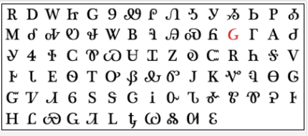  Sequoyah Language Video  https://cdn.studiesweekly.com/online/resources/pod_media/pod_video_sequoyah_FINAL_720p_v2.mp4  Independent Research:  https://cdn.studiesweekly.com/online/merlin_assets/worksheets/Sequoyah%2B-%2BWhat%2527s%2Bthe%2BMain%2BIdea.pd  Week 6  Five region activity project intro- Students will choose a region (Northeast, West, Midwest, Southwest, and Southeast) in the classroom and describe how they might think the Native Americans lived in that region.  Week 7 Students will begin to work on their project (Flip grid, powerpoint or poster) to show their society. They will also present these posters to the class. They will use books and/or internet access to research their region and continue to work on gathering information for their society.  Research categories include:  - Location - Resources - Clothing - Transportation - Arts/Crafts - Tribes Week 8 :Student presentations - Climate - Food/Diet - Type of Home - Weapons/Tools - Customs/Beliefs - Other  Students will present their society projects to the class and describe  Name of the society  What will they eat.  How will they obtain food.  What kind of clothing will they wear.  What kind of shelter will they have?  What kind of art does the society create?  What are laws/rules?  How will they make money  Students will reflect on how they worked as a group, what challenges they had and how they overcame their challenges. | If it is possible, an additional teacher or para-pro could work into groups as needed or could be used to lead a group of learners that may need additional support.  An organizer will be a great resource for students to frequently revisit to remember what they have been learning. It is very important to make the document useful and not merely “complete.” Many students will need to reread it often. Students may need guidance to do this. It is crucial that they are able to read back what they have written.  If writing is not developmentally appropriate, students could be given a copy after the lesson. It is very important that students review the content about each region. Students could highlight or color the key vocabulary terms
- Learning Experiences in Specials:  How are Specials Courses able to connect to this unit? | - Local/National/Global Connections:  How can we connect the content to local/national/global issues? | - Student Action:  What learning experiences support potential student-initiated action?
Art  Students will work in groups to create collaborative art projects and learn about cooperating with others. Students will study the works of artists who collaborated with other artists in their creations during this unit as well.  PE  3rd grade’s central idea for this unit is: Locations affect economy, culture, and development. In P.E. we will do a twist on this theme and instead focus on how locations affect our performance of different physical activities. Example: Inside vs. Outside play during cold weather. | CNN in 10 - Student friendly news broadcast  Local-SEL Sanford Harmony –Conflict Resolution  Native Americans in Georgia  Native American Heritage Month  Augusta Museum of History – The Georgia Council on American Indian Concerns | Student choice research project will support student-initiated action.  Students may be prompted to check out books in the media center or learn more about Native American Heritage month on their own.  Students may choose to visit a Native American Heritage Month celebration, festival or landmark in our local area.
- Student Agency and Play:  What learning experiences provide students with voice, choice and ownership? What play opportunities will be provided by Kindergarten/Pre-K? hands on/STEAM for K-5? |  | - Resources:  Which resources will you and the students use? This may include people, places, technologies, learning spaces and physical materials.
Students will have the opportunity to choose which type of presentation they would like to present pertaining to creating their own societies. Students will also have the opportunity to learn how to research so that they can complete this learning experience.  Visit Smithsonian’s National Museum of the American Indian at http://www.nmai.si.edu/  Students will have a choice in which objects they select to complete the learning experience |  | My World- Social Studies Textbook  Smithsonian website (Native Americans)  http://www.nativechild.com/article.html  (Gallery Walk) American Indian Shelter Video:  https://www.youtube.com/watch?v=7xlEfyl2UsQ  Independent Research: https://cdn.studiesweekly.com/online/merlin_assets/worksheets/American%2BIndian%2BShelters.pdf  Native American for Kids | An insightful look into the history of the Native Americans (Review)  Sequoyah Language Video  https://cdn.studiesweekly.com/online/resources/pod_media/pod_video_sequoyah_FINAL_720p_v2.mp4  Cherokee Language Chart  Augusta Museum of History – The Georgia Council on American Indian Concerns
Section 5: Reflection (Write the year, change font color for each year)W
- Reflect on learning experiences:
Rozier- Students were able to complete several learning experiences during this unit. Students were able to read, compare, and contrast the book The Rough Face Girl with the original Cinderella story. This allowed them to understand how to view the differences and similarities of two stories with similar story lines. As the unit continues, students were able to view images and videos pertaining to the past and present Native American cultures. When students conducted their research based projects, our Media Specialist conducted a live session showing students how to properly research information on the web. Students were then broken up into groups pertaining to the regions of the United States where Native American tribes were/are located. Presentations of their specific Native American tribes were conducted.

Murdaugh-Gist- Students were able to connect to the central theme and learning targets through many activities that included reading comprehension, hands on activities through educational research, journaling, self-reflections after viewing educational learning videos that were presented to students. These videos allowed the students to connect real life living in comparison to that of the Native Americans. Students connected with prior knowledge from the previous ELA learning targets of comparing and contrasting, main idea, asking and answering questions, and sequencing. Students learned how to properly and safely research on their own through an interactive learning session with our Media Specialist Mrs. Shoemaker. During closing reflections students responded to journal prompts of open ended questions that related to the Native American Cultures. Students completed projects in MYON that related to the Native Americans. Read Works and Studies weekly were also tools used to allow students to engage with the Native American cultures in various regions. Students were able to apply higher order thinking and express their understanding of the culture and how it relates to the how they live today.

Denson: Students were able to receive a two part lesson from the Media Specialist to learn appropriate researching skills and websites that would assist them with their project. They used technology to visit the virtual museum of Native American History. Additionally, students were able to write in their journal about their research experience, about what they found interesting and what they would like to learn in the future about Native Americans. For their research templates students used “8” boxes to write details in 6 areas, to include food, clothing, art, houses, life and games. Students also compared and contrasted their way of living to the living of the Native Americans. In the teacher stations students used text such as the Rough Faced Girl, How Sky far away to expand their knowledge and make connections for their guided reading.
- How were the tasks differentiated to meet different learning styles? |  | - How did the learning experiences and strategies we used throughout the unit help to develop and show students understanding of the central idea?
Rozier- The tasks were differentiated to meet the different learning styles by providing students with texts that corresponds with their learning needs. Students were assigned activities through Readworks and Seesaw that allowed them to receive the information based on their levels. Also, when it was time to conduct the research project, they were able to have a choice board of how they would like to conduct their presentations. This allowed students to take action of their learning and to show their personal interest through their assignment.  Murdaugh-Gist- Task were differentiated with students in many ways:  Passages were assigned based on student Lexile and skill levels. During our Guided reading sessions leveled readers were used to connect students with the grade level standards to achieve the learning targets and answer the essential questions of the unit. Students were also place in instructional groups to complete assignments of the unit and work with technology based activities. Choice boards were incorporated to allow students to drive their thinking and learning during this unit. This showed more focus and motivation to dive deeper into the unit theme and provocations.  Denson: Students were able to use choice boards to determine their path for learning. Additionally, They were also assigned passages and books in Myon, Readworks and Benchmark on their Lexile level. |  | Denson: The students were able to see how things have changed over time when it relates to their housing, clothing and the way we eat and find food. Students have been able to show understanding in their journal reflections.  Rozier- Students were able to understand the central idea of how our past connects to our present through our learning experiences. As we were researching, viewing images, and watching videos, students were able to reflect on their particular cultures and traditions that were passed down from generation to generation.  Murdaugh-Gist - Learning how to research played a vital role in the students making real life connections to their modern day lives. They were able to see how daily living has evolved into the resources they have access to in their community and homes. Students were transported back into the times of the Native Americans through educational videos that sparked their thinking and reflections on learning cultures of Native Americans and themselves also. Students completed journal reflections to express thoughts and demonstrate understanding of the unit.
- What learning experiences best supported students’ development and demonstration of the attributes of the learner profile and approaches to learning? |  | - How effective were the summative assessments in measuring student learning? What, if any, changes need to be made to the assessments?
Denson- The virtual museum and research lessons really aided in the success of this unit. Students were able to learn lifelong skills when it comes to finding out new information on a subject that is not familiar with them. They learned how key words work and demonstrated the following learner profiles; Inquirer, thinker and reflective.  Murdaugh-Gist: Students worked in groups to create and act out living as a Native American. Students had to include the academic vocabulary and share with the class during their dramatizations facts that they have learned from the unit and their research.  Rozier- Having students participate in virtual tours and participate in a research project allowed for students to understand the content that was taught and approaches to learning. During the project period, students were able to communicate and research with their group members which ultimately promoted student agency. |  | Denson- The summative assessments worked well with the students. The rubrics provided key details that allowed the students to know what we were looking for.  Murdaugh-Gist : The summative assessments were effective and sufficient for the students to demonstrate learning and understanding of the unit and learning objectives.  Rozier- The summative assessments when measuring student learning was effective. Students were able to demonstrate their learning of the central idea, lines of inquiry, and learning experiences through the research process.
- What student-initiated inquiries (questions) arose from this unit of inquiry? |  | - What student action arose from this connec of inquiry?
Denson: During the research portion students came up with a lot of great questions like, Why were the Native Americans good hunters, What did they do for work and why did they hunt for animals and What things did they have in their home. They then further researched the questions and was able to find the answers. Students then wrote essays based on their research.  Murdaugh-Gist: Students participated in picture walks which led to inquiries about the native American culture : habitats, everyday life, food resources, and survival questions were initiated by the students.  Rozier- Students asked questions throughout the unit which were answered while they conducted their research. Students were curious about how traditions are came about and how the Native American culture was similar to their own. |  | Denson: Students wanted to do more research and learn more about the Native American culture and history. They then begin to compare and contrast the Native American lives to their lives. They then understood how the past now connects to our present.  Murdaugh-Gist: Students' thinking was activated and they were motivated to research further in to the life and culture of Native Americans. Students began connecting with not only the research but also images of Native Americans.  Rozier- Students wanted to present their research projects in many different ways. They wanted to have a choice so that they could present in ways that best interest them that connected to unit of study.
- Any additional notes or changes that need to be considered next year?
Art:
Students collaborated and acted as models as they drew their partners in various poses. Some classes worked together with ease while others needed more direction and discussion on cooperation and how to kindly work with their peers on their artworks.

Section 6: Picture Evidence
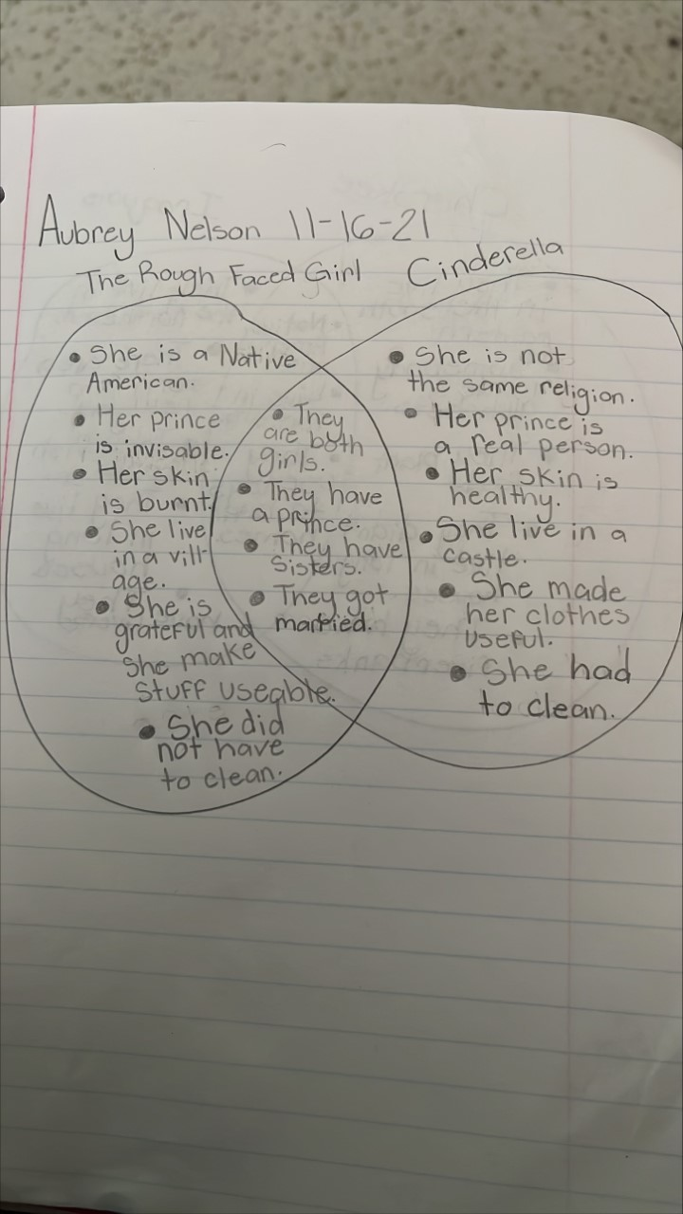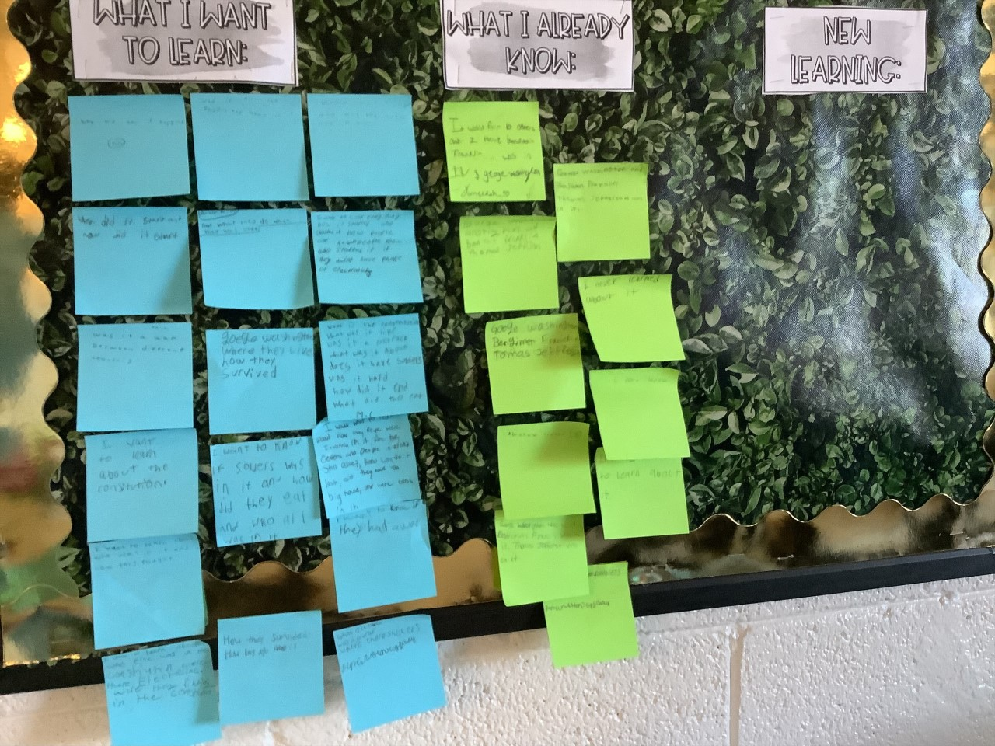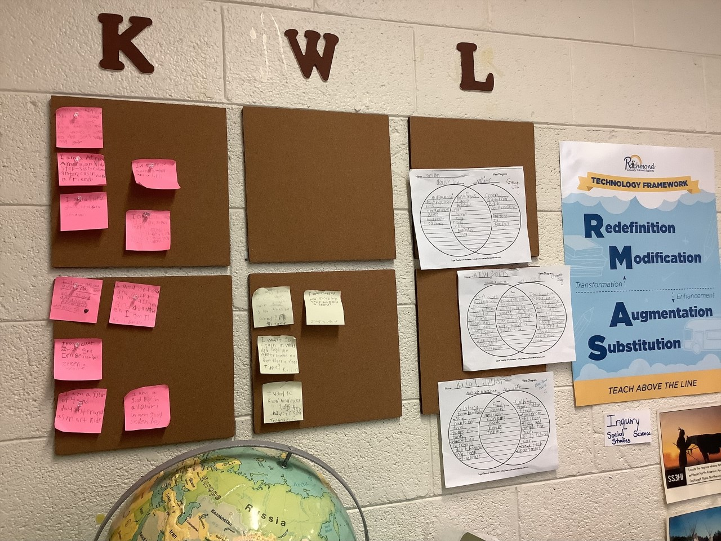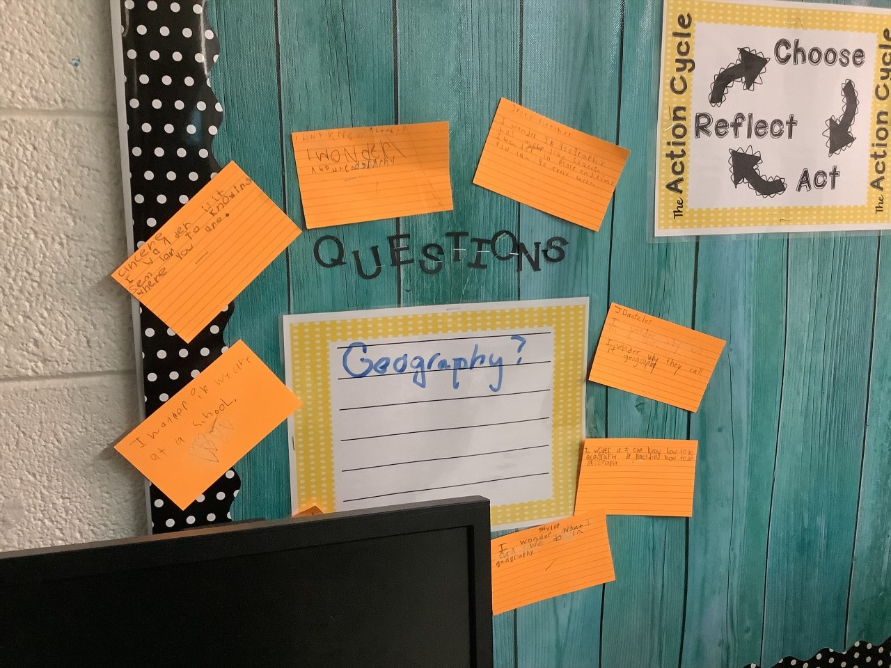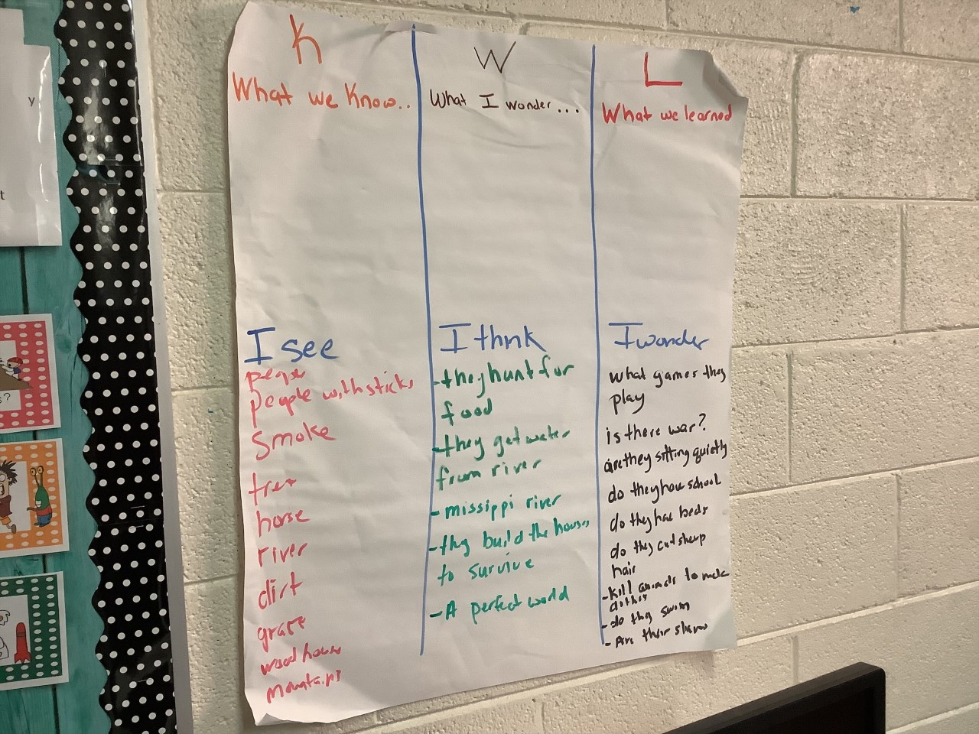
**Scroll Down for Unit Standards**

Unit Standards:

ELA:3RL.9
3Rl.7

Math:

Science:

Social Studies:
SS3H1-all
SS3G3

