**How to Earn the IB Diploma (DP)**

* Earn at least 24 points and successfully complete:

All assessments * CAS * Extended Essay * TOK

* DP students must take 3 Higher Level (HL) classes and 3 Standard Level (SL) classes
  + SL: at least 150 hours of instruction
  + HL: at least 240 hours of instruction (plus one more topic and one more paper than SL)
* IB classes are graded on a 1-7 scale (4-7 is considered an acceptable score)
* Each class grade is generated from two types of assessment components
  + Internal Assessments (IA) – graded by the teacher with samples sent to IB for moderation
  + External Assessments (EA) – graded by IB examiners, these are essays and exams

Example: English HL

IA: Individual Oral Commentary (IOC): 15% Individual Oral Presentation (IOP): 15%

EA: Written Assignment: 25% Paper 1: 20% Paper 2: 25%

* Each component is scored separately
* total number of points earned is converted to the 1-7 scale
* CAS – must be completed successfully
* Extended Essay/TOK matrix
  + Performance on these components can earn 0-3 points

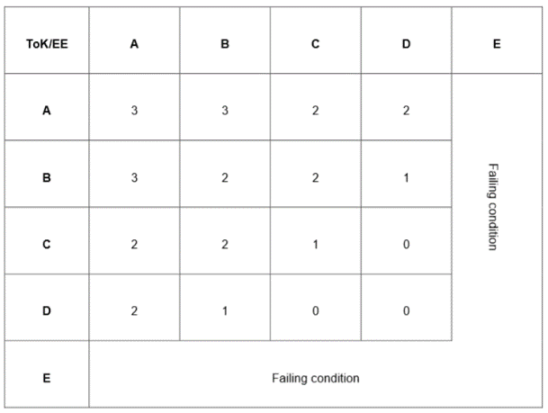

* **Six classes x 7 points = 42 possible points + TOK/EE = 3 possible points = 45 possible points**

**Things to keep in mind:**

* **No grade of N or E (non-submittal or failing) * No grade of 1**
* **No more than two grades of 2 * No more than three grades of 3**
* **At least 12 total points earned in HL classes * At least 9 total points earned in SL classes**
* **No penalty for academic misconduct from IB Final Award Committee**

**Students have three (3) examination sessions in which to satisfy the requirements – students CAN retest!**