Grade Level: Dates: Sept. 7 – Oct 15
School Information  School: Copeland Elementary  School Code: 060043  Teachers: Hall, Jackson, Yeldell  Buffer: None | Transdisciplinary Theme: How We Organize Ourselves  Segment of Theme: Human made systems and communities  Over Arching Concept: Design
Section 1: Overview
- Central Idea: Beliefs and ideas influence how the world is organized.
- Key Concepts: Function, Change and Perspective
- Guiding Related Concepts: | - Lines of Inquiry: | - Teacher Questions (Guided Questions):
Rights  Responsibilities  Government  Surface Features  Classification  System | - When there is conflict between or within societies, change is the result.  - The actions of individuals and groups can affect a society.  - Natural build systems can determine the development of civilization. | DOK Level 3 & 4  Compare the United States to your individually researched country. How are the government and surface features similar and different?  What amendments would you want to add to the constitution?  If you were to design your own government, what would it be like?  How could surface features affect the design of buildings and cities?  If you could research any country what country would you research and why?  What rights and responsibilities do you have in the classroom? School? Community? Country? Are these appropriate or should you have more/less and why?
- Prior Content Knowledge: | - Assessing the Lines of Inquiry:
Students should have prior knowledge of how the country was formed- via revolutionary war and the signing of the declaration of independence as well as the ratification of the constitution (4th grade standard) | How will you assess student’s understanding of the lines of inquiry?  Nations Project  Science/Classification/Surface Features
Section 2: What Are Our Target Goals?
- Concept Based Summative Assessment: | - Targeted Approaches to Learning (highlight 3): | - Targeted Learner Profile Attributes (highlight 2):
Nation Project – 6 part project with rubric (see learing activities) | Social Skills, Research Skills, Communication Skills. Thinking Skills, Self-Management Skills | well-balanced, caring, principled, open-minded, risk taker, knowledgeable, communicator, reflective, thinker, inquirer
Section 3: What Assessments will be provided in this unit of inquiry?
- Pre-Assessments:  What assessment will be given at the beginning of the unit to inform current understanding | - Formative Content Based Assessments:  What assessments will be given to monitor student learning of content? | - Summative Content Based Assessments:  What assessments will be given for students to show mastery of unit content?
Content pre-assessments – Canvas  Writing pre-assessments – Canvas  Reading pre- assessments – iReady | Teacher conferencing – Weekly check in  Teacher conferencing – Nation's Group Project (Guide students through the culminating project) Weekly checklist for each portion of the assignment | Post Assessments Content and Writing – Canvas  Post Assessments Reading – iReady
Section 4: How will we Facilitate Learning?
- Provocation:  How will interest into this unit be sparked? | - Learning Experiences:  What activities/experiences will help facilitate the learning? | - Evidence of Differentiation:  How will the learning experiences be adjusted to different learning styles/abilities?
Classification- blind sort, identify the mystery animal  Government- icivics games, become a lawyer- how will you defend?  Surface features- play with clay, water, sand- explore outside, draw observations | 1. Research a country of choice independently while researching as a class focusing on government and create a government for a new country  -inquiry us constitution  -inquiry class country constitution  -discuss elements of a constitution (ideals, government design, powers of gov, and rights of people)  -create a constitution for a ‘new’ nation in groups  2. Develop a fake country as a group with researched geographical features and produce a map of said country  -inquiry us geographical map  -inquiry class country map  -create a map for ‘new’ country as a group including 5 geographical features as discussed  3. Develop a national plant and animal for the new country  -research classification through a blind animal sort  -virtual field trip to discuss classification  -research an animal of choice  -create an animal for your country based on the geography of your country, and explain its classification  -research classification through a blind plant sort  -observe plants in our current habitat (backyard field trip)  -create a plant that would survive well in your ‘new’ country  4. write a narrative story that takes place in students developed country as either historical fiction or traditional fiction  -read samples of historical fiction focusing on elements of us history or your countries history  -write narratives focusing on newly developed country | Reading groups are groups for country projects, determined by Lexile level and reading comprehension, articles and assignments are scaled to students reading level
- Learning Experiences in Specials:  How are Specials Courses able to connect to this unit? | - Local/National/Global Connections:  How can we connect the content to local/national/global issues? | - Student Action:  What learning experiences support potential student-initiated action?
PE  One of their lines of inquiry for this unit is every action has a consequence. In P.E. we will focus on activities that demonstrate bodily actions that have either expected or unexpected consequences. | Independent research into other countries to connect back to research on USA and student developed classrooms | Classification of classroom library  Students writing stories based in their developed countries
- Student Agency and Play:  What learning experiences provide students with voice, choice and ownership? What play opportunities will be provided by Kindergarten/Pre-K? hands on/STEAM for K-5? |  | - Resources:  Which resources will you and the students use? This may include people, places, technologies, learning spaces and physical materials.
Students can develop their own countries in groups- adding imagination and creation to the history and science that they will be learning. Students are creating an entire country of their own, from the map to the government |  | Benchmark, Myon, library, and Newsela for reading and research materials (books and laptops)  PowerPoint for presentations
Section 5: Reflection (Write the year, change font color for each year)
- Reflect on learning experiences:
Hall- The learning experiences for this unit were very meaningful and engaging for the student. They truly enjoyed creating their own countries and coming up with their own rules and laws. They were able to make connections with their country and the United States.
Jackson- In this unit, were given opportunities that allow students to connect deeply with the central idea and make their own inquiries about beliefs and ideas. The students were able to use the importance of beliefs and ideas to shape their perspectives on how they would structure and organize their country.
Yeldell- Students really enjoyed the constitution development, and looking at our constitution and the south Korean constitution were a particular favorite. Students wrote excellent constitutions for their own country, and had spirited discussions about rights and amendments. Students also enjoyed creating new plants and animals, and developed buildings for their countries that should last despite different destructive natural forces. This unit combined creativity and knowledge with global views to start students thinking about how countries are organized and creating something new.
- How were the tasks differentiated to meet different learning styles? |  | - How did the learning experiences and strategies we used throughout the unit help to develop and show students understanding of the central idea?
Hall-Students who had trouble writing narratives were able to express their stories with pictures and symbols.  Jackson – Task were differentiated into parts to allow students to determine what steps they needed to complete their assignments. Students were given opportunities to conformed their findings in a way they would be able to explain to their peers and myself.  Yeldell- Through conversations and art students were all able to contribute to their group work and individual work. Often students had to talk and draw before the writing stage, and this helped so that students had an idea of how they wanted to compose their writing. Myon was also used for the majority of the reading and read-alouds, and this allowed for scaffolding reading. |  | Hall- Having students “create their own” with each lesson helped them make a connection with classification and the rights citizens possess in a country. They were able to get real life experience and have fun while completing each task given.  Jackson- Students were able to shape their own learning and generate opinions on how beliefs and ideas play a huge part on the world and how is organized. When students thought about their amendments and saw how their own beliefs did not match with their peers they understood the complexity of structing a country.  Yeldell- The creative aspect allowed us to assess our students and the depth of their understanding while accounting for different levels of reading and writing ability. For example, I have one student who reads at a kindergarten level, but she was able to draw the amendments in the bill of rights and she was able to design a vascular and non-vascular plant. She was also able to draw a seed growing in the cracks of a rock as a demonstration of weathering, despite being unable to write well about the topic.
- What learning experiences best supported students’ development and demonstration of the attributes of the learner profile and approaches to learning? |  | - How effective were the summative assessments in measuring student learning? What, if any, changes need to be made to the assessments?
Hall- The learning experiences that best supported students’ development, the attributes of the learner profile, and approaches to learning are the narratives focused on the country they developed and the inquiry into different constitutions.  Jackson –The learning experience that supported students was the opportunity to develop their countries and used their learning experiences to guide decisions on the type of countries they wished to create.  Yeldell- The experience that best supported students development was the compare and contrast of two different constitutions and the subsequent creation of a new countries constitution. |  | The summative assessments were very effective in measuring student learning. The assessments do not need any changes.  Jackson- The summative assessment was a great tool to summarize everything covered within the unit. The assessment does not require any changes at the moment.  Yeldell-The summative assessment was a great tool to utilize. If I were to make changes, I would find a way to incorporate the three activities into one pamphlet or brochure for the country, allowing students to have a mini showcase style piece of work.
- What student-initiated inquiries (questions) arose from this unit of inquiry? |  | - What student action arose from this unit of inquiry?
Students wanted to know if other countries had constitutions which lead into us the inquiry of different constitutions. Students asked questions about animal classification. They wanted to know why snakes are considered vertebrae's.  Jackson- Students wanted to know the following questions:  - Are all animals and plants classified the same in different countries?  - What laws are set in place that require opinions from citizens?  - Is the process of becoming a citizen in the United States hard in other countries?  Yeldell-Students were curious as to why our constitution didn’t include healthcare and education, so we took some time to discuss the state and federal system in the us. We then looked briefly at the state constitution and discussed the separation of powers in a country like the USA. When discussing constructive and destructive forces we stepped into plate tectonics a bit as students wanted to know how volcanoes, mountains, and trenches were created in the first place. It was not initially a part of our standards as this is taught in middle school. But we took a moment to follow that question and touch on something they will see later. |  | Students wanted to learn more about the constitutions of different countries so we looked into other countries besides our class county of Haiti.  Jackson- The students wanted to learn about other countries constitutions and compared them to the United States. As well as viewing different counties constitutions, students took laws that they thought fit their point of view and implement them into their narratives for their countries.  Yeldell- Students were curious about Korea’s constitution so we dived into that a bit deeper (Korea is our class country that we have been learning about). I had a student go home and look up the current president of South Korea and the political parties because she was curious to see what they looked like. Another student was very interested in the law aspect of the constitutional rights, so they used their free time to play on icivics.org as a lawyer running a law firm that helps people with bill of rights questions.
- Any additional notes or changes that need to be considered next year?
Yeldell-I would start this unit earlier, it felt a bit rushed at the end. I would also make a final brochure or website to visit the created country as a final showcase-style piece.
Section 6: Picture Evidence
https://photos.app.goo.gl/zqASHWtcnpM1uxfu8
This link contains pictures of work samples from all three classes, to include student-made constitutions, pictures of plant weathering, structural designs to survive natural forces, and amendments that students designed.
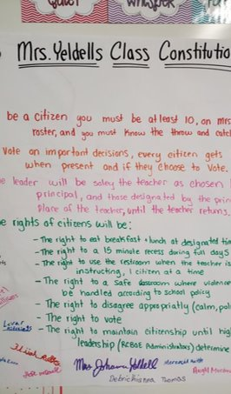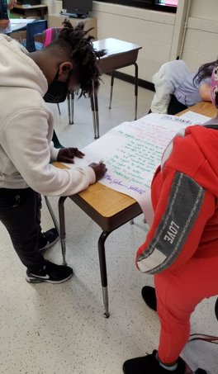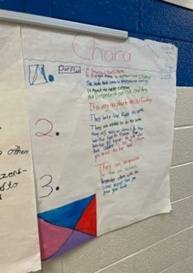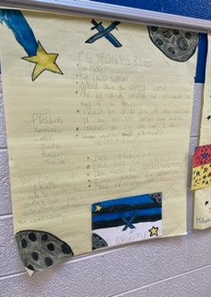
**Scroll Down for Unit Standards**

Unit Standards:

ELA:
ELAGSE5RL1
ELAGSE5RL4
ELAGSE5RI1
ELAGSE5RI4

Math:

Science:
S5L1
S5E1

Social Studies:

SS5CG1
SS5CG2
SS5E2
SS5E3
SS5E4

