Grade Level: 3rd Dates: Jan 24,2022-Feb 18,2022
School Information  School: Copeland Elementary  School Code: 060043  Teachers: Gist, Denson, Rozier, Brace  Buffer: | Transdisciplinary Theme: Sharing the Planet  Segment of Theme: economic activities and their impact of humankind and the environment  Over Arching Concept: Area and Perimeter
Section 1: Overview
- Central Idea: Formulas are used to solve global problems.
- Key Concepts: Function-How does it work, Connection- How it is linked to other things
- Guiding Related Concepts: | - Lines of Inquiry: | - Teacher Questions (Guided Questions):
Vocabulary:  Area  Formula  Length  Multiply  Perimeter  Rectangle  Square  Square Unit  Width | - Area and perimeter are individual parts that connect and support every day life. (Connection)  -Measurements when placed in formulas create solutions to real world problems. (Function) | DOK Level 3 & 4  How can the knowledge of area be used to solve real world problems?  What is the difference between area and perimeter  How do we calculate area?  How do we calculate perimeter?  How do you determine what unit of measure to use when finding area and perimeter?
- Prior Content Knowledge: | - Assessing the Lines of Inquiry:
Students will need to be familiar with units of measure, measuring tools. They will also need understand the relationship between the dimension of an array and the total number of items in the array. | How will you assess student’s understanding of the lines of inquiry?  Students will work in groups to list examples of where area and perimeter can be used.  Students will be given the dog kennel and Garden learning experiences well implementation of formulas can be evaluated.  Students will demonstrate they can find the area and perimeter of shapes.  Students will demonstrate they can determine the measurement of shapes.
Section 2: What Are Our Target Goals?
- Concept Based Summative Assessment: | - Targeted Approaches to Learning (highlight 3): | - Targeted Learner Profile Attributes (highlight 2):
-Garden Beautification project.  Students will be required to measure the area located by the playground to find the perimeter and area. They will then be required to create a plan to submit for Admin with the data they found. The plan will include what types of flowers, materials required and the space needed. They should also have details about when the garden can be started. All requirements will be placed on a rubrics. | Research Skills, Communication Skills. Thinking Skills, self-management skills | Communicator, reflective, thinker, inquirer
Section 3: What Assessments will be provided in this unit of inquiry?
- Pre-Assessments:  What assessment will be given at the beginning of the unit to inform current understanding | - Formative Content Based Assessments:  What assessments will be given to monitor student learning of content? | - Summative Content Based Assessments:  What assessments will be given for students to show mastery of unit content?
District Pre-assessment Grade 3 Unit 3 Pre-assessments  Ready Math Unit 15, 16 & 32 student pre-test  Discussions about vocabulary to clarify meaning | Unit 3 Informal ready math checks  Exit tickets  Station work activities  Seesaw  Teacher observation  Practice problems | Unit 3 Content Mastery Assessments Post assessment  Unit 3 District Assessment  Kahoot  Blooket  Seesaw
Section 4: How will we Facilitate Learning?
- Provocation:  How will interest into this unit be sparked? | - Learning Experiences:  What activities/experiences will help facilitate the learning? | - Evidence of Differentiation:  How will the learning experiences be adjusted to different learning styles/abilities?
Students will watch a video from Flocabulary that discusses area and perimeter.  https://www.flocabulary.com/unit/area-and-perimeter/  Read aloud about Perimeter  Student will also be shown a picture of a dog. They will then be told that this dog needs a new kennel. | Week 1 (Tuning In)  Students will learn about area and perimeter by learning definitions and formulas. They will decompose a 3 inch by 5 inch rectangle. They will use a ruler to mark inches to connect it to rows and columns of squares. They will then discuss length, width, and area of square units.  Week 2 (Finding Out)  Students will practice area and perimeter by completing a scoot on area and perimeters. This is where they walk around and solve different problems that are placed around the classroom.  Week 3 (Sorting Out)  Students will be giving word problems or mini challenges to practice critical thinking skills to figure out solutions for area and perimeters. The first practice will be them creating a dog Kennel or a kennel for any pet that they have.  Week 4 (Going Further)  Students will work in groups to create a garden to submit for a school’s beautification project. They will be required to figure out the measurements and area required based on their plans. They will then have to create a proposal to present to Admin. They will present it in a powerpoint, Flip grid or poster presentation as a group. | Additional teacher or para-pro could work into groups as needed or could be used to lead a group of learners that may need additional support.  Students can be given manipulatives, multiplication chart and calculators to assist with  Students can look at the flowerbed set up in the front of the school and pictures to get ideas.  Small group / peer assistance
- Learning Experiences in Specials:  How are Specials Courses able to connect to this unit? | - Local/National/Global Connections:  How can we connect the content to local/national/global issues? | - Student Action:  What learning experiences support potential student-initiated action?
Mahon- The Art teacher will work with students to create rock art to go in the garden if the project gets approved. | Students can make connections that area and perimeter are required for various things that we use every day such as size of carpet in a room, how much paint to buy for a room, buildings, houses, parks, gardens and dog kennels | Garden beautification project will help students build a legacy at the school. It will also help them cross reference or be transdisciplinary with other subjects such as (habitats) or soil requirements for certain plants to grow and in what weather.
- Student Agency and Play:  What learning experiences provide students with voice, choice and ownership? What play opportunities will be provided by Kindergarten/Pre-K? hands on/STEAM for K-5? |  | - Resources:  Which resources will you and the students use? This may include people, places, technologies, learning spaces and physical materials.
Students will participate in three hands on experiences.  3 inch by 5inch rectangle into square inches- Students will learn about area and perimeter by learning definitions and formulas. They will decompose a 3 inch by 5 inch rectangle. They will use a ruler to mark inches to connect it to rows and columns of squares. They will then discuss length, width, and area of square units.  Min- Students will do mini challenges to practice critical thinking skills to figure out area and perimeters The first practice will be them creating a dog Kennel or a kennel for any pet that they have.  Garden Beautification-Students will work in groups to create a garden to submit for a schools beautification project. They will be required to figure out the measurements and area required based on their plans  Math Robots- Students will work independently to create a full body robot creating the head, neck, arms, legs and body using square unit graphs and art supplies. Students will share with table their robots and how they were able to calculate the area of each body part. |  | Brainpop Jr, Area https://jr.brainpop.com/math/measurement/area/  Brain pop jr Perimeter  https://jr.brainpop.com/math/measurement/perimeter/  Flocabulary  https://www.flocabulary.com/unit/area-and-perimeter/  I’ready Toolbox & Resources Lessons 15,16,18 & 32  I’ready Text book  Area near playground that garden can go in.  Students will use grid paper, measuring tapes, index cards
Section 5: Reflection (Write the year, change font color for each year)
- Reflect on learning experiences:
Denson-The learning experiences for this unit really provided a lot of hands on learning for the students. Students had to choose how they would go about getting the information in order to answer the questions. In order to get to the final project of the garden, students participated in several activities that led up to it. They completed a scoot around the classroom that allowed them to practice using the numbers provided to figure out areas and perimeter. They then went to the next step of learning that would be using yard sticks and how to measure items and how it related to area.. Students had to critical think how they could still figure out how to measure the information if they didn’t have enough sticks to wrap around the playground. They were able to communicate and find a solution. One thing that I would change about the lesson is to make sure that I have multiple types of measurement tools, and do a quick reteach on how to measure items.

Rozier- The learning experiences consisted of students being able to relate real life into looking area and perimeter. Students were able to measure the Pre-k playground, create a dog kennel with using area and perimeter, and also taking a look at the garden that we have located at the school. As far as the use of technology, students participated in Gizmo activities that mimic a garden where they were able to virtually make a garden with using area and perimeter.

Murdaugh-Gist- Students were hooked into the lesson with real-world life applications of area and perimeter. Starting the lesson with turn and talk thinking sessions about favorite places they have visited that are spacious. Students shared favorite places of the indoor trampoline park, bowling alleys, playgrounds and gyms. The conversation and thinking was expanded to getting students to critically think of how big or large they thought the areas were. We included our ELA learning targets as well, comparing and contrasting which areas they thought were larger or smaller or the same size. The students were able to journey outside to their very own playground and measure equipment and hopscotch game area. Students utilized technology with IXL related activities, Brain POP Jr. Learning video and vocabulary activities to connect learning and thinking. Students created area and perimeter robots applying their knowledge and understanding of the unit. Each student was able to create their robot based on their thinking of the concepts.

Brace- Students started the lesson with an I see I think I wonder of various measuring objects to get an idea of how they interpreted measurement. Students shared their real life connections with the activity sharing that they have seen their parents use rulers, yard sticks, measuring tapes, and balances also in their home and also with their jobs. Students were then able to grasp the vocabulary of the unit and apply it to the technological activities using manipulatives. Students created robots using the knowledge they have learned about area and perimeter. They applied the mathematical concepts and the robots were very unique and diverse. Student really enjoyed the activity.
- How were the tasks differentiated to meet different learning styles? |  | - How did the learning experiences and strategies we used throughout the unit help to develop and show students understanding of the central idea?
Denson- The task were differentiated by having several methods of learning. Students were also able to work in groups so that they could help each other. Finally students had several ways of learning to include concrete, representative and abstract to meet all of the needs. They also received extra support.  Rozier- The tasks were differentiated to meet the different learning styles were allowing students that are kinesthetic learners a chance to have several opportunities to participate in hands on activities. Students that were more tech savvy enjoyed the Gizmo activities.  Murdaugh-Gist – Tasks were differentiated to address all learning levels and skillsets within the class. Students who experienced challenges making connections to the concepts and terms were reinforced with small group instruction. The students all also worked with peers to connect thinking and generate more conversation around the unit theme. The use of manipulatives also was a great concrete reinforcement to the students during the unit. Technology of application assignments aided in the learning of all levels for each student.  Brace- Differentiating the assignments for maximized retention of the lesson and understanding of the concepts of the unit. Students worked on the technology assignments in IREADY and IXL. Small group instruction was very effective with closing learning gaps. Students were able to use manipulatives to apply the concepts in the unit in collaborative groups, whole group , small group, and intervention. |  | Denson: The students were able to connect area and perimeter to real world and global scenarios. The playground and garden activities showed the students that a lot of planning takes place and contributes to materials needed for things such as this. They really enjoyed the activity and really understood the lines of inquiry.  Rozier- Students understood the central idea of formulas are used to solve global problems. Students understood this concept thoroughly during the dog kennel activity. This activity gave students a real life scenario of creating their own business and designing using formulas to make sure that the dog kennels size is useful for the dogs listed. Students were able to work together during this lesson.  Murdaugh-Gist –Students grasped the central idea as they were able to apply the concepts to their real world life. They embraced the measuring activity with going outside and measuring the equipment and play area. The students really liked how they were able to apply math to things they see and engage with every day.  Brace- The students made global connections with area and perimeter in this unit as it related to the central idea. Students reflected and connected with the what they learned each day through various activities in Seesaw and IXL.
- What learning experiences best supported students’ development and demonstration of the attributes of the learner profile and approaches to learning? |  | - How effective were the summative assessments in measuring student learning? What, if any, changes need to be made to the assessments?
Denson- The learning experience that best supports student development was the culminating task of measuring the playground and the garden. The students were showed communication by having organize their plans to  Rozier- The learning experiences that best supported students’ development was measuring of the playground and finding it’s area and perimeter. Students also became architects when designing their own dog kennels.  Murdaugh-Gist - Students were able to apply concepts and understanding when they created the area and perimeter robots. Students also showed understanding of the unit tasks with actually measuring the playground area equipment and play areas.  Brace- Students worked on robots that enabled them to apply their knowledge of area and perimeter from the unit. Students also learned and engaged measuring various objects in their very own classrooms. |  | Denson- The summative assessments were very effective because the students were able to use all their skills and knowledge to complete it.  Rozier- The summative assessment allowed for students to receive immediate feedback and to understand the central idea and lines of inquiry that matched the learning experiences.  Murdaugh-Gist- Summative assessments were effective in this unit. The students were able to show what they had learned and were able to apply it.  Brace- The summative assessments were tied to the learning targets and central idea of the unit. Students demonstrated a knowledge of understanding and retention of the unit content.
- What student-initiated inquiries (questions) arose from this unit of inquiry? |  | - What student action arose from this unit of inquiry?
Denson- The initiated inquires that arose from this unit were why do we measure, and how many different forms of measurement are they, and why do we need to know area. Throughout the unit, students were able to answer all of the questions.  Rozier- Can I find the area and perimeter of our classroom? Is area and perimeter all around us? Will we use area and perimeter be used when we get older?  Murdaugh-Gist – Initiated inquiries that arose from the unit were: Why are there so many ways to measure things. How do we know which tool to use to measure things. Students learned from unit discoveries the necessary tools and times to measure.  Brace- Students had several questions that they were able to discover and answer in this unit. Students wanted to know how they could measure different objects in their own classroom environment such as books, desks, laptops. Students learned in the unit how to do this. |  | Denson- The actions that arose from this unit were that the students became interested in what plants could grow in their area.  Rozier- Students were able to collaborate with their classmates when measuring the playground and hold class discussions about area and perimeter that were student centered.  Murdaugh-Gist – Students grew interest in wanting to see how much room was left on the playground to measure and add more play equipment for them to play on.  Brace – Students wanted to create more robots to create a robot community mural and also when it came to measuring outside they inquired about wanting to make the playground larger.
- w
Section 6: Picture Evidence
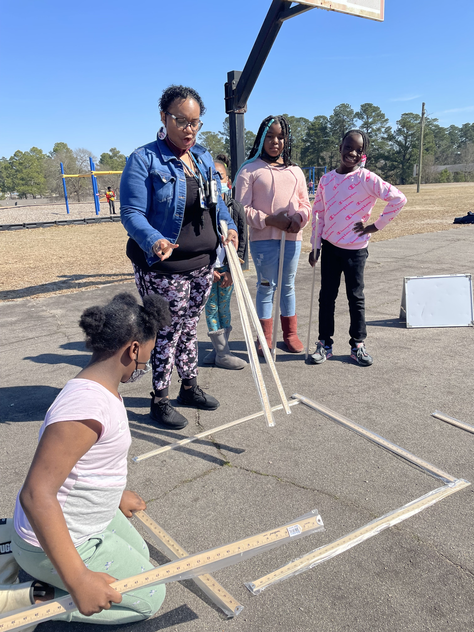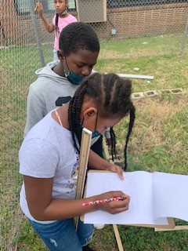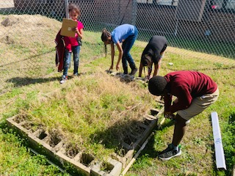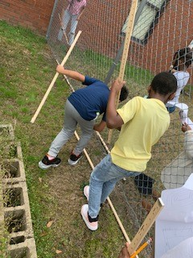

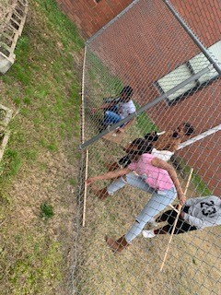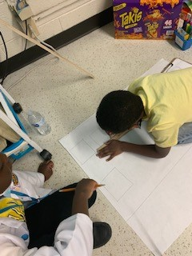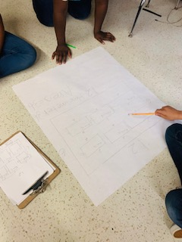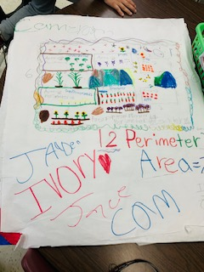

Videos

IMG_5257.MOV

IMG_5114.MOV

IMG_5259.MOV

**Scroll Down for Unit Standards**

Unit Standards:

ELA:

Math:

MGSE3.OA.8 Solve two-step word problems using the four operations. Represent these problems using equations with a letter standing for the unknown quantity. Assess the reasonableness of answers using mental computation and estimation strategies including rounding. ‡

MGSE3.MD.7 Relate area to the operations of multiplication and addition.
a. Find the area of a rectangle with whole-number side lengths by tiling it, and show that the area is the same as would be found by multiplying the side lengths.
b. Multiply side lengths to find areas of rectangles with whole number side lengths in the context of solving real world and mathematical problems, and represent whole-number products as rectangular areas in mathematical reasoning.
c. Use tiling to show in a concrete case that the area of a rectangle with whole-number side lengths a and b + c is the sum of a × b and a × c. Use area models to represent the distributive property in mathematical reasoning
Science:

Social Studies:

