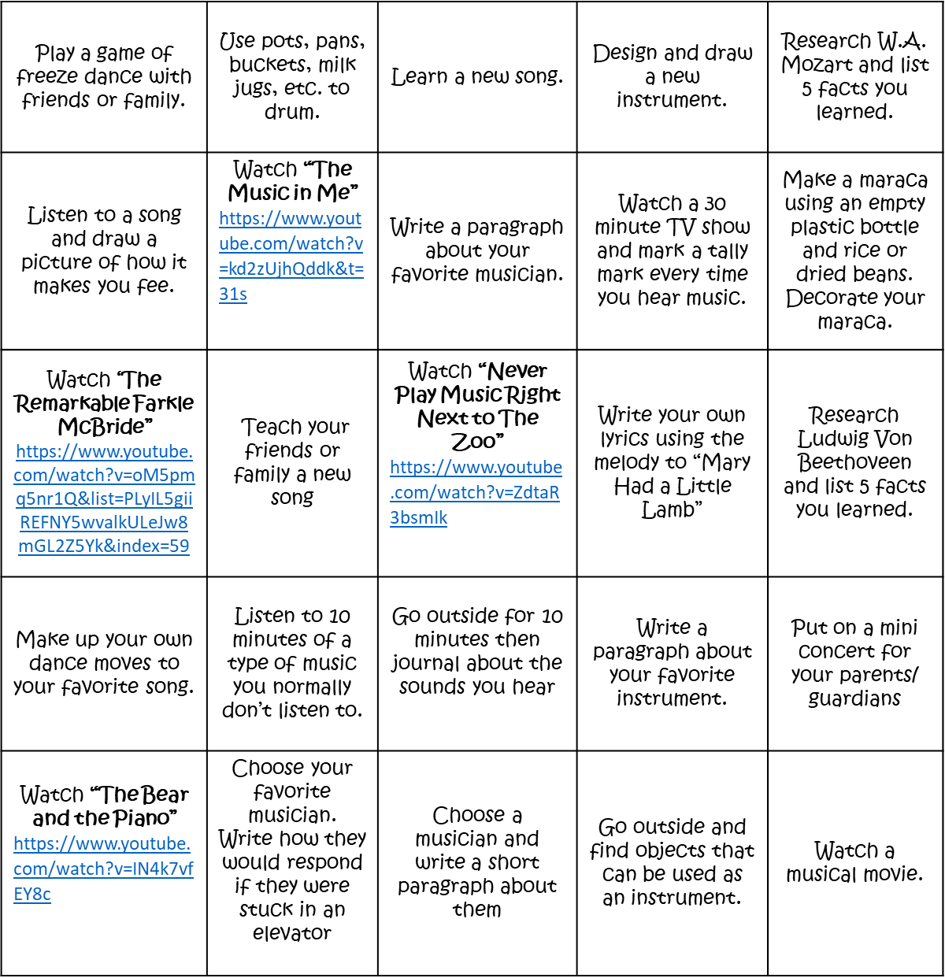

**Distance Learning Activities**

Choose one activity to complete each day