Formatting in the table of contents (TOC) and
setting up styles to generate a table of contents

(Because there are a lot of images, each page may take a few seconds to fully load)

These instructions and images are in Microsoft Word 2003. Walden isn’t currently using Word 2007, so I’m not sure how these instructions will fit for those of you with that version. Stay tuned!

1. Here’s how to get all your page numbers to line up nicely:
Type in a heading, then hit the tab key and then the page number. Continue entering all your headings and page numbers. Now, highlight the entire table and go into Format-Tabs. You will see Tab stop position; enter 6”, then click Right under the Alignment heading, and then click the number 2 selection under the Leader heading, which will have dots next to it. Then hit OK and all the tabs will line up the page numbers.

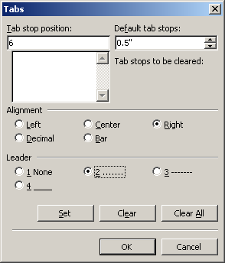

If you click on the paragraph symbol ¶ on your formatting toolbar, you’ll see the tabs entered in the sample TOC below.

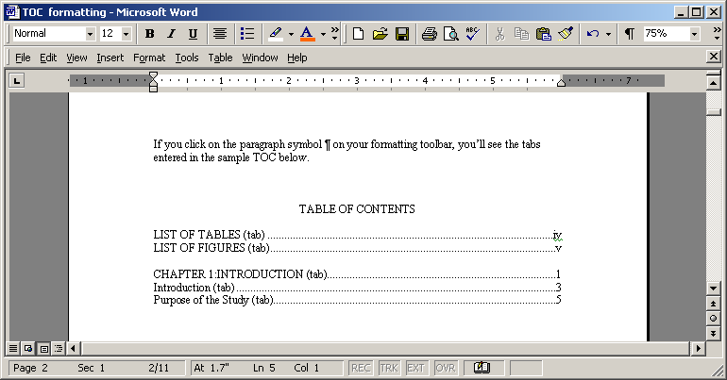

TABLE OF CONTENTS

List of Tables (tab) iv
List of Figures (tab) v

CHAPTER 1:INTRODUCTION (tab) 1
Introduction (tab) 3
Purpose of the Study (tab) 5

Important: If you want to add the dot leader after you’ve entered your TOC, make sure you don’t have tabs other than the one between the end of the heading and the page number. Delete all existing tabs before adding the one for the dot leader.
2. If you’re not using a template or the Microsoft Word function for automatically generating your table of contents, here’s how to format the headings in the table of contents manually.
Important: Applying styles to format your headings is optional. It’s perfectly fine to format each heading manually as you go along.

Follow the model above for beginning your TOC. Each heading level below the L1 heading will be indented, to show that it is a subheading of the one above it. Per APA 3.30, use at least two subheadings for any given heading. If you find you have only one, leave it out. Tip: Be sure to use the indents rather than tabs for the L2 or L3 subheadings. So, for example, if you put your cursor in front of the first subheadings, you’ll see the indent of ¼ on the ruler; if you put your cursor in front of the next level of subheading, you’ll see the indent at ½ inch:
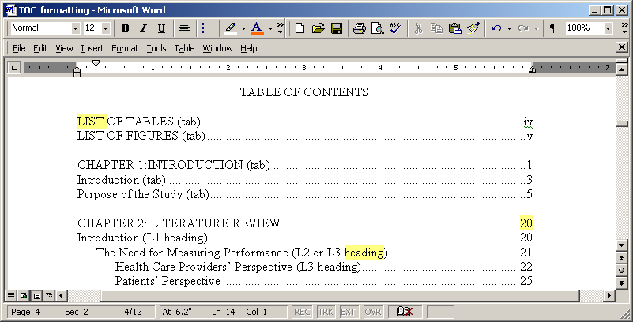
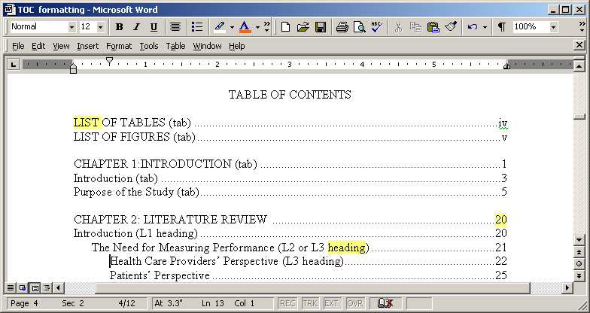

TABLE OF CONTENTS

List of Tables (tab) iv
List of Figures (tab) v

CHAPTER 1:INTRODUCTION (tab) 1
Introduction (tab) 3
Purpose of the Study (tab) 5

CHAPTER 2: LITERATURE REVIEW 20
Introduction (L1 heading) 20
The Need for Measuring Performance (L2 or L3 heading) 21
Health Care Providers’ Perspective (L3 heading) 22
Patients’ Perspective 25
Key Performance Indicators 27
Methodologies Used in Assessment of Performance 30
Longitudinal Method 31
Survey Method 36

CHAPTER 3: RESEARCH METHODOLOGY 60

CHAPTER 4: RESULTS 80

CHAPTER 5: SUMMARY, CONCLUSIONS, AND RECOMMENDATIONS 120

REFERENCES 140

APPENDIX A: TITLE OF APPENDIX 150
APPENDIX B: TITLE OF APPENDIX 152

CURRICULUM VITAE 157
3. If you want to create a table of contents that you can automatically update as you revise your text, you will use custom styles.

If you've already applied custom styles to your headings, you can tell Word which styles to use when it's building the table of contents.

Click where you want to insert the table of contents.
On the Insert menu, click Index and Tables, and then click the Table of Contents tab.
Click Options.

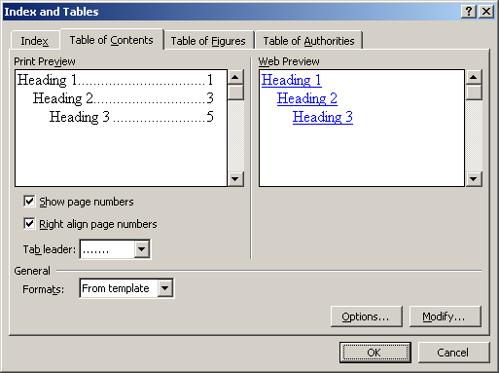

Under Available styles, find a style you've applied to headings in your document.

Under TOC level, to the right of the style name, enter a number from 1 to 9 to indicate the level you want that heading style to represent.

Repeat steps 4 and 5 for each heading style you want to include in the table of contents.
Click OK.

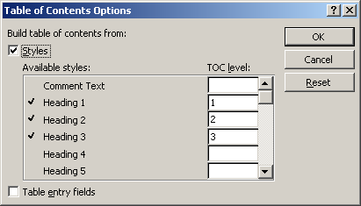

4. If you have not yet applied styles to your headings, you can create your styles by following these instructions:

On the Format menu, click Style.

In the Styles box, select the style you want to modify, and then click Modify.

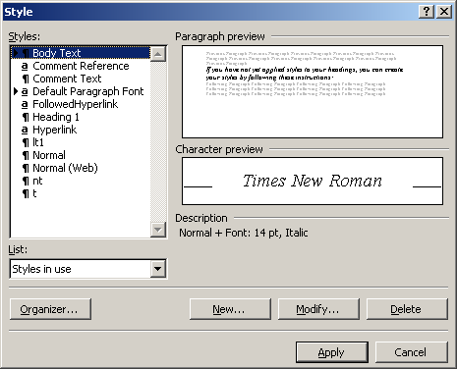

Click Format, and then click the attribute — such as Font— you want to change.
So for example, if you want to set your body text to Times New Roman, 12 point, Regular. If you want to choose another font, just select that font from the list.

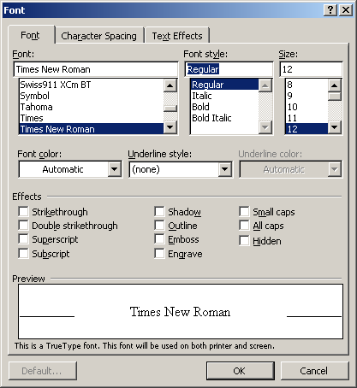

Then, go back to Format and click on Paragraph. Choose Left for Alignment, Special First line By 0.5”, and Line spacing, Double.

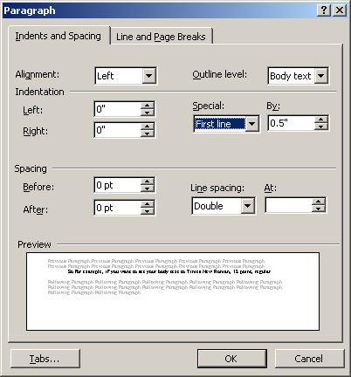

Click OK after you’ve changed each attribute.
If you want to add a new style, rather than clicking on the Modify button, click on the New button. For example, if you want to set up a style for your chapter headings, name the style APA L5, or whatever.

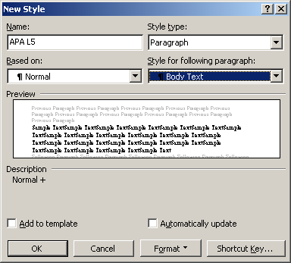

When you click on the Format button, you’ll see a drop-down menu listing Font, Paragraph, and so on. When you select Font, you’ll get this screen:
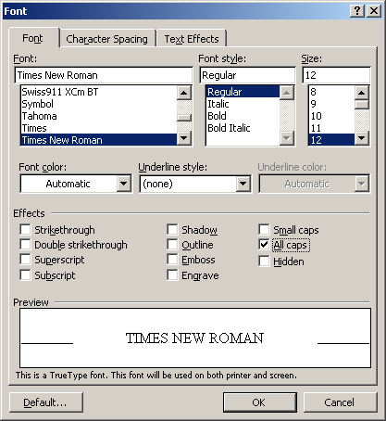
The font for APA Level 5 will be the same font that you choose for your text, Times New Roman, for example, and Regular, 12 point, and all caps.

When you select Paragraph, you’ll get this screen:
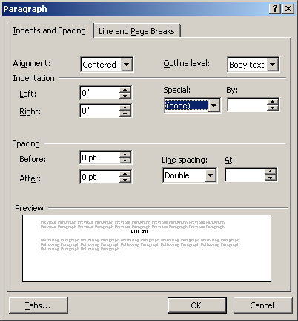
The Alignment should be Centered, and the Line spacing, Double. Be sure that the Spacing Before and After are both set at 0 pt.
Your styles will then show up in the far left side of the formatting toolbar.
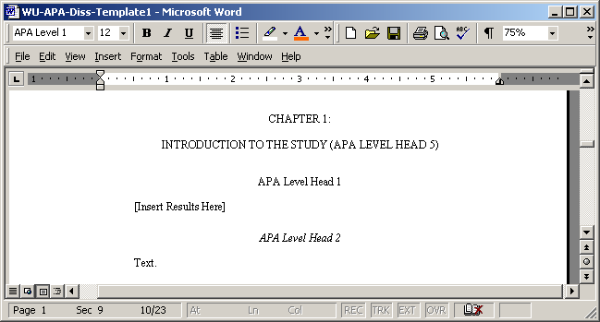
After you’ve typed in a heading, simply highlight it, go to the style menu in the upper left corner and select the heading level.

Repeat the process to set up each new style.

If you want to generate your table of contents after you have completed your paper, make sure that when you are creating your styles, you check the box that says Add to template. Then, put your cursor on the table of contents page, under the L5 heading TABLE OF CONTENTS, then go to Insert, Index and Tables, and under Formats, select From template and the number of levels (Show levels) you want to show. Then hit OK.
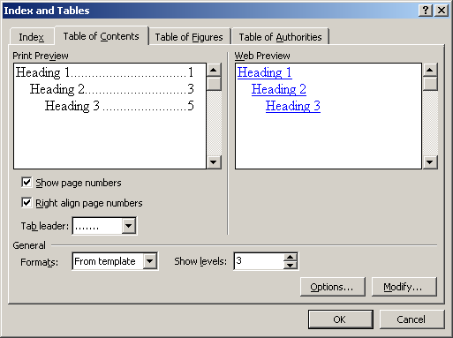
This will also allow you to automatically update your page numbers in the Table of Contents as you revised your text. Click to the left of the left of the TOC and hit F9. This will bring up a window where you can indicate that you want to update the page numbers or the entire table. If you’ve changed heading titles, you will want to select Update entire table.
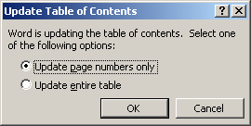

Important: The Help feature in Microsoft Word can be useful at any point to get additional assistance, or, if you have a young son or daughter, niece or nephew, grandson or granddaughter, or techie-type friend who can help explain all this craziness, press them into service, using bribery if necessary (kidding, of course!). Also, make use of the Concierges and Writing Center staff at residencies for help with Microsoft Word. Do check the Writing Center Web site as well for other up-to-date formatting help for KAMs, course papers, theses, and dissertations.

