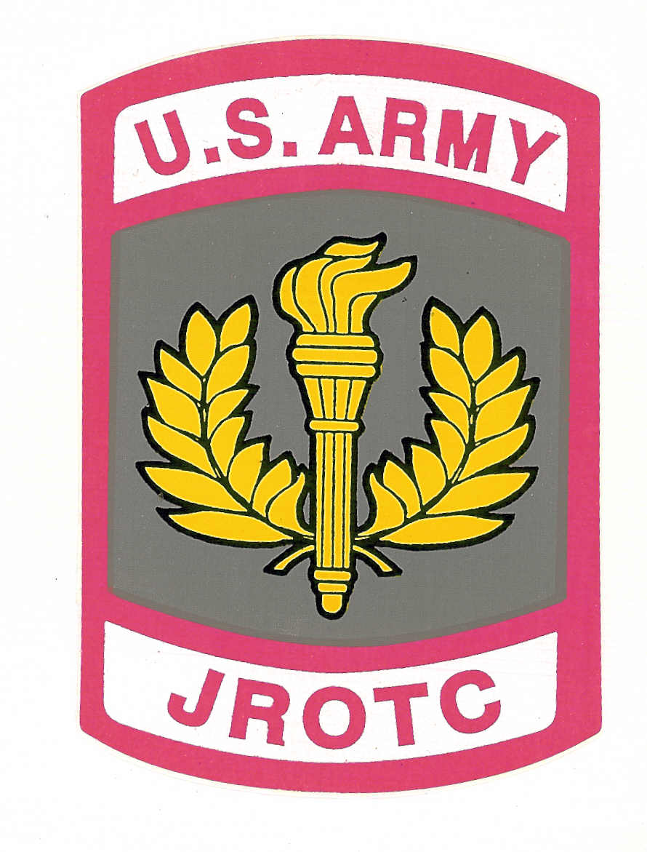

Memorandum of Information

Subject: Cadet Staff and Leadership Positions

All Cadet Staff and Cadet Leadership are required to attend the weekly leadership meeting on Tuesday after school at 1500 hrs and are highly suggested to be on a team as Team Commander.
Cadets requesting to perform these positions are encourage to apply for the desired position.
Cadets must be prepared to write a short essay stating why they should be considered for the staff or leadership position.
Cadets need to write brief descriptions on their duties and responsibilities.
Cadets must also prepare a brief outline on how they will be able to attend the weekly meetings and perform their duties by managing their time among other after school activities and explaini their means of transportation.
All Cadet Staff and Cadet Leadership members must govern themselves accordingly in order to receive the appropriate rank.
(NOTE: All information need to be neatly typed on the same document)

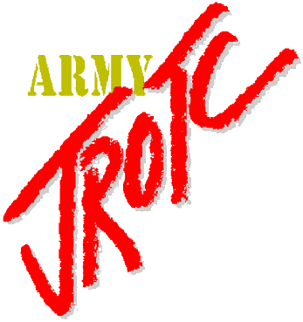

“To motivate young people to be better Citizens”

