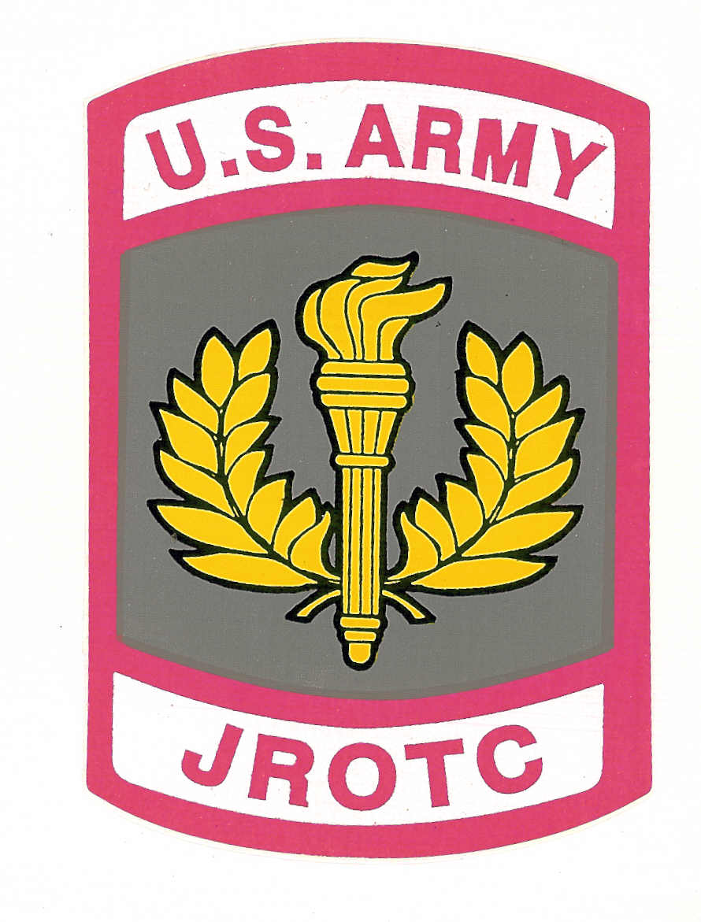

LANEY JROTC DEPT

LCLHS-JROTC
Memorandum for Record
Subject: JROTC Cadet Agreement
I, _________________________________have been approved by the Laney JROTC Instructors
to be enrolled in the JROTC Program. I have acknowledged and accepted the terms and
conditions reference the structure and discipline of the JROTC Program. I am committed to
demonstrating a positive and motivative attitude toward my education and learning experience.
As a Cadet in JROTC, I am considered an ambassador to the school. I will always “Set The
Example” by doing what’s right and not what’s popular. My goal and objective is to help make
Laney JROTC the Best JROTC Program in Richmond County.

I pledge to follow the JROTC Instructor’s guidance and instructions, uphold the JROTC Values
and Cadet Ethos as a Cadet of Laney JROTC. If for any reason I don’t meet the obligation of
my Duties and Responsibilities, Fail to meet the JROTC Standard of Expectations, Display
negative actions or behavior as a student or cadet, do anything unbecoming that will bring
discredit to myself, the School, or the JROTC Program, I understand that possibly my position,
title, rank, incentives, and/or ASU uniform can be suspended or retrieved until further action is
taken by the Instructors.

This Cadet have agreed and pledged to uphold the leadership standards, structure, and
expectations of the Laney JROTC Program. As the Instructor, I will facilitate, teach, coach,
mentor, observe, evaluate, and retrain the cadets as needed to ensure their success as a productive
Cadet in accordance with JROTC Policies and Procedures.

___________________________________ ______________________________________
Cadet Signature Instructor Signature


“STEP UP TO THE CHALLENGE”

