**Melismatic and Syllabic Singing**

**Melismatic** - when more than one note is sung to a single syllable.

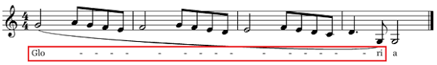

**Syllabic** – lyrics have primarily one syllable of text per musical note.

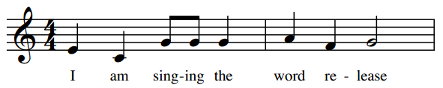

Syllabic and melismatic example:

