**Part-writing Rules**

**General:**

* **Parallel 5ths** – between the **same two voices**

0 voice leading points

pw%20errors/parallel%205ths.pdf

* **Parallel octaves** – between the **same two voices**

0 voice leading points

pw%20errors/parallel%20octaves.pdf

* **Direct (hidden) 5ths or octaves between soprano and bass unless soprano moves by step**

1 voice leading point

pw%20errors/direct%205ths.pdf

* **Parallel unisons**

0 voice leading points

* **5ths or octaves by contrary motion**

0 voice leading points

pw%20errors/5ths%20by%20contrary%20motion.pdf

* **More than an octave between adjacent upper voices**

1/2 point for chord - can check voice leading in and out

pw%20errors/spacing.pdf

**Melody:**

* **Melodic A2**

0 voice leading points

pw%20errors/A2%20error.pdf

* **Melodic A4**

0 voice leading points

pw%20errors/A4%20error.pdf

* **Leap greater than a 5th**

0 voice leading points

* **Approach an altered note from above** (to avoid A2 or A4) and resolve it back up in order to avoid melodic A2 or A4 in order to avoid a melodic A2 or A4

pw%20errors/voice%20leading.pdf

* **Leading tone always needs to resolve when in soprano**

0 voice leading points

pw%20errors/resolve%20LT%20in%20soprano.pdf

* Try to make leading tone resolve in inner voice, but you don’t have to according to AP rules
* **Motion to crossed voices**

0 chord construction points

1 voice leading point

pw%20errors/cross%20voicing.pdf

~ or ~

* **Voice overlap**

1 voice leading point

pw%20errors/voice%20overlap.pdf

**Doubling:**

* **Root position triads and chords – can leave out the chordal 5th** (make sure you have the 3rd!!)

0 chord construction points

* **Inverted triads and chords – all notes must be present**

0 chord construction points

**6/4 chords:**

Cadential 6/4:

* I6/4 resolves to the V at the cadence
* **Bass note is doubled**
* Upper voices resolve down
* Keep the common tone

½ point (if bass note not doubled)

Check voice leading

pw%20errors/cadential%20I6:4.pdf

Passing 6/4:

* Bass note (5th) acts as a passing tone
* **Bass note is doubled**
* Can be found as a I6/4 between the IV and IV6 chords or as a V6/4 between the I and I6 chord

Incorrectly resolved passing 6/4 chord

0 voice leading points

pw%20errors/passing%206:4%20%232.pdf

pw%20errors/passing%206:4.pdf

Arpeggiated 6/4:

* Bass note (5th) acts as a passing tone
* Bass note is doubled

Incorrectly resolved arpeggiated 6/4 chord

0 voice leading points

pw%20errors/arpeggiated%206:4.pdf

Pedal 6/4:

* Also known as stationary bass
* Bass note is doubled
* Bass note (5th) is preceded and followed by the same tone and is placed between two root positions of the same triad

Incorrectly resolved pedal 6/4

0 voice leading points

pw%20errors/pedal%20bass%20%231.pdf

* **Don’t approach a chordal 7th by a downward leap**

1 voice leading point

**7 chords:**

V7:

* **Resolve the chordal 7th down one step**.
* 0 voice leading points for incorrectly resolved V7 chord

pw%20errors/V7%20chord%20resolution.pdf

vii7:

* Vii7 generally resolves to I but can go through the V7 chord first
* **Chordal 7th resolves down**
* **Root resolves up**
* **Chordal 3rd resolves up**
* This causes the chordal 3rd to double

Incorrectly resolved vii7 chord

0 voice leading points

pw%20errors/vii7%20resolution.pdf

ii7:

* **Chordal 7th resolves down**

Incorrectly resolved ii7 chord

0 voice leading points

**pw%20errors/ii7%20resolution.pdf**

**Secondary dominants:**

* **Resolve the 3rd of the chord up one step (triad)**
* **Don’t double the 3rd (altered note)**

Incorrectly resolved triad

0 voice leading points

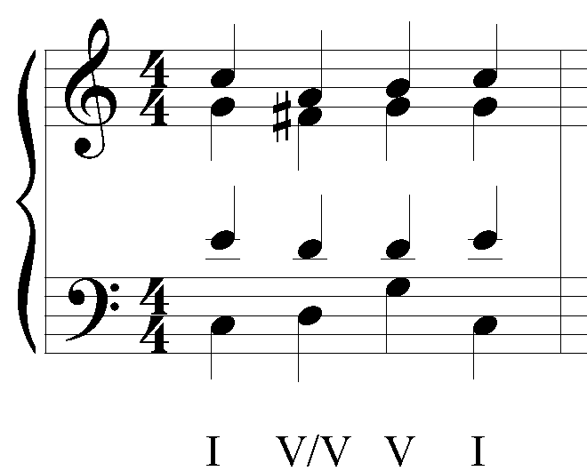

* **Resolve the chordal 7th down** (7 chord)
* **Resolve the chordal 3rd up**

Incorrectly resolved chord

0 voice leading points

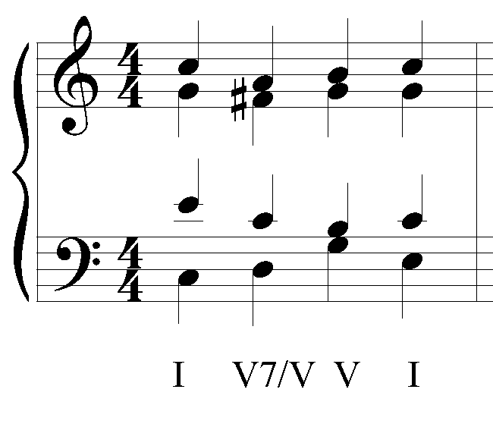

**Special notes:**

V7/IV

* **Can only be used as a 7th chord**
* In a major key lower the chordal 7th to create a Mm7
* In minor key raise the 3rd and add the unaltered 7th to create a Mm7

0 chord creation points

0 voice leading points

V/iii, V7/iii

* **Raise both the chordal 3rd and 5th**

0 chord creation points

0 voice leading points