**Texture**

***Accompaniment*** – musical part that provides the rhythmic and/or harmonic support for the melody or main themes of a song or instrumental piece

***Alberti bass* -** a kind of broken chord or arpeggiated accompaniment, where the notes of the chord are presented in the order lowest, highest, middle, highest.

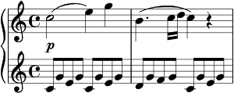

***Canon*** – think Canon in D – a melody that can be sung against itself – like Row, Row, Row Your Boat

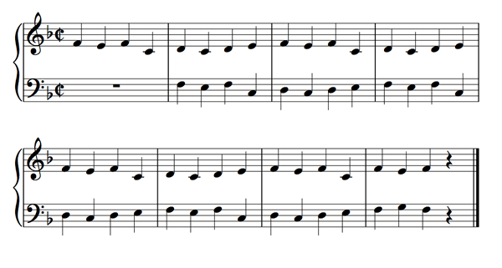

***Chordal accompaniment*** – musical support for a soloist

***Monophonic*** – single melody line.

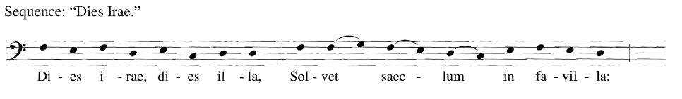

* Can be ***doubled*** at the octave.

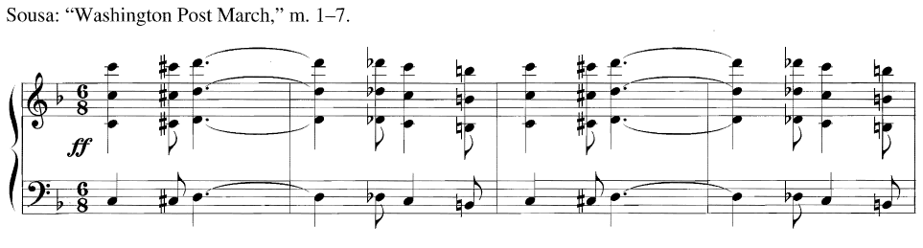

***Polyphonic*** – two lines moving independently of each other, or in imitation.

* Different melodies moving independently of each other.

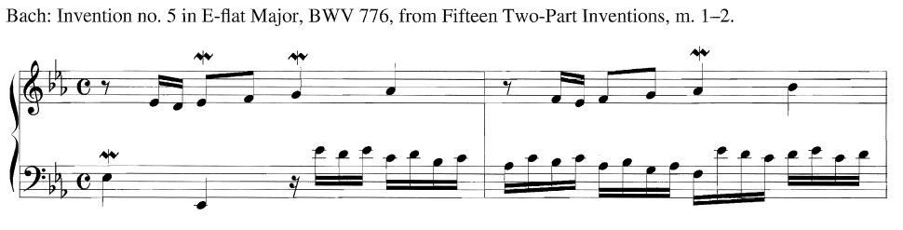

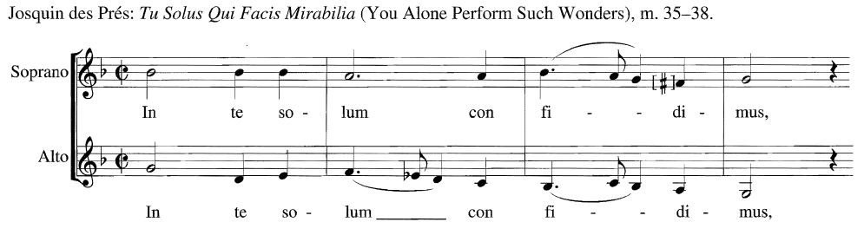

* Two or more lines imitating each other

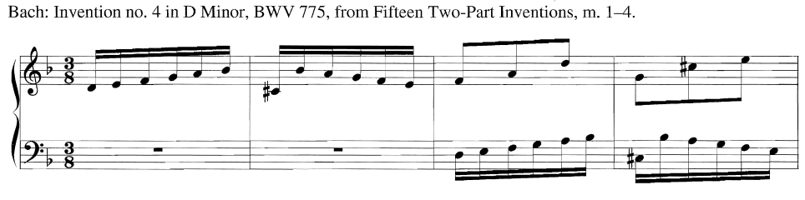

***Counterpoint/contrapuntal*** - relationship between two or more voices independent in contour and rhythm

* **Imitation** – musical gesture is repeated later in a different form, but retaining its original character
* **Imitative polyphony** – two or more equally prominent, simultaneous melodic lines, those lines being similar in shape and sound
* **Nonimitative polyphony** – two or more melodic lines playing distinct melodies
* **Countermelody** – accompanying melody sounding against the principle melody

***Homophony, homophonic*** – melody and accompaniment

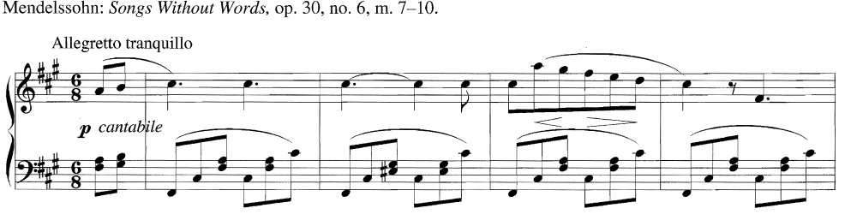

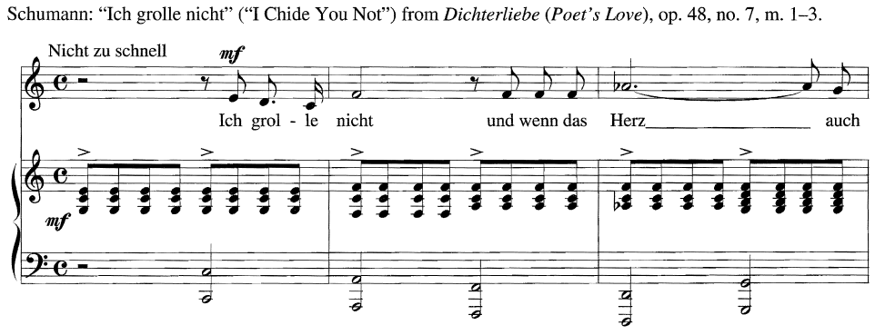

***Chordal (or homorhythmic)*** – similar rhythm in all parts, like a church hymn

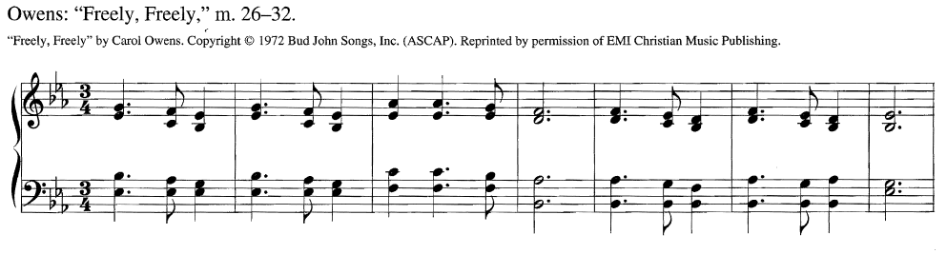

***Heterophonic*** – simultaneous variation of a single melodic line.

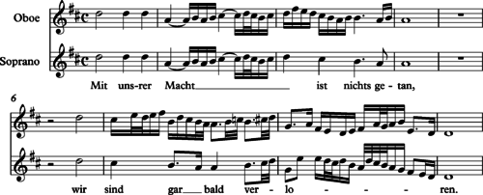

***Doubling*** – writing a given note twice in a chord

***Instrumentation***

* Brass
* Basso continuo
* Instrumental transposition
* Percussion
* Rhythm section
* Strings
* Timbre
* Winds
* Woodwinds

***Melody*** - String or series of notes together, one after the other

***Ostinato*** – a short musical pattern which is repeated throughout a given passage. Ostinatos generally are a part of the supporting or accompanying material in a piece of music.

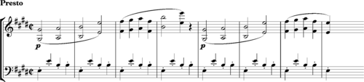

***Register*** – the range of musical notes that someone’s voice or a musical instrument can reach

***Solo, soli*** - alone

***Tessitura*** – the average range of a particular voice or instrument in a composition. If a tessitura is “high,” the notes tend to be in the higher extreme of the total range of that voice or instrument.

***Tutti*** – every instrument playing together

***Walking bass*** – usually moves by steps played on bass or piano with each note usually having the duration of a quarter note

