HOMEWORK

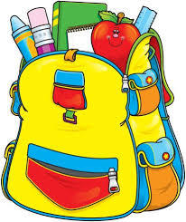

Short homework assignments will be given Monday-Thursday in phonics and math. The homework will be on a skill that has been taught. Homework teaches responsibility and allows the student to practice and reinforce skills.